Required Components
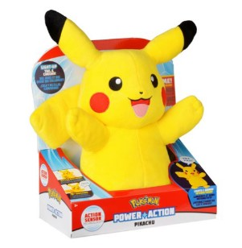 | 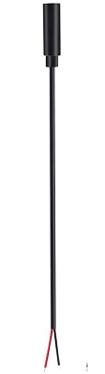 | 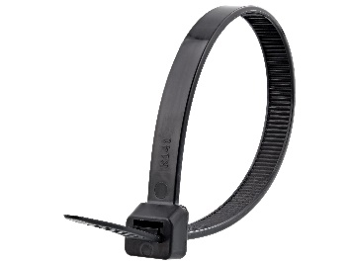 | BOM  - Pokémon – Power Action Pikachu Toy  - 3.5 mm Female Cable  - Cable tie (small – around 15 cm)  Refer to the Tool and Component List for purchasing details.

Required Tools
- Phillip screwdriver
- Wire strippers
- Flush cutters
- Soldering iron and solder
- Drill and1/8 drill bit

Required Personal Protective Equipment (PPE)
- Safety glasses

Assembly Instructions

- To start, pull the inside compartment from inside the toy. The compartment is connected to fabric inside the toy and if needed can be cut from the fabric but it should be able to be pulled out enough to work with.  - Unscrew the screws in the four corners, this will allow you to take the “top” of this compartment off and reveal the inside. | 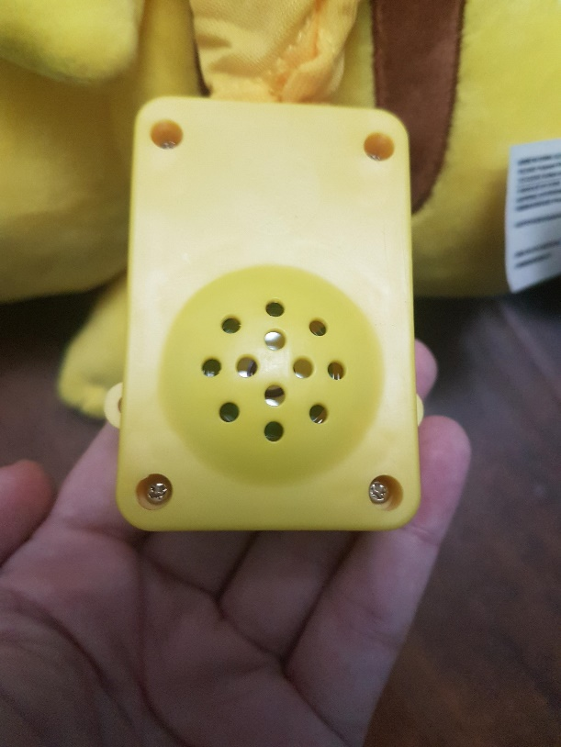
- This toy will be adapted via cable. To do this, drill a hole with a 1/8 drill bit in the “top” of the compartment. The cable will be threaded through this hole so you can check that the cable fits and that there is enough room for the cable and the compartment to be closed again. | 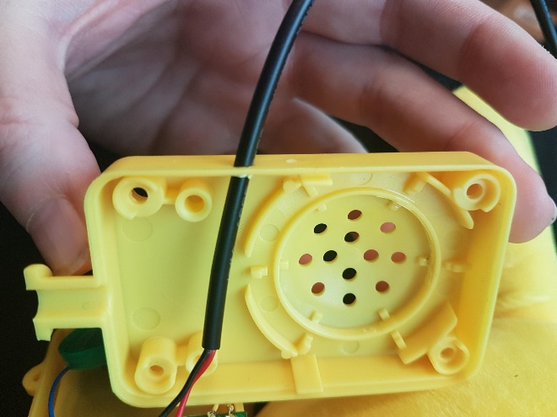
- Before threading through the compartment, we can prepare the cable. Using the open end, or cut end, of your wire strip approximately 2 cm of the outside wire. This will reveal the wires on the inside. (Depending on your cable, this may already be done)
- Next strip approximately 0.5 cm of the individual internal wires
- Tin your wire. The best way to do this is cover the exposed wire end in solder. This will help you solder onto the board | 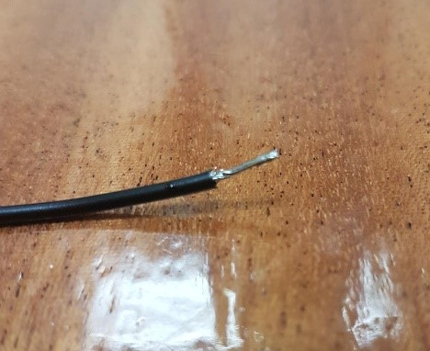
- Thread the end of the cable through the drilled hole. You want the open end, or the end showing internal wires to be inside the compartment. You will be soldering these wires onto the board. | 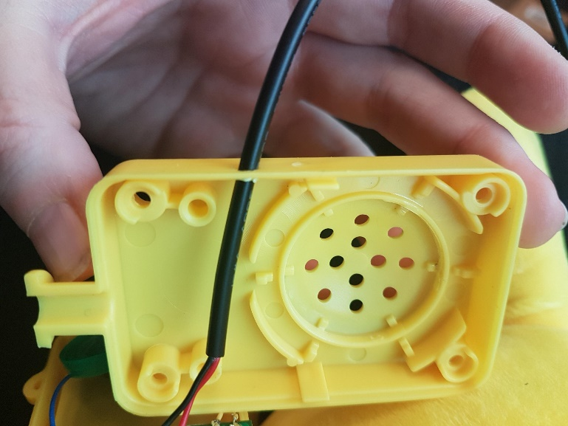
- Solder one wire end on to the indicated spot on board. You will be soldering onto the spots where the white wires are and should be careful that those wires also stay connected. You may want to use your iron to heat the spot and solder already on the wire to connect. Solder the other wire on to the other spot indicated on the board. | 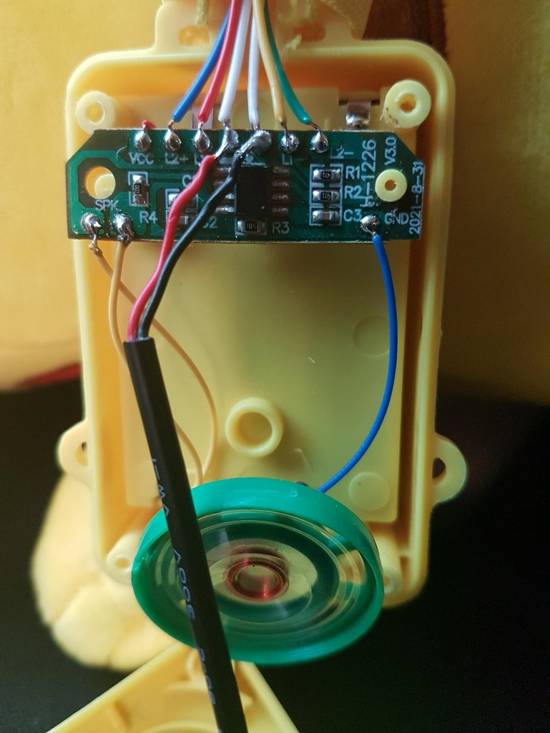
- Once the wire is connected, attach a cable tie to the cable, on the inside of the white case- as close as possible to where it enters. Tighten the cable tie as much as you can.  This cable tie will serve as strain relieve, so that if the cable is pulled it won’t break the solder connections. | 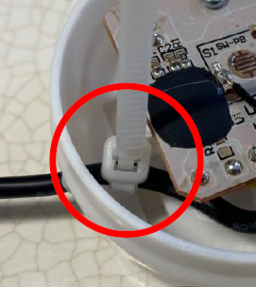
- The toy can now be tested by plugging a switch into the cable. When the switch is activated, Pikachu should sing. Reassemble the compartment with screws and the cable coming out of the side. The compartment can be put back into the toy, with the cable coming out so a switch can be plugged in without opening the toy back up. | 