Required Components
 | 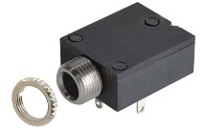 | 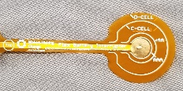 | BOM  - Spinning Light Wand  - 3.5mm mono jack and nut x 1  - Flex PCB  - 3D printed stand (2 pcs)  - Screw (x2)  - AA battery (x3)  Refer to the Tool and Component List for purchasing details.
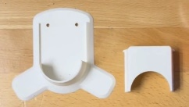 | 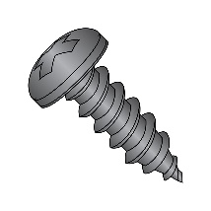 | 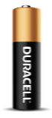

Required Tools
- Phillip screwdriver
- Soldering iron and solder
- Scissor

Required Personal Protective Equipment (PPE)
- Safety glasses

Assembly Instructions
- Locate your battery interrupter PCB and mono jack.  You will notice the prongs from the mono jack match up with the holes in the PCB. Lay the battery interrupter on top of the mono jack, with the metal prongs going through the holes. | 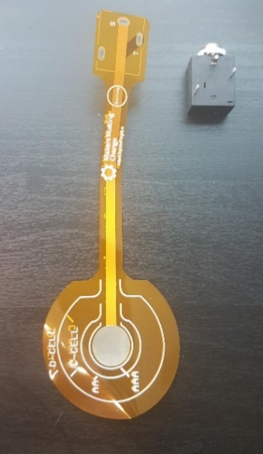
- At the base, add solder to the metal prongs so the PCB and mono jack are connected.  Make sure the PCB is flat against the mono jack as possible  The metal ring, or nut, that is around the input of the mono jack can be removed and set aside. | 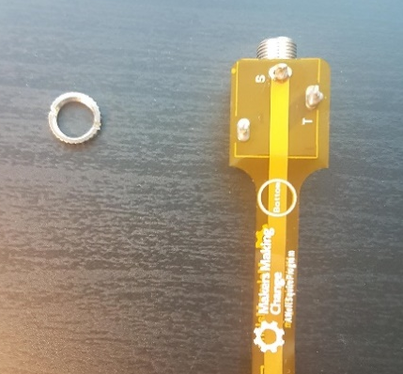
- Cut flex PCB down to the correct battery size. For this toy, cut around the line marked AA  Solder the mono jack to the flex PCB (yellow circles). Insert the flex PCB on top of a AA battery (middle image). Secure the mono jack to the 3d printed base (right). Insert the wand into the 3d printed base and secure with two screws underneath. | 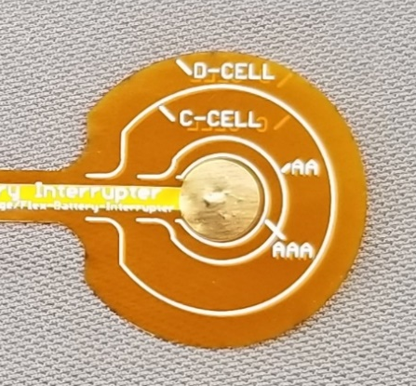
- Open the battery compartment and insert 3 AA batteries  Insert the flex PCB on top of one of the batteries | 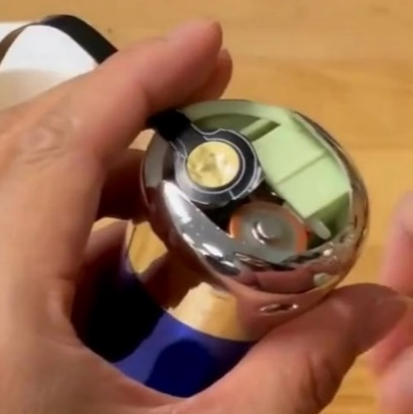
- Secure the mono jack to the 3d printed base | 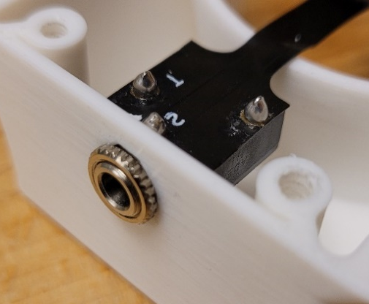
- Insert the wand into the 3d printed base and secure with two screws underneath. | 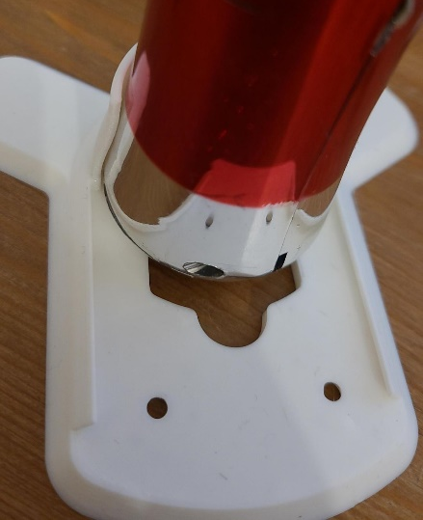
- Toy is complete! Test with a switch.

