Required Components
 | 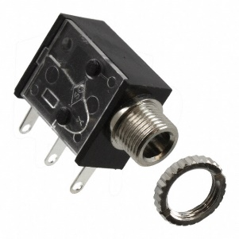 | BOM  - WeOfferWhatYouWant First Guitar Toy  - Mono Jack (x4)  - 22 AWG Wire  - 10 nF Capacitors (x2)  Refer to the Tool and Component List for purchasing details.
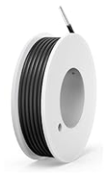 | 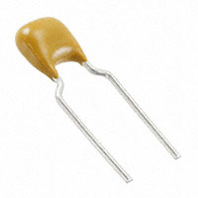

Required Tools
- Small Phillips screwdriver
- Drill and 1/4” drill bit
- Wire strippers
- Soldering iron and solder
- File (optional)

Required Personal Protective Equipment (PPE)
- Safety glasses

Assembly Instructions
- Turn over the toy and remove all 9 screws. | 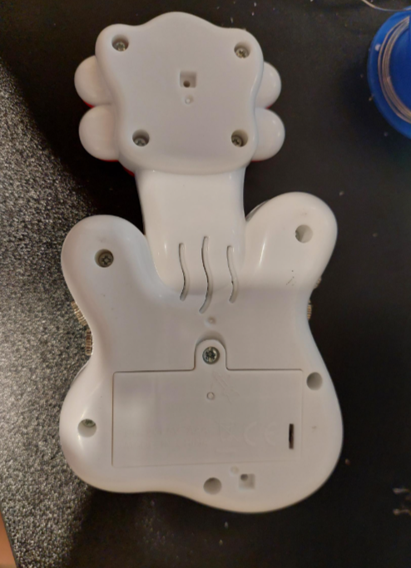
- Remove the silicone button. You should be able to pull the two silicone legs out of the small holes. | 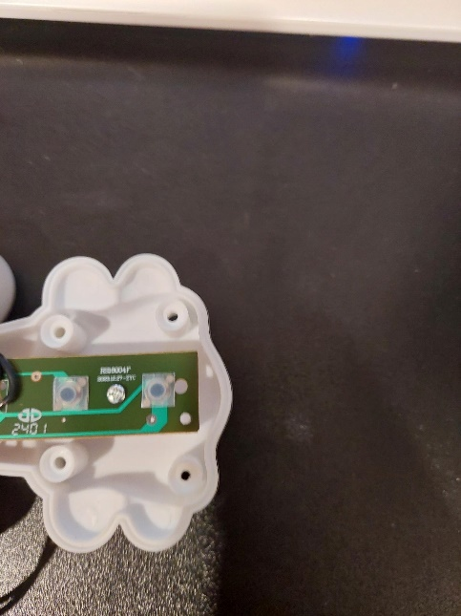
- Cut 4 lengths of wire about 10cm long | 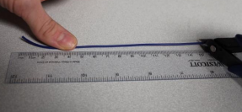
- Strip approximately 0.5cm off of the small wires. | 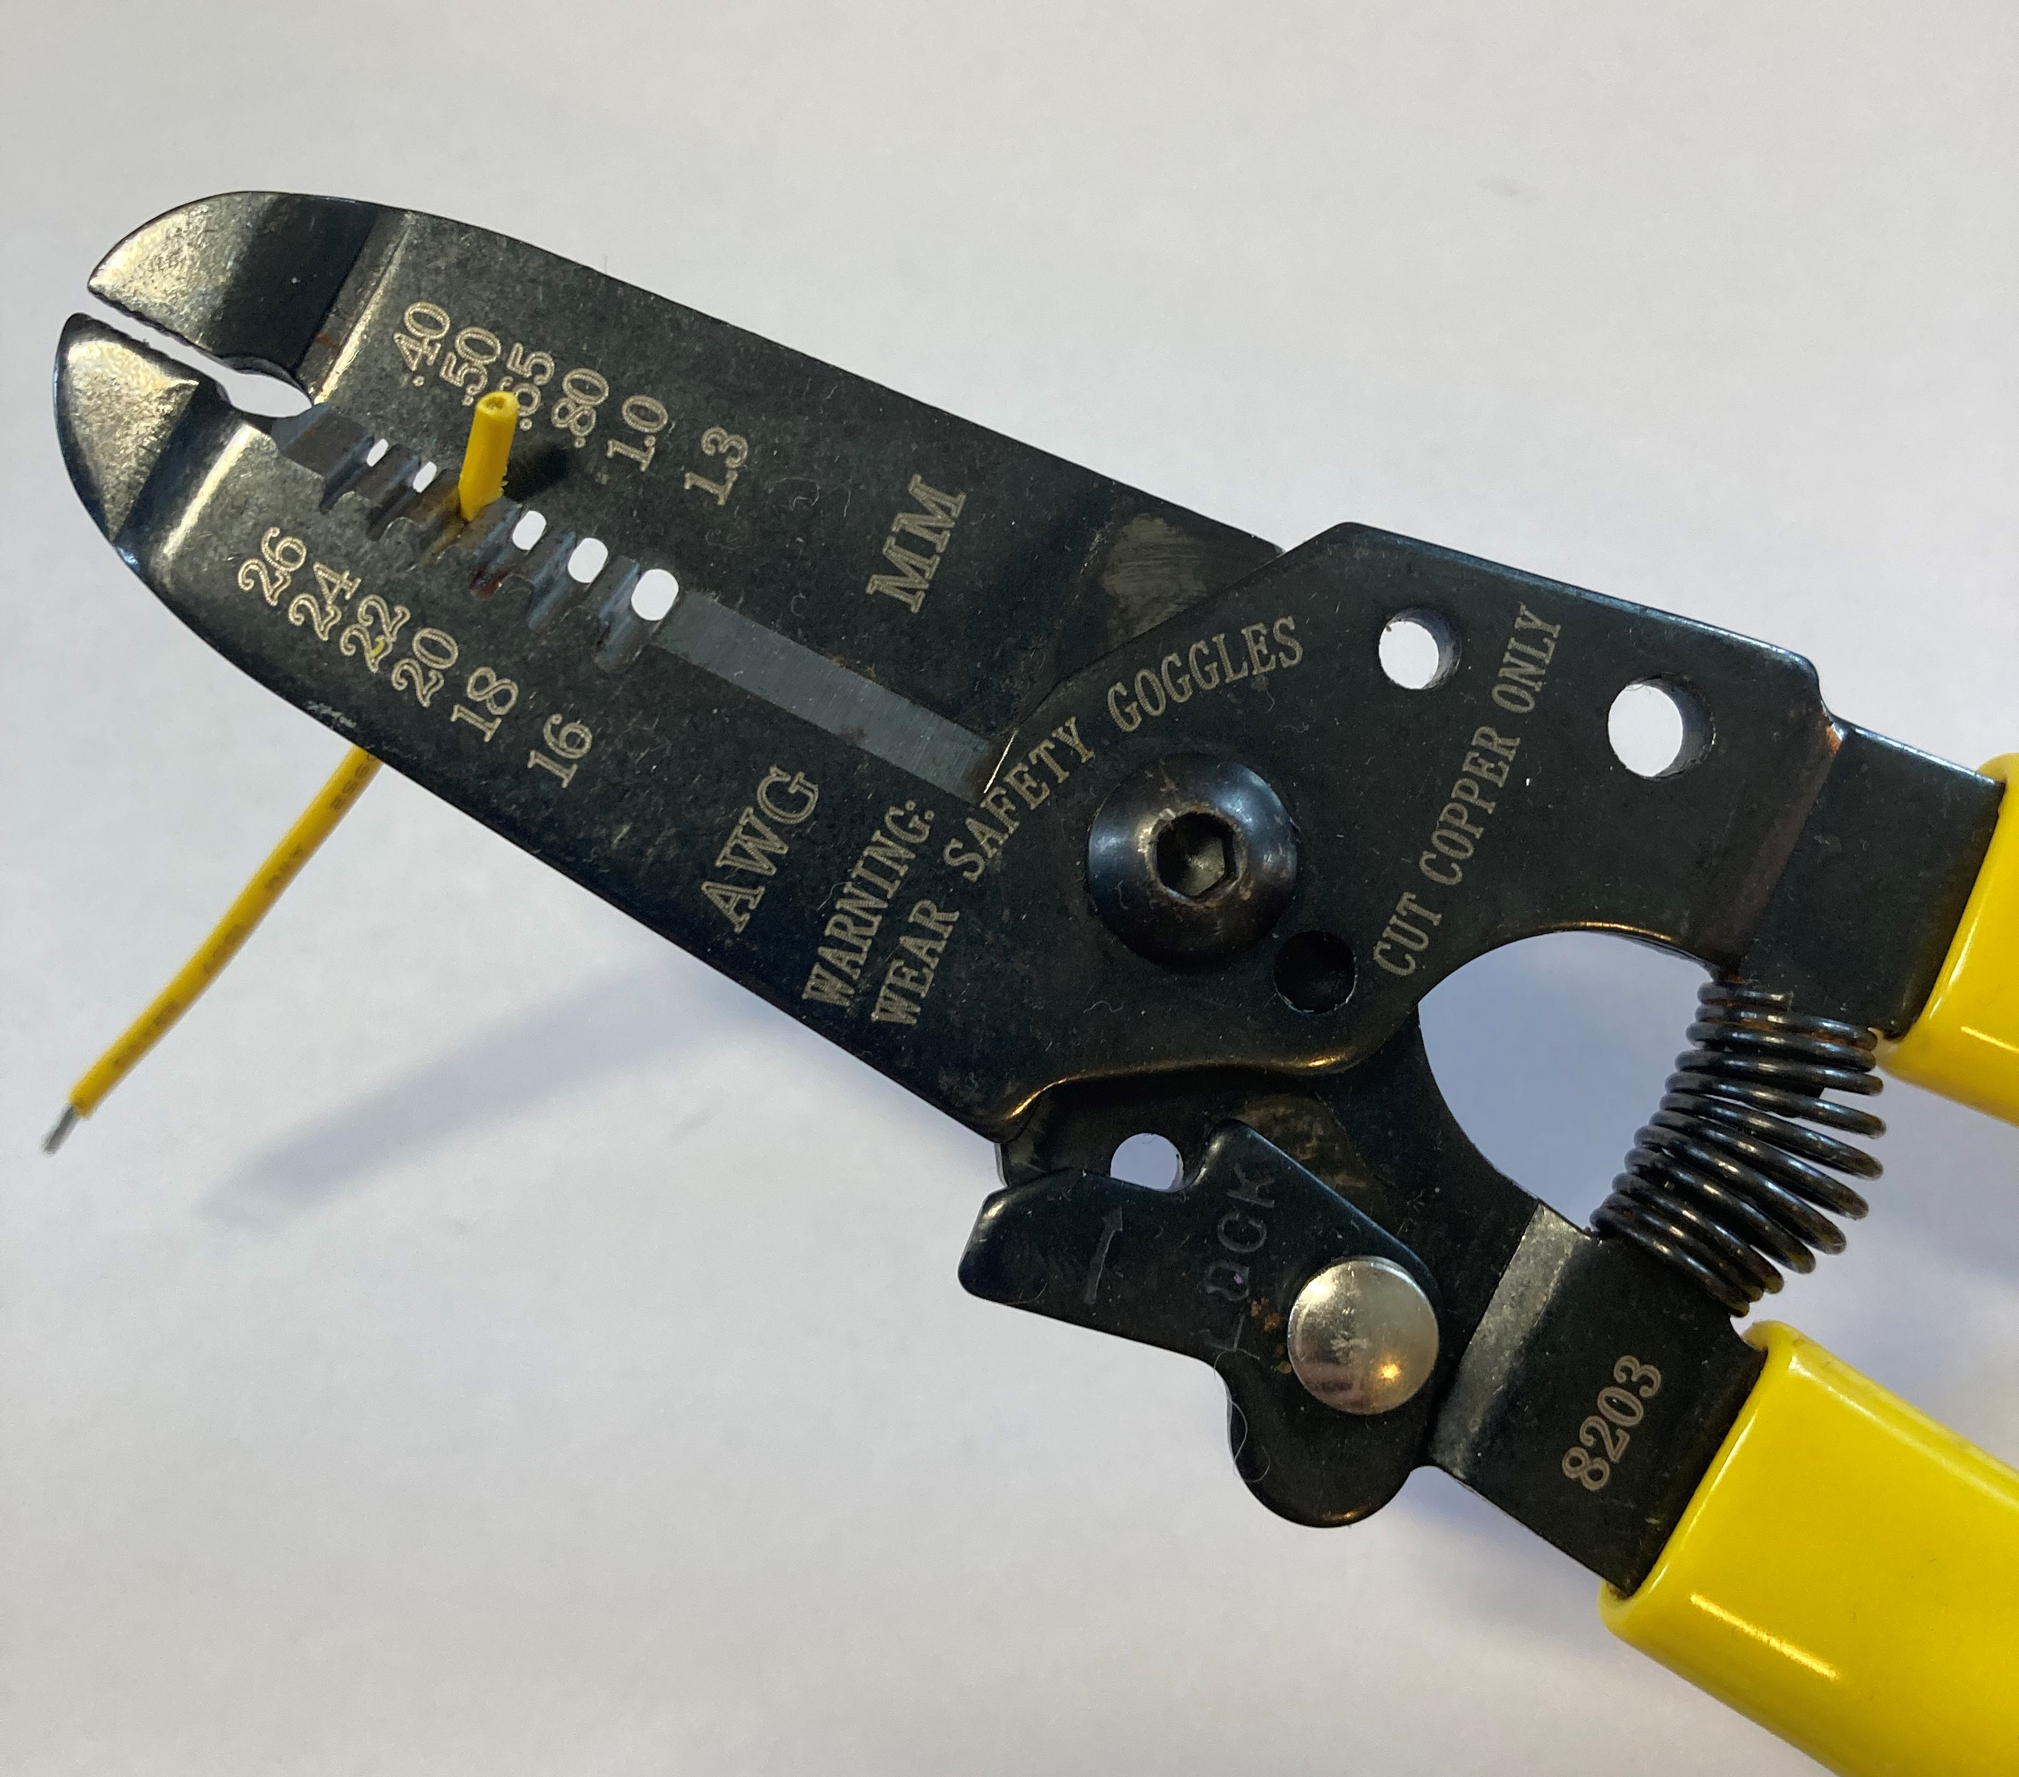  0.5 cm
- Solder a wire to the first leg of a mono jack, solder a second wire to the second leg of the mono jack. Repeat with the second mono jack and other wires | 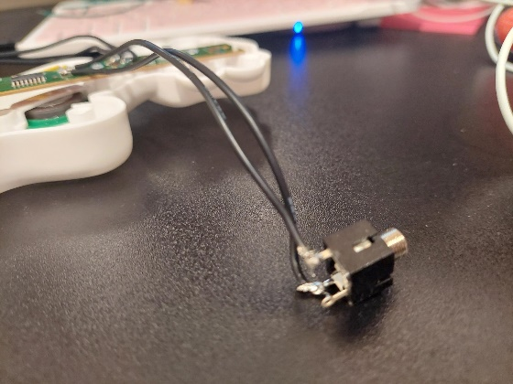
- Prior to soldering to the device, tin your wire. The best way to do this is cover the exposed wire end in solder. | 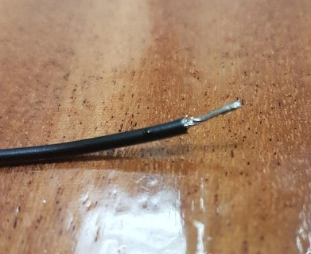
- Solder the two wires of the jack onto the circuit board as shown. Any wire of the two wires will work.  Repeat on all four sets of points.  Note: It is easy to melt the board; use caution. | 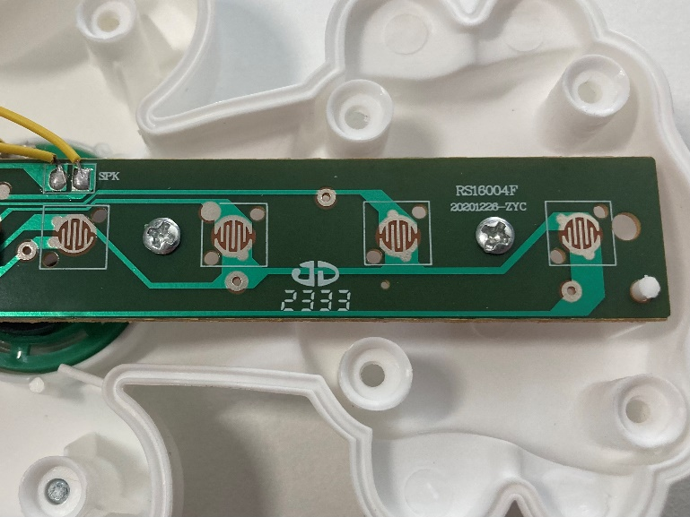
- Solder the capacitors onto the two jacks in the centre of the guitar. | 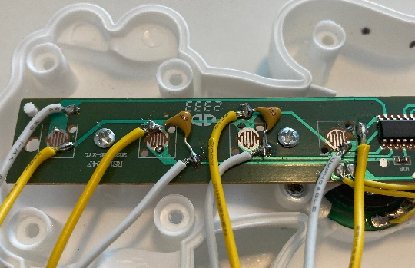
- Drill 1 hole on the top of the casing as directed in the photos. | 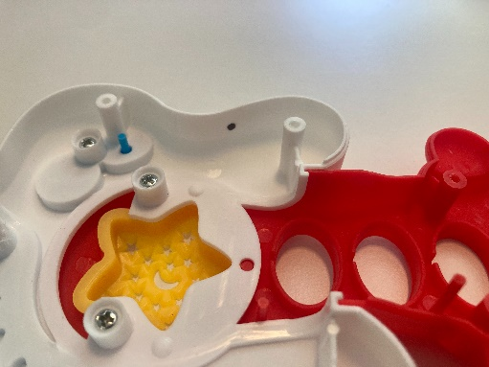
- Drill 3 remaining holes in the bottom casing. Ensure you are spacing out space for the jacks. | 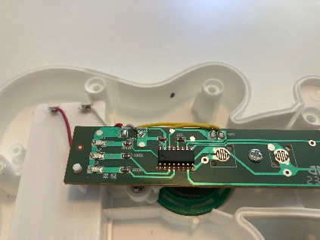  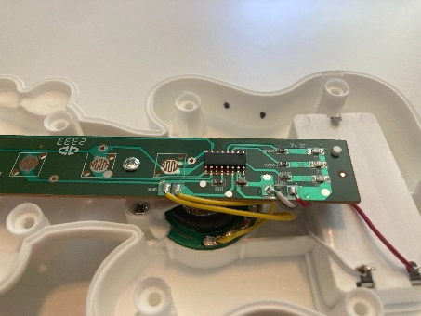
- Plug in an assistive switch and test all 4 jacks.
If the toy doesn’t turn on when the switch is activated, check the soldered connections.
- If the toy is working properly, insert the mono jacks through the drilled holes and screw the rings on the outside of the toy.
- Place the toy back together and re-insert the screws that were removed earlier, being careful not to pinch any wires.

Re-test the toy to ensure it is still functioning properly.

