Required Components
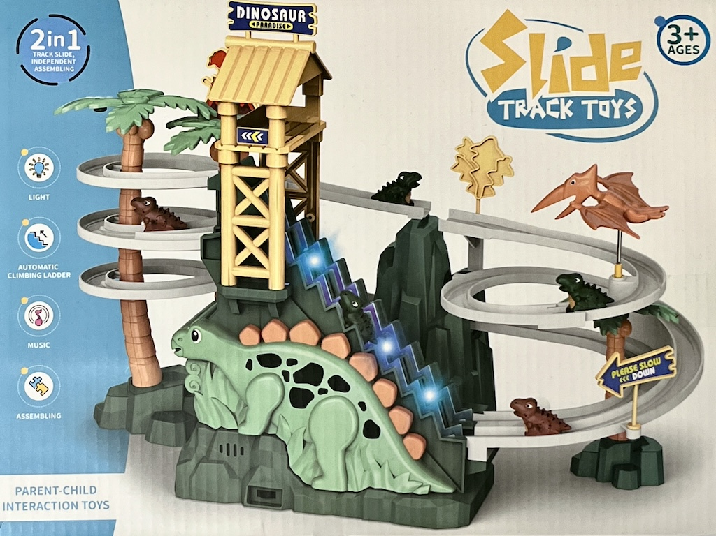 | 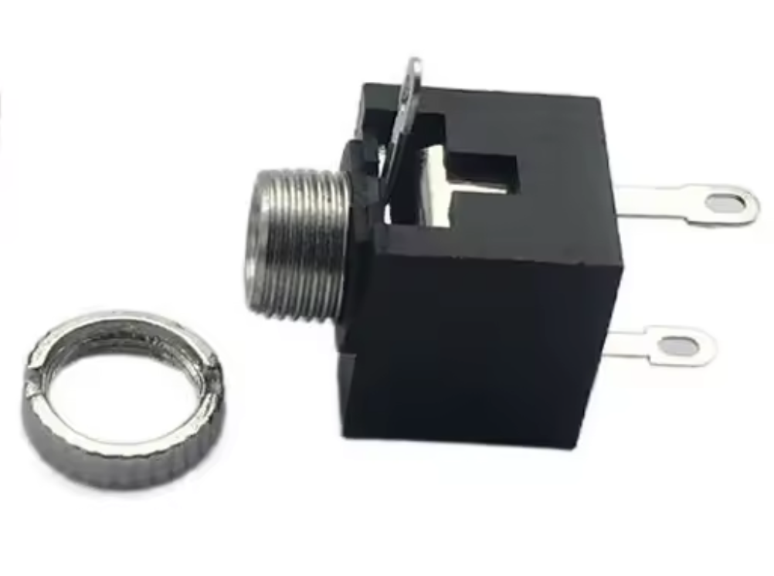 | BOM  - Slide Track Toys Dinosaur Paradise  - 3.5 mm Mono Jack with Ring  - 22 AWG Wire (Stranded)  - Electrical Tape  - 3 AA Batteries.  Refer to the Tool and Component List for purchasing details.
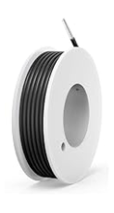 | 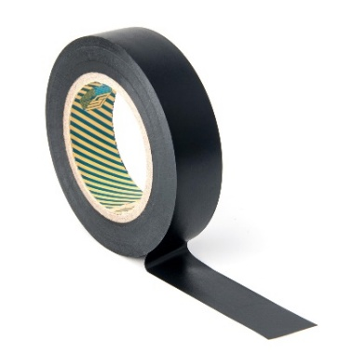 | - 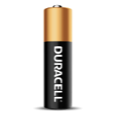

Required Tools
- Small Phillips #1 Screwdriver (3mm Diameter, Shaft > 42 mm)
- Small flat screwdriver
- Ruler
- Wire cutters
- Wire strippers
- Needle nose pliers
- Drill and 1/4” drill bit
- Soldering Iron and electrical solder (type 60/40 or 63/37 alloy, rosin core)

Required Personal Protective Equipment (PPE)
- Safety glasses

Assembly Instructions
- Carefully remove the toy from its packaging without damaging it (we will be repackaging the toy after adapting). | 
- Loosen and remove the top screw on the dinosaur side of the toy.  *Note: keep screws, and keep track of where they came from if there are multiple different sized screws | 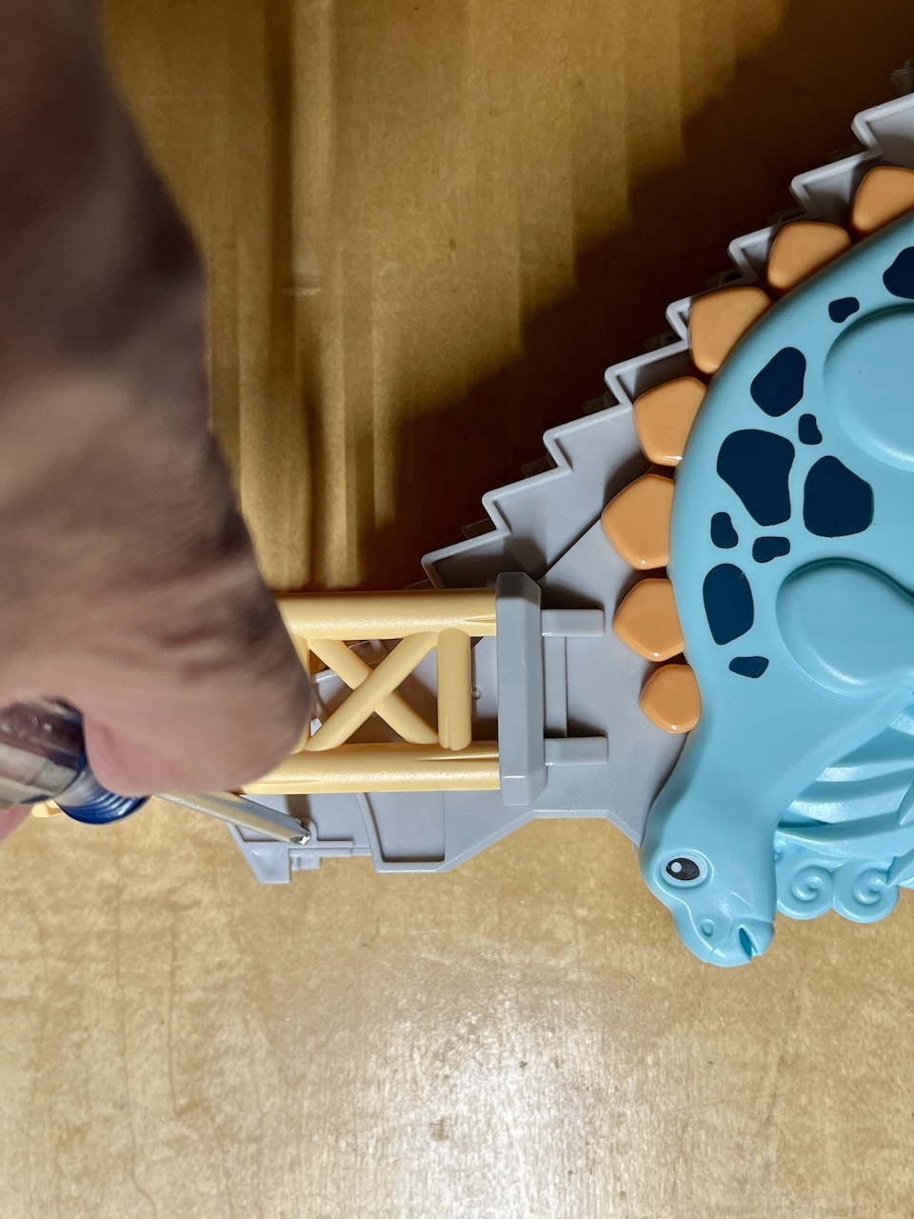
- Flip the toy around and remove the remainder of the screws on the backside of the toy.  *Note: keep screws, and keep track of where they came from if there are multiple different sized screws | 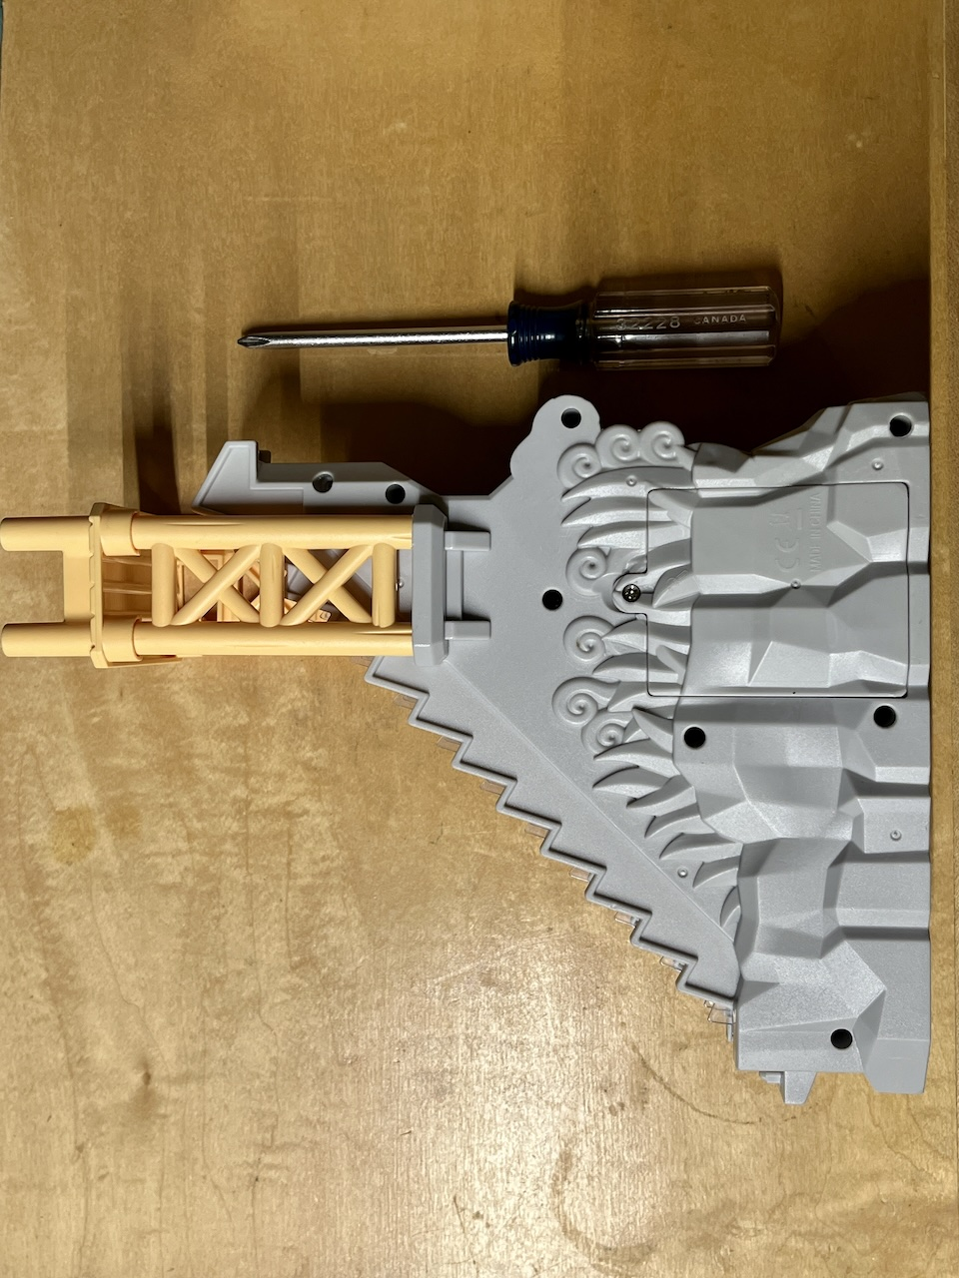
- Using the same Phillips screwdriver, remove the battery hatch screw, and place the battery hatch lid aside. | 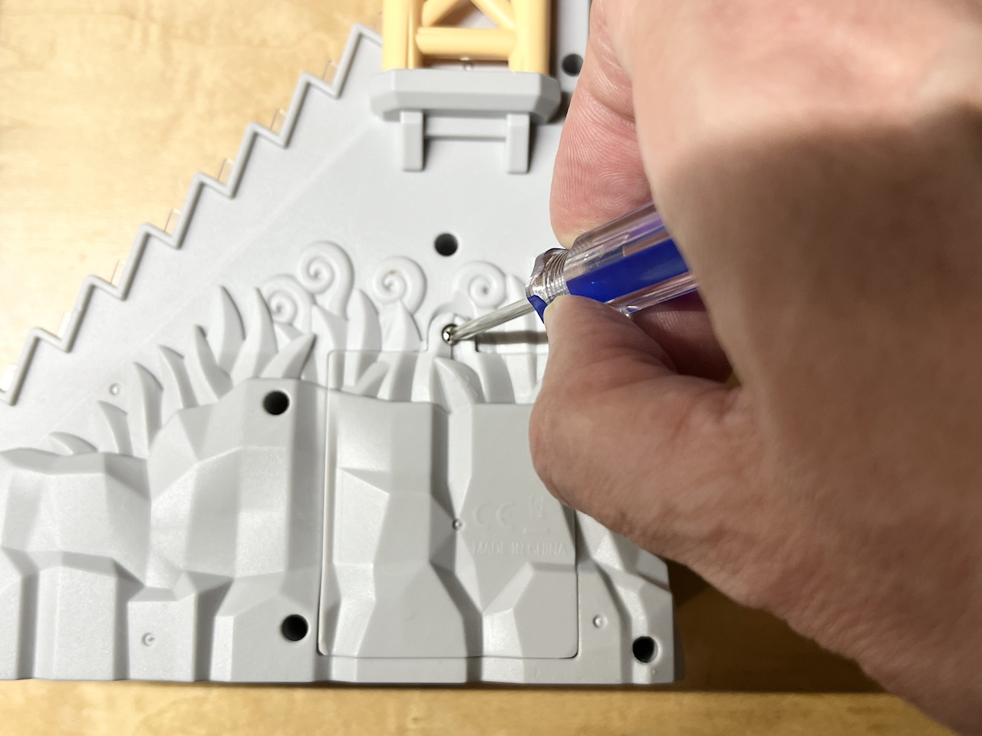
- Loosen the top tower platform by wiggling while pulling it away from the tower. This will allow for easier separation of the 2 halves of the toy.  Once the tower platform is freed, place it aside. This will be returned when the toy is reassembled. | 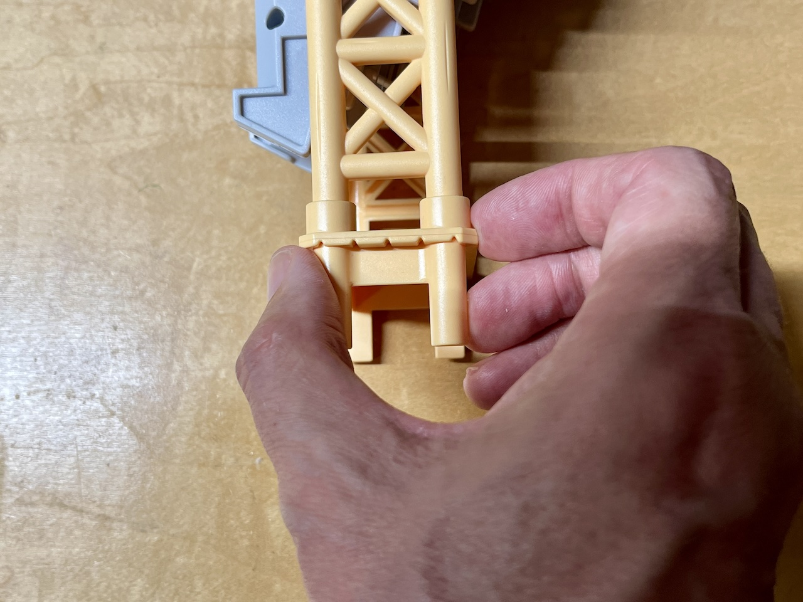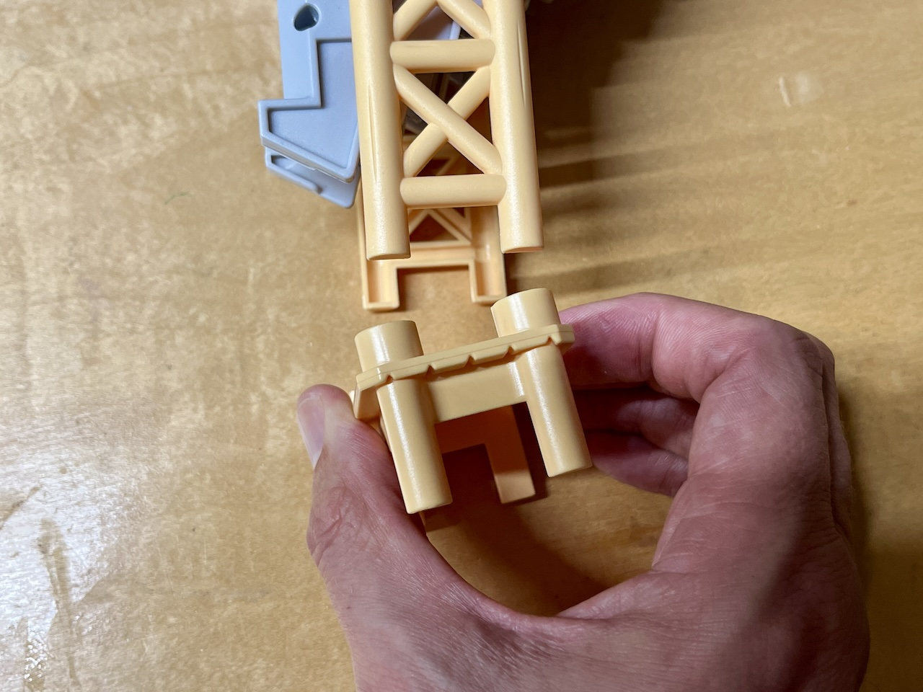
- Carefully separate the two halves of the toy. Do this by lifting the backside of the dinosaur toy (top of photo) up away from the front side (bottom of photo)  Don't force it. If you find it's getting a little bit stuck on the back end of the dinosaur, see the next step. | 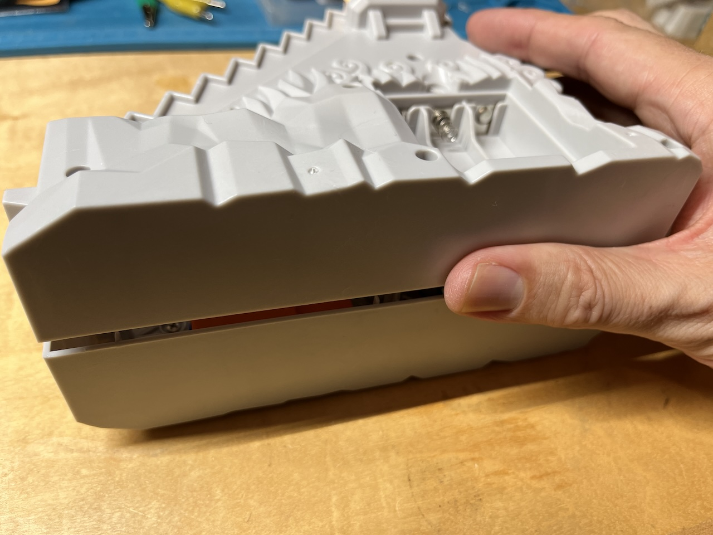
- If the backend of the dinosaur toy doesn't release easily, you may need to use a thin flat screwdriver. Gently pry the stair base posts, to release the backend of the toy. | 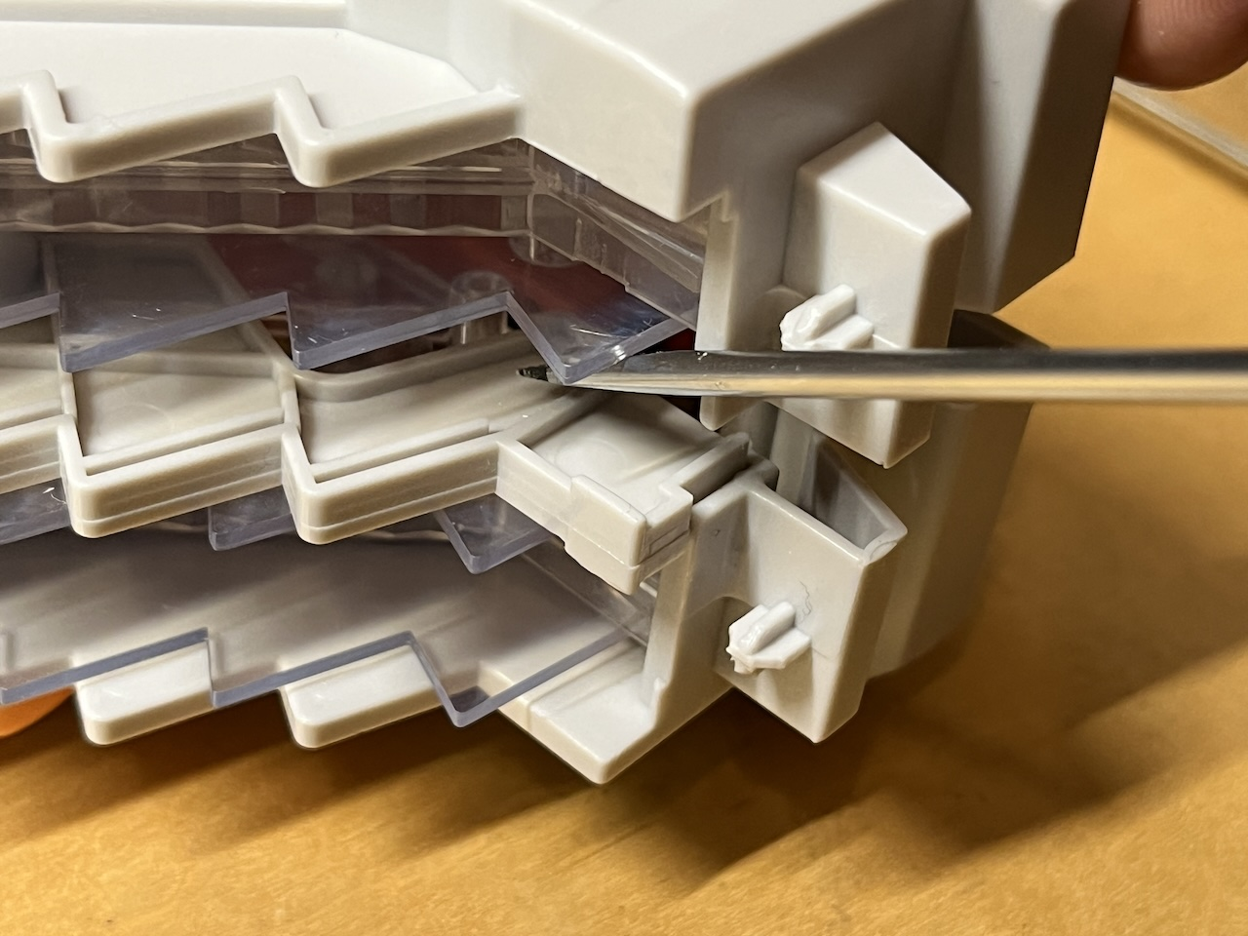
- Fold the backside of the toy gently to the right, to access the wiring inside the toy. | 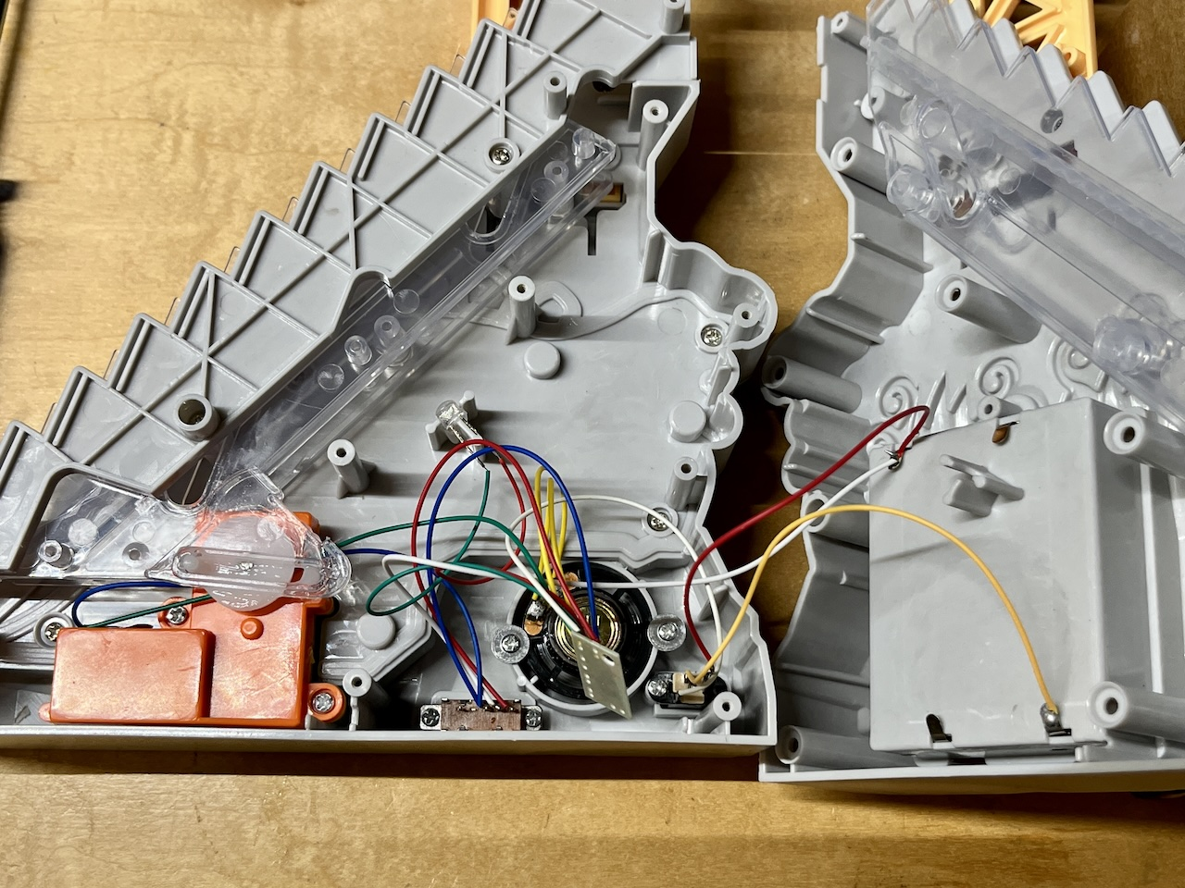
Note: At the base of the toy you'll find the power switch. The central wire (white) carries power from the positive terminal of the battery pack. if the switch is turned on (pushed left), the battery power is diverted to BOTH the stair motor (blue wire) AND the sound player (red wire). | 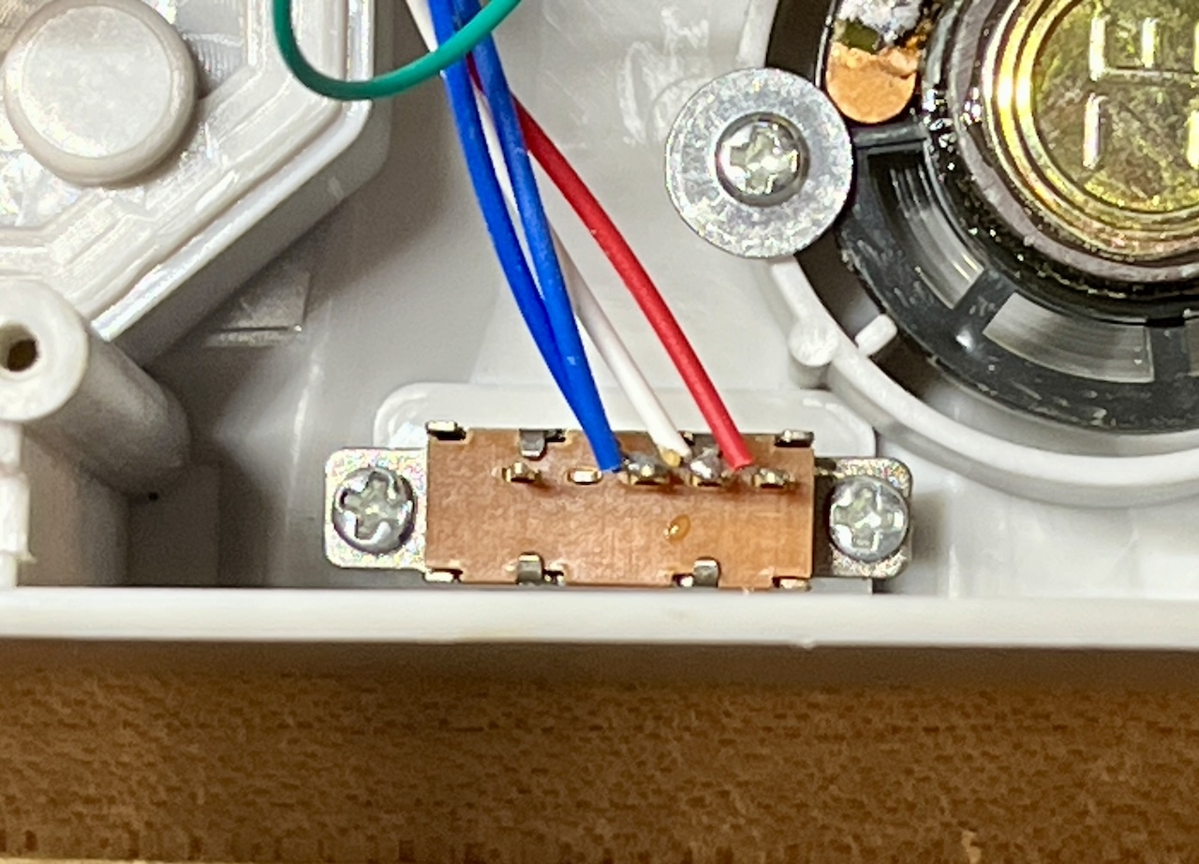
Note: Reference photo of 3 position switch settings, printed on the box of the dinosaur toy) | 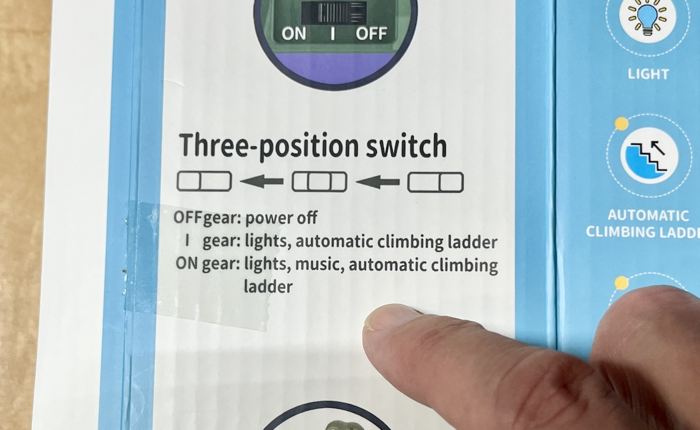
- Temporarily tape blue and green motor wires to the bottom case as shown. This will allow room for drilling the switch adaption hole, lessening the chance of wires being chewed or caught by the drill bit. | 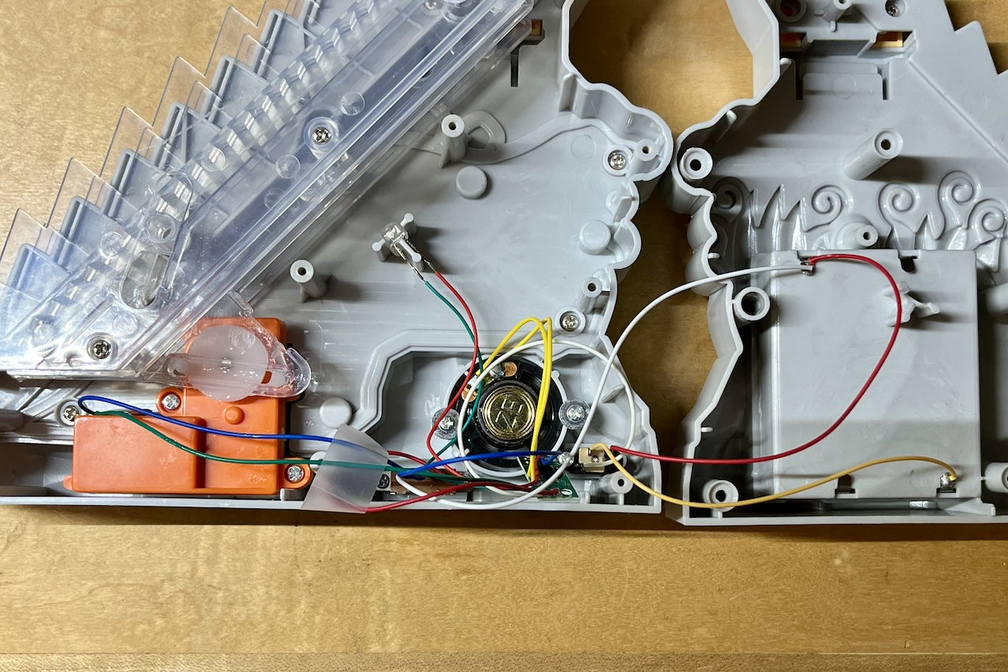
- Using a marker, mark a spot in the centre of the well area to the left of the speaker. This will help keep your drill centred. | 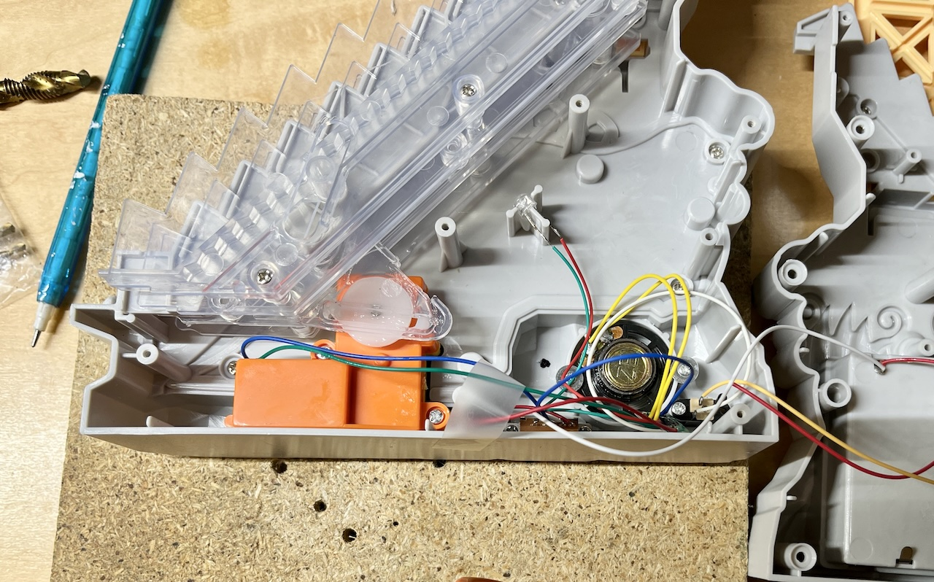
- Using a ¼” drill bit, drill a hole into the position you marked in the previous step as shown on the right. Test the toy again. | 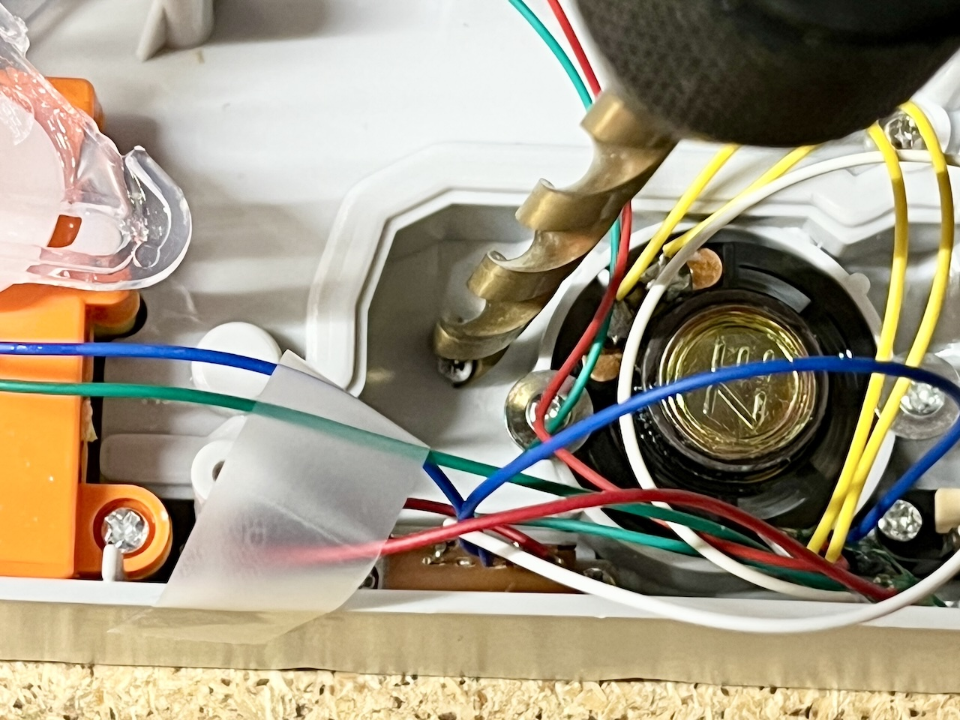
- Pull the centre wire from the switch (white wire) about a centimetre past the bottom case (as shown) and cut it using wire cutters. | 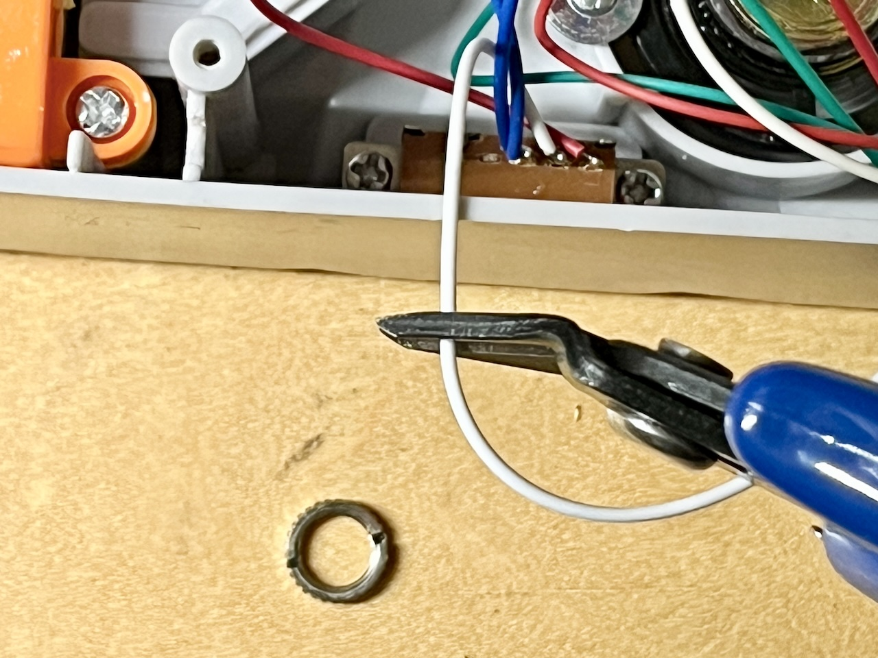
- Strip about 6 mm (1/4”) of insulation from the wire using wire strippers. | 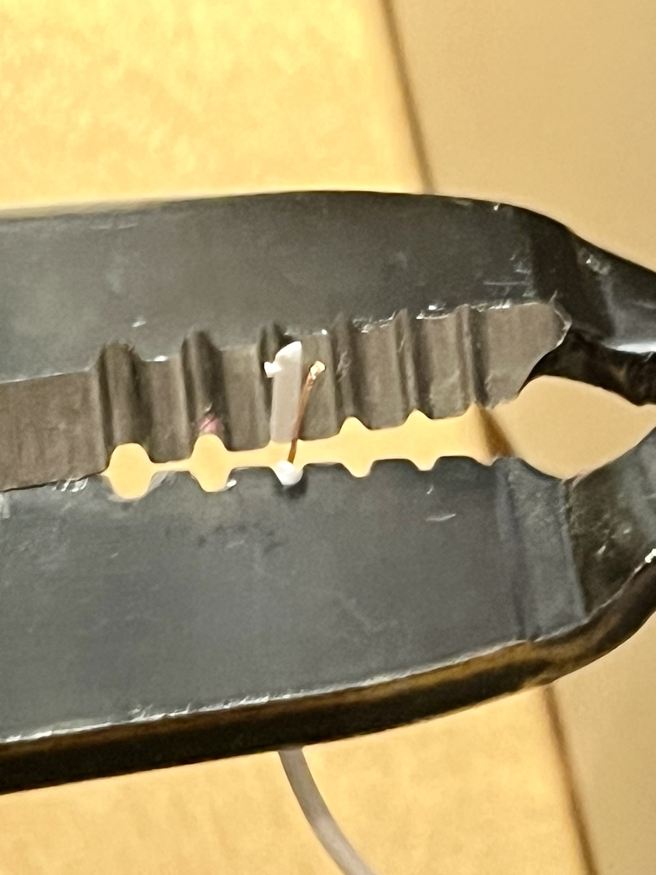

- Solder the side of the white wire that goes to the battery compartment, to one of the two tabs on the mono jack.  Note: depending on the mono jack you are using, see the photo showing which two tabs on the mono jack to solder to. | 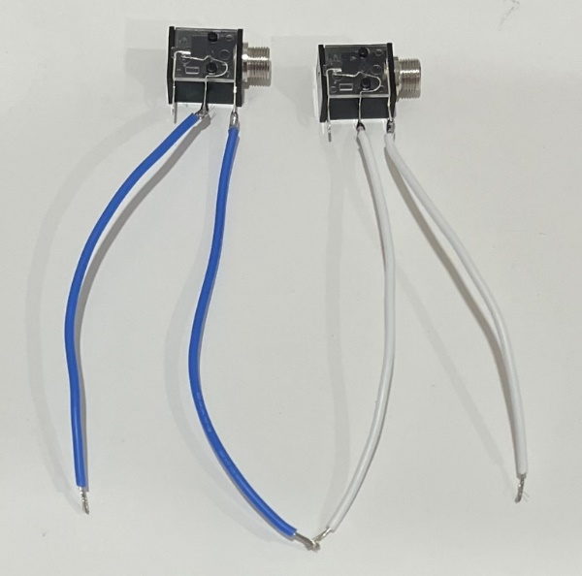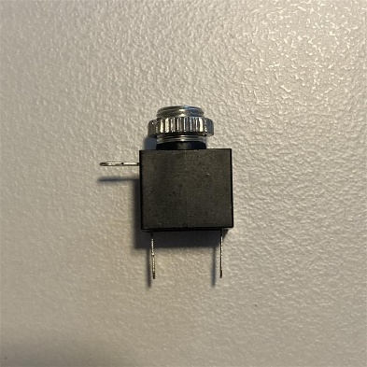  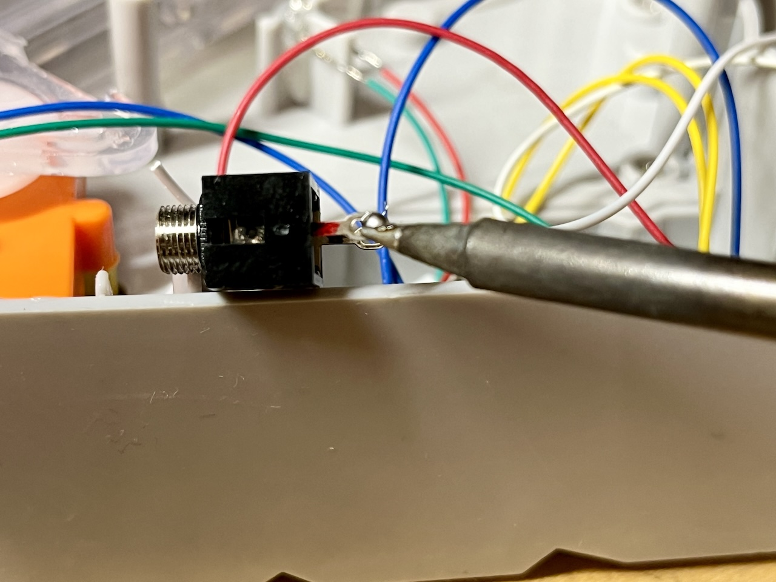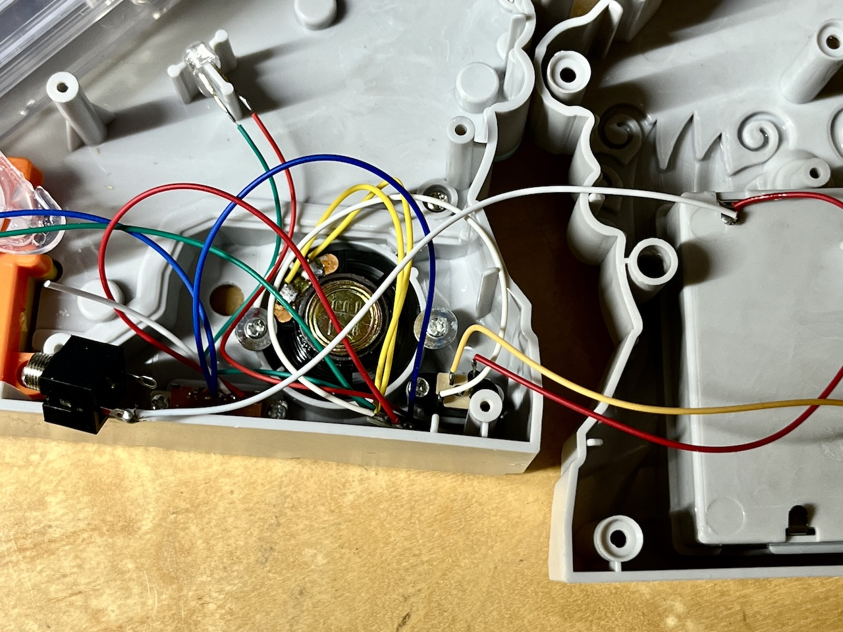
- Solder the side of the white wire that goes to the switch, to the other tab on the mono jack. | 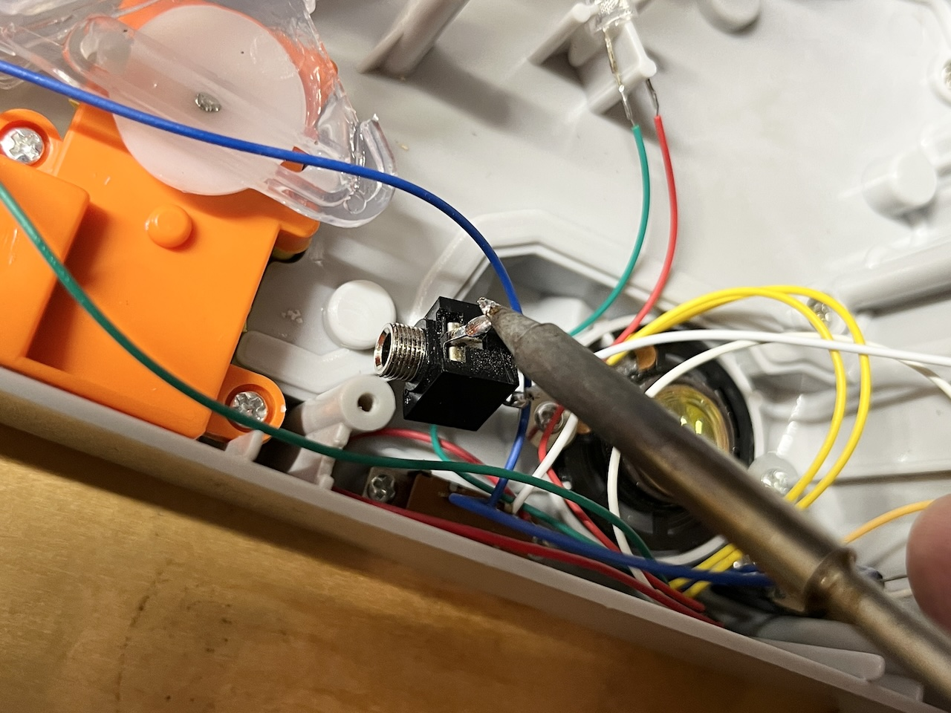
- Remove the retaining ring from the mono jack and push the mono jack through the drilled hole from the inside. | 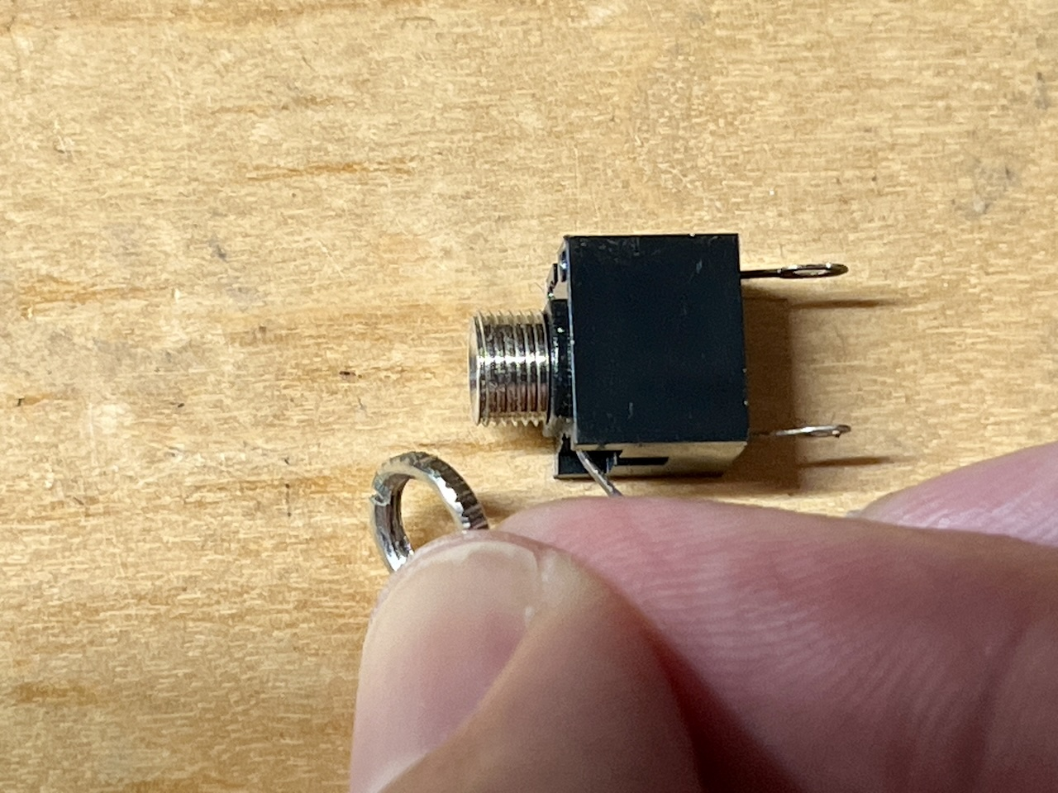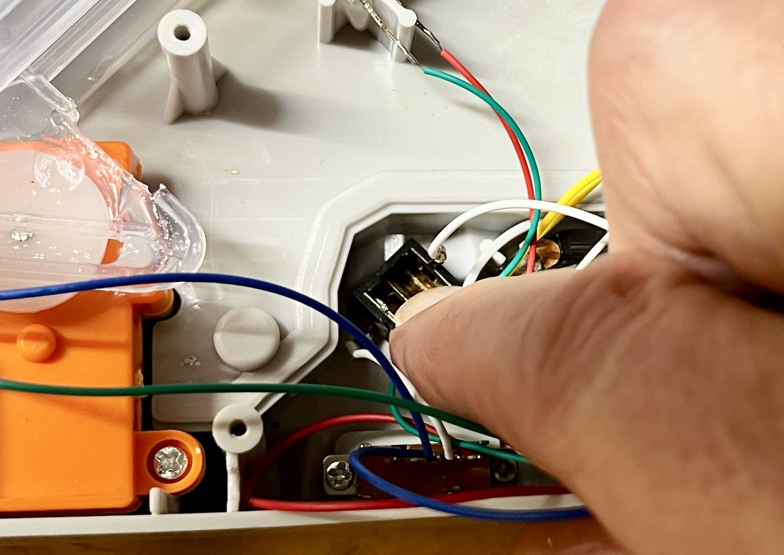

- Wrap any exposed solder joints with a small piece of electrical tape. | 
- Temporarily tape the clear plastic stairs to the case of the toy. This will prevent stairs from falling out when you screw the retaining ring onto the jack.
- Flip the front side of the dinosaur toy. Reinstall the retaining ring on the jack, from the outside of the toy, and tighten to secure as shown in the photo. Using needle nose pliers can help make this extra secure. | 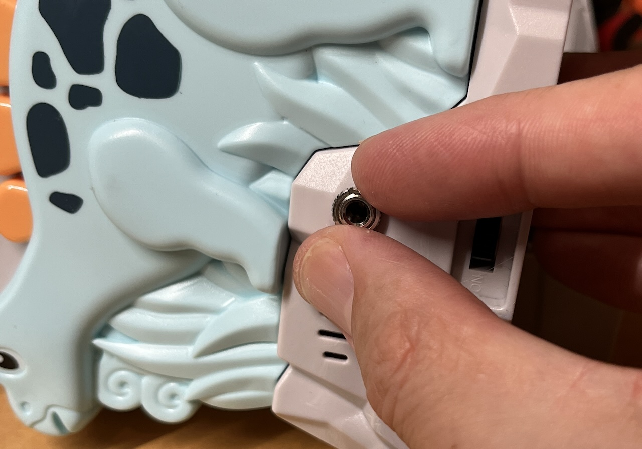
- Close the case by flipping the back side of Dino toy onto the front side as shown. | 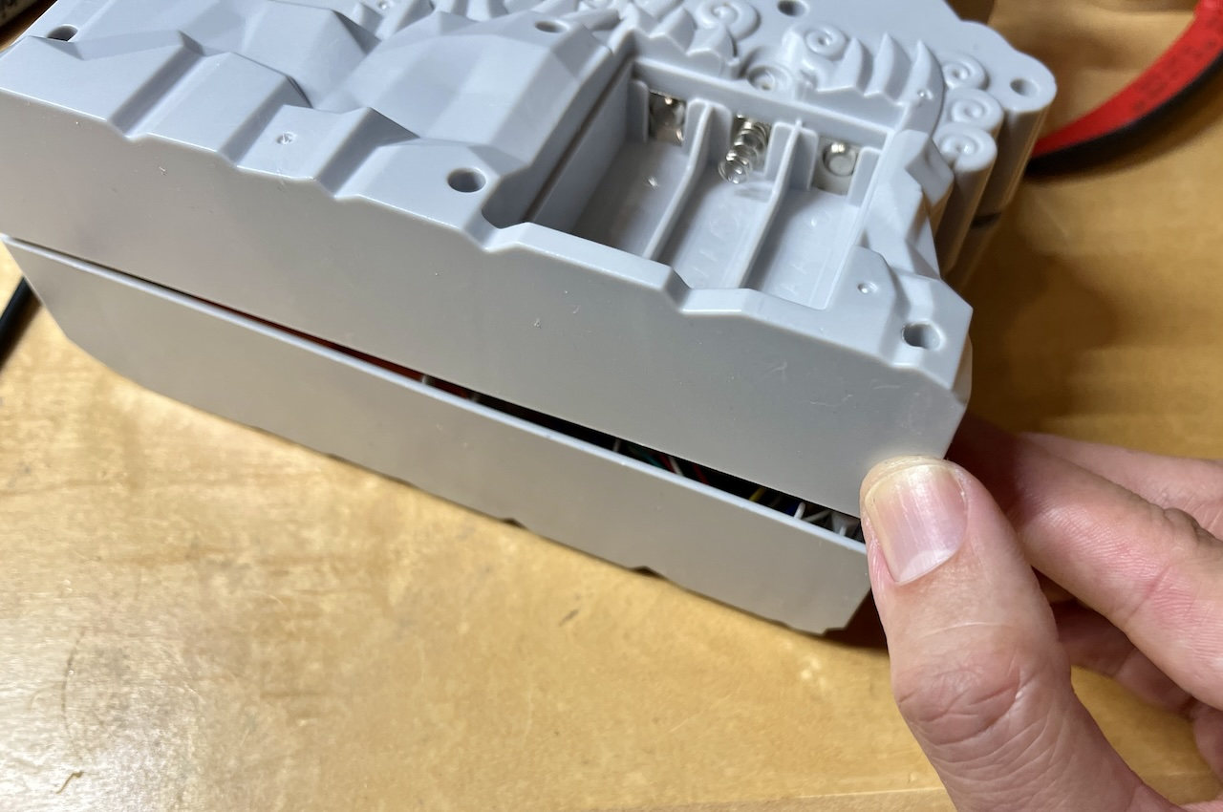
- Reassemble the toy using the screws set aside earlier. Ensure you have no missing tools.  Install 3 AA batteries into the battery compartment. Make sure the batteries are oriented correctly, as marked inside the battery case. | 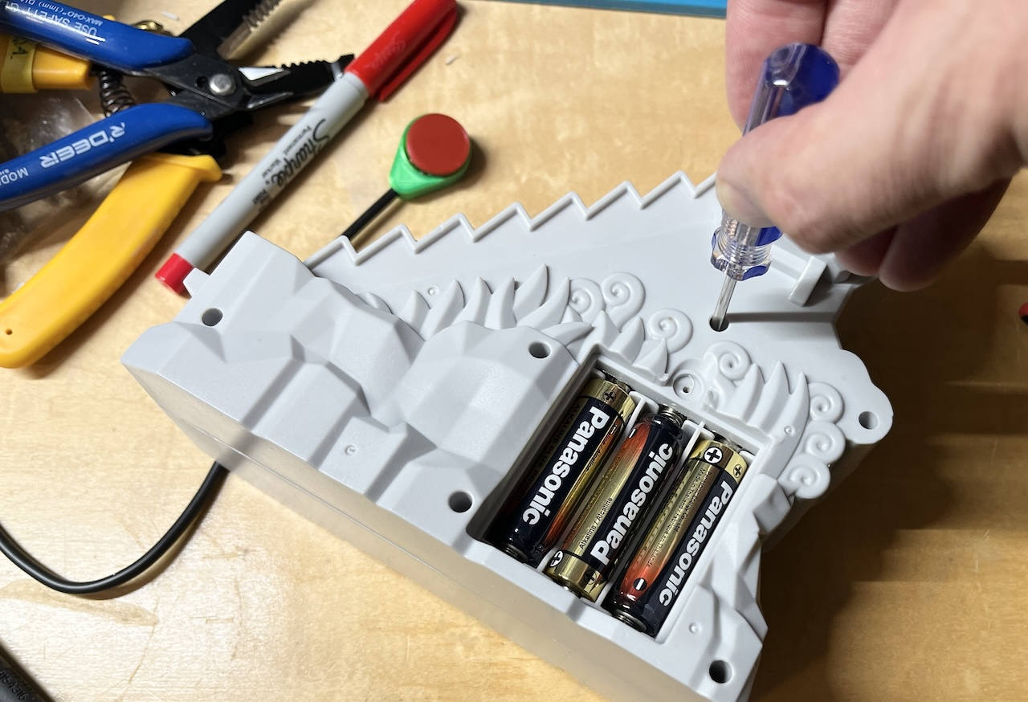
- It is now time to test the toy. Insert the three batteries into the battery compartment and an assistive switch into the mono jack. Move the original sliding switch to the “ON” (fully left) position. The toy will activate when the assistive switch is pressed.  Then, move the sliding switch to the center position and test again, there should be movement but not sound effects. | 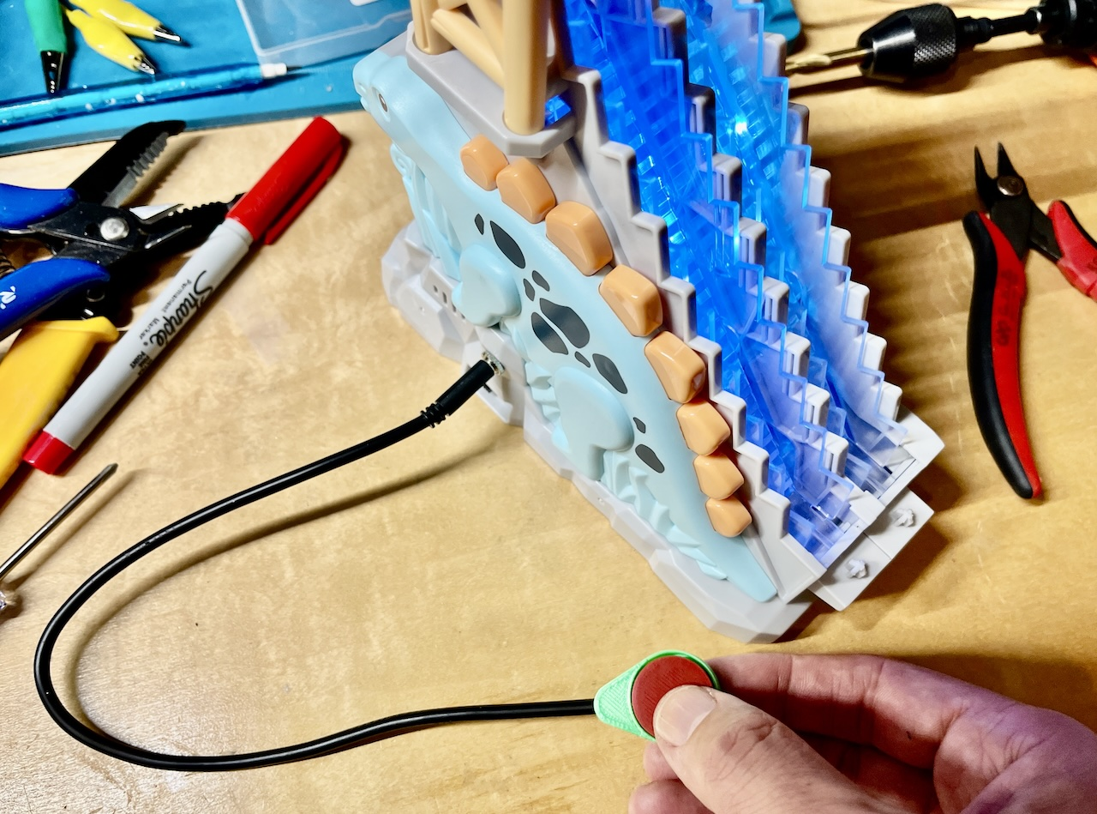
- If the toy operates as intended, return the tower platform to the top of the Dino toy. If it doesn’t, see the troubleshooting notes below.  Note that the platform has a front wall, which should be closest to the mouth side of the dinosaur and not the tail side. The final completion steps for the toy will be to follow the instructions to complete the track area | 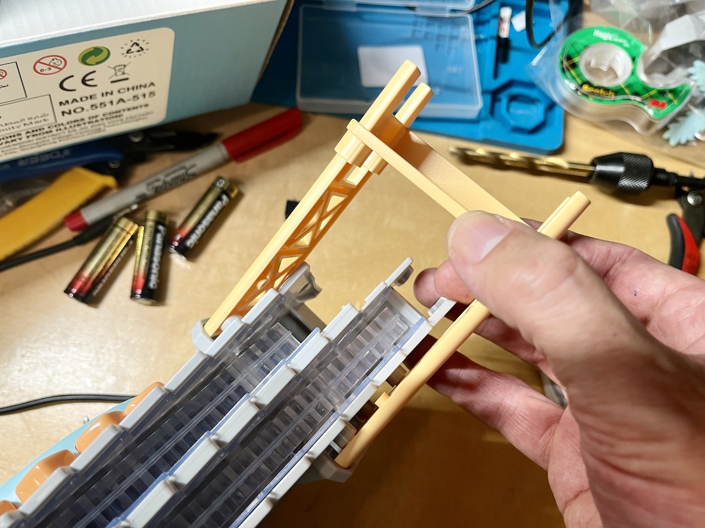
Troubleshooting Notes:
- If the toy does not turn on, please check the soldered connections.

- If the toy does not turn off when the switch is released, the connection is shorted. Check for areas of touching solder and separate using a soldering iron, or by adding electrical tape.
- Test the toy again. If it is still working properly, repackage the toy and the adapted toy is complete! | 

