Required Components
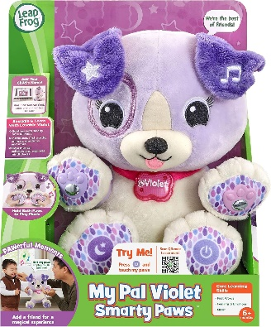  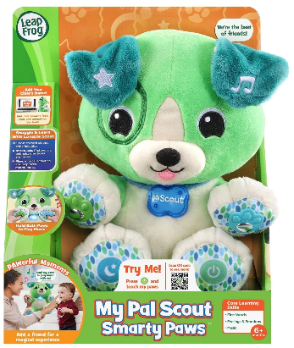 | 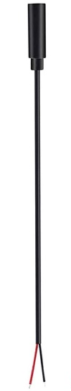 | BOM  - Leap Frog My Pal Scout or Violet Smarty Paws (Walmart Scout, Walmart Violet, Amazon Scout, Amazon Violet, Amazon Scout French)  - 3.5mm Mono Cable (x4)  - Cable Ties (x2 – 4’’ and 18’’)  - Electrical Tape  - 3D Printed Mono Cable Case  - #4 3/8’’ Screws (x2)  Refer to the Tool and Component List for purchasing details.
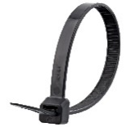  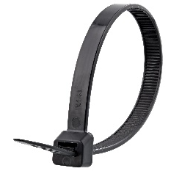 | 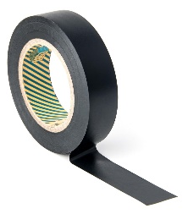
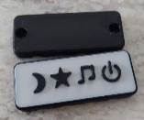 | 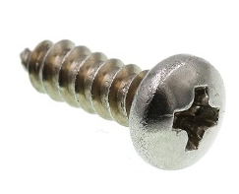

Required Tools
- Phillip screwdriver
- Wire strippers
- Flush cutters
- Soldering iron and solder
- Scissors

Required Personal Protective Equipment (PPE)
- Safety glasses

Assembly Instructions
- Open the toy carefully by cutting the toy out of the packaging. | 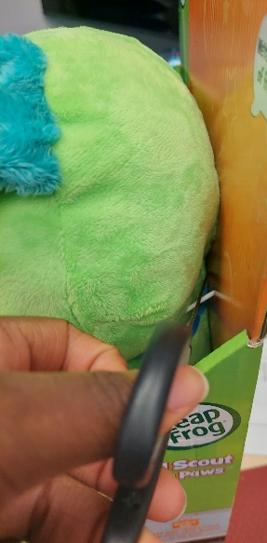
- Once the toy has been removed open the Velcro on the back of the toy and pull out the white internal casing. | 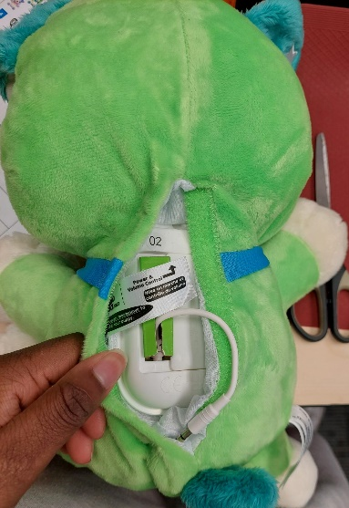  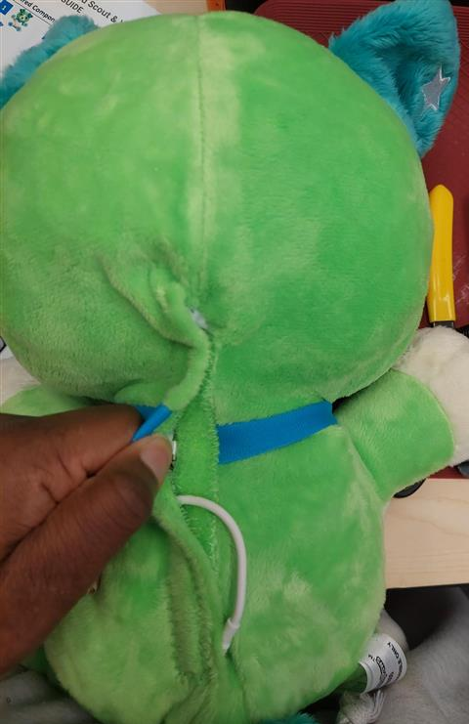
- Near the bottom of the case by the printed “Item No.”, carefully tear the fabric by 1cm to expose the cable tie underneath. Cut off the cable tie knot to release the casing from the fabric. Pull the cable tie out as this is now garbage. | 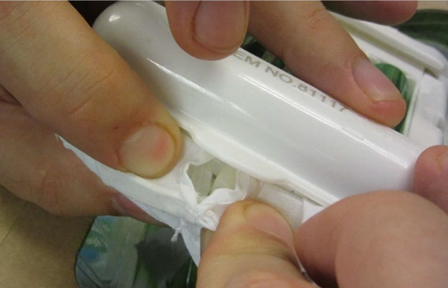
- Each switch on the toy will have two wires leading to it, and the switches are in the ears and feet of the toy. To determine which wire goes to which switch, you can trace the wires from the plastic case to the switch to which they are connected. The ears and feet have images which represent what each switch does when pressed.  Note: wire colours will be different on all toys. Trace the wires to each paw to keep track of which wires are responsible for each feature  Note: There are extra wires that will not be used in this toy adaptation | 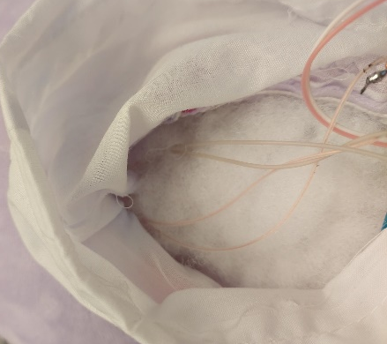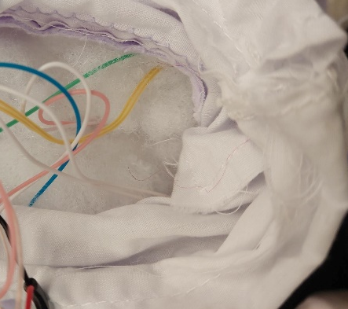
- Working with one wire at a time, cut through the middle of the wire and strip 3 cm off each end.  Note: It is important to follow steps 6-10 one wire at a time to avoid mixing up the wires and switches. | 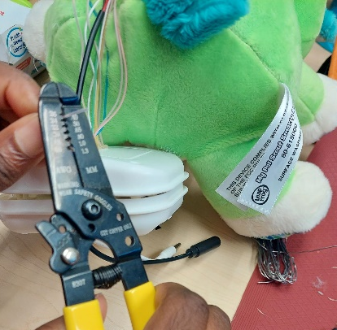
- Take your two newly stripped wires and one of the wires from the female cable and twist the three wire ends together.  Note: Some of the female cables come pre-stripped others may not. Strip the insulation from the ends of the female cable wires if necessary. | 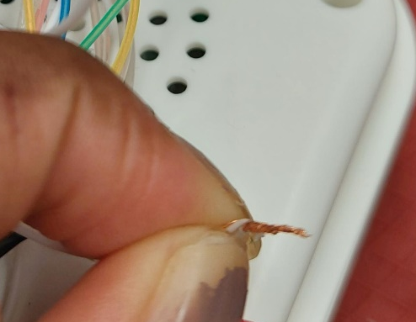
- Solder the three wires together. | 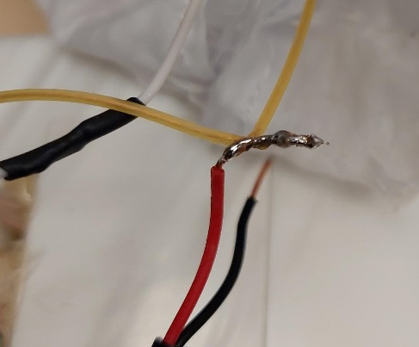
- Repeat steps 6-8 to the other wire going to the same switch, and the other female jack wire. | 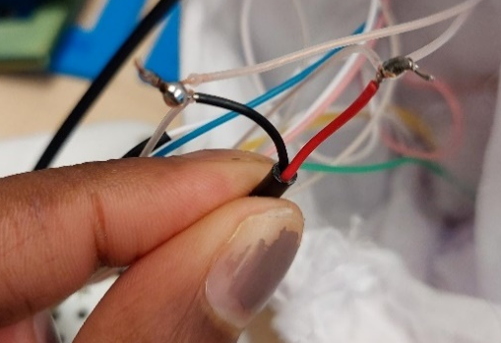
- Stop and test with an adaptive switch.
Label the female mono jack with tape and a marker to easily keep track of each function

- Repeat steps 6 – 10 for the three other remaining jacks.
- Wrap the exposed, soldered cables in electrical tape. | 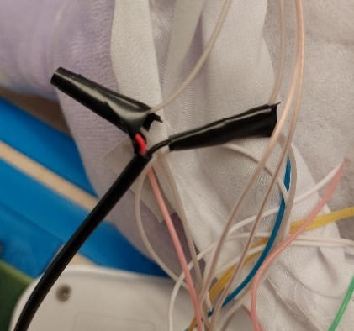
- Once all cables have been tested and wrapped in electrical tape, we are ready to re-assemble. | 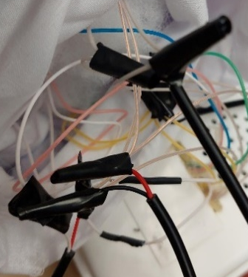
- Place all the wires back inside the belly of the toy. Pull the female audio leads through to the outside and using the new cable tie, “reseal” the casing back into the fabric of the plushy. There will be a hole to feed the cable tie through the spot of the one we cut away to get into the toy.  Once the cable tie has been tightened. Cut off the excess end of the cable tie and tuck the head of the cable tie into the fabric. | 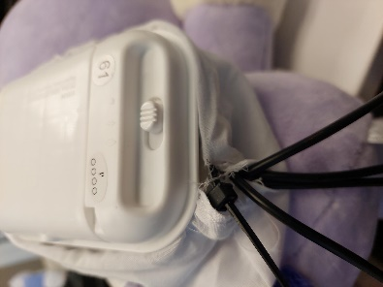
- Secure the audio cables in the cable clamp, ensuring the jacks go in their corresponding spots based on the images that match the images on the toy’s paws. This can be done using a switch to test each jack and pushing on the buttons in the paws to compare. | 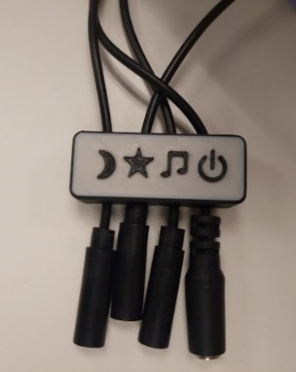
- Secure the four cables with the 4’’ cable tie directly above the 3D printed cable clamp | 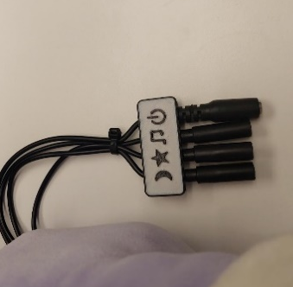
- Test the toy again, and ensure each cable matches the symbol on the 3D printed cable clamp
- Repackage the toy in the original box | 