Required Components
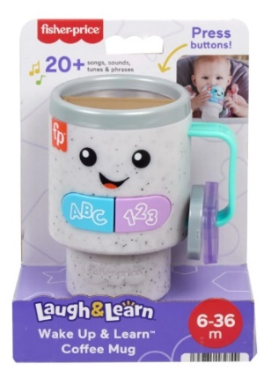 | 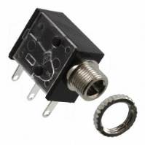 | 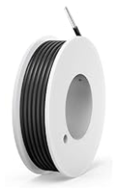 | BOM  - Fisher-Price Wake Up and Learn Coffee Mug  - (2x) 3.5 mm Mono Jack and Ring  - 22 AWG Wire  LR44 Batteries (x3) included  Refer to the Tool and Component List for purchasing details.

Required Tools
- Scissors
- Phillips or Flat Head Screwdriver
- Ruler
- Wire strippers
- Soldering iron and solder
- Drill and 1/4” drill bit
- Packaging Tape

Required Personal Protective Equipment (PPE)
- Safety glasses

Assembly Instructions
- Use scissors to cut the tape on the bottom and sides to open the cardboard packaging. We will be repackaging the toy at the end so be careful not to rip the cardboard. | 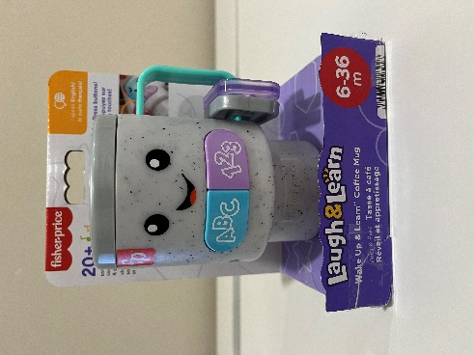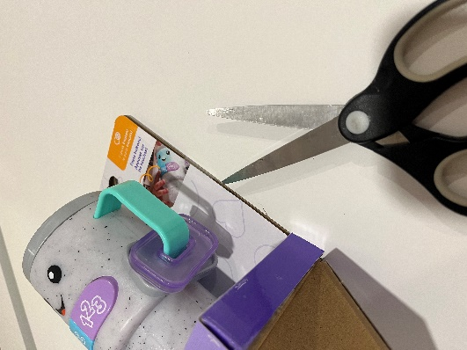
- Twist the two white plastic pieces counterclockwise to release the toy from the cardboard. Set aside all packaging. | 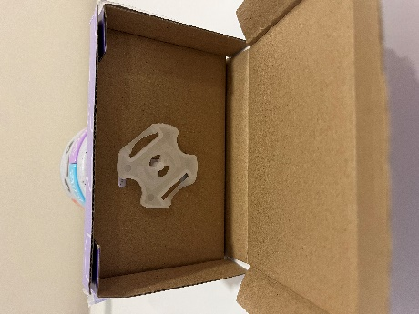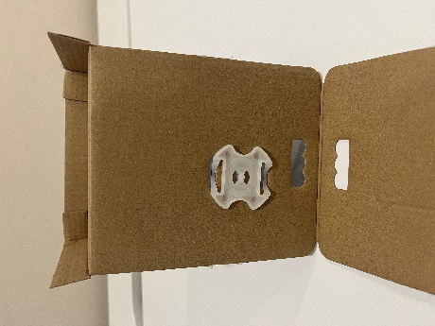
- Use a screwdriver to open the battery cover, remove and set aside the 3 circular batteries. | 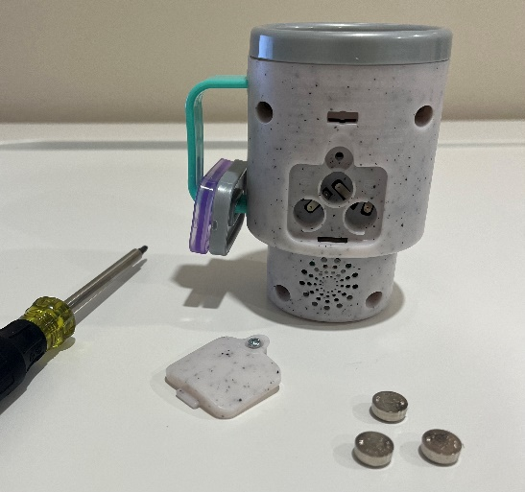

- Remove and set aside the 4 screws from the back of the coffee cup. | 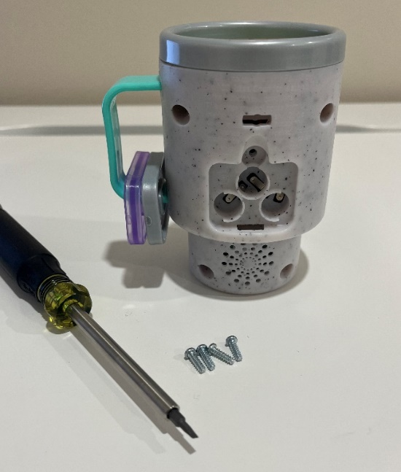
- Separate the two halves of the cup, being careful not to pull on the wires. | 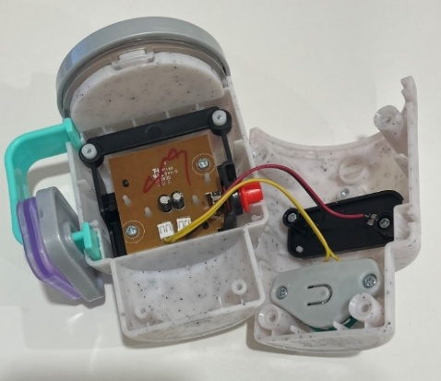
- Cut 4 pieces of wire, each 10 cm long. | 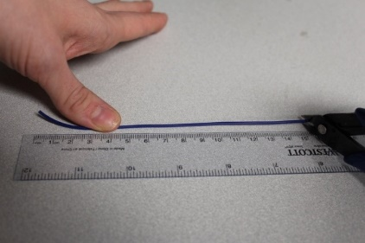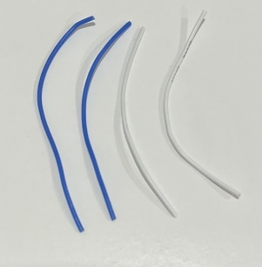
- Use wire strippers to strip approximately 0.5 cm off each end of the wires. | 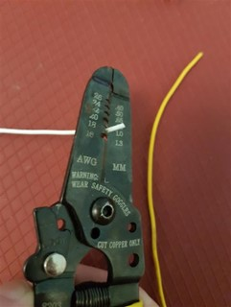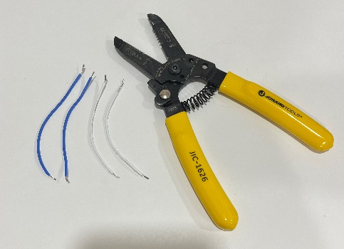
- Solder two wires onto the front two tabs of the mono jacks. | 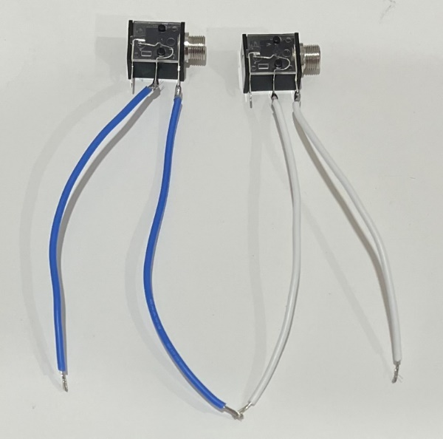
- Tin the other ends of the wires by adding a small amount of solder to each wire. | 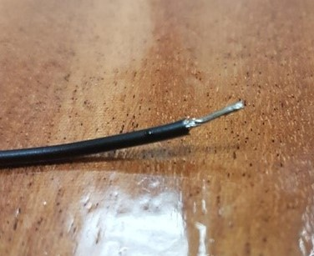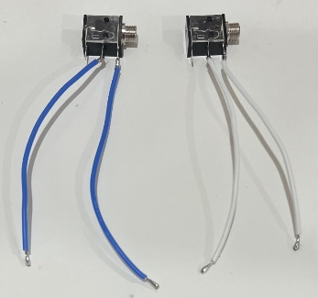
- Use a screwdriver to remove the 2 screws that connect the printed circuit board (PCB) to the cup. Set these two screws aside. | 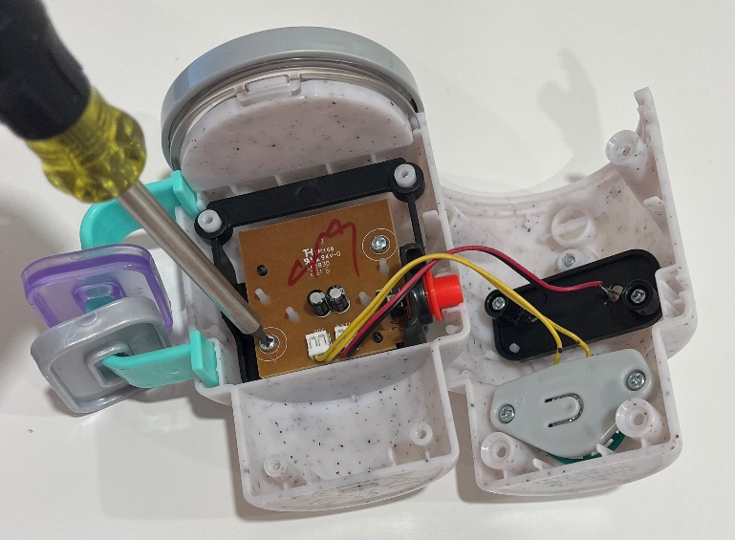

- Position the PCB on the back half of the toy and set the front half aside.  Solder one wire from a mono jack onto the connection on the board labelled TP3, solder the other wire to the connection labelled GND. Position and solder the wires so the silicone button is between them. | 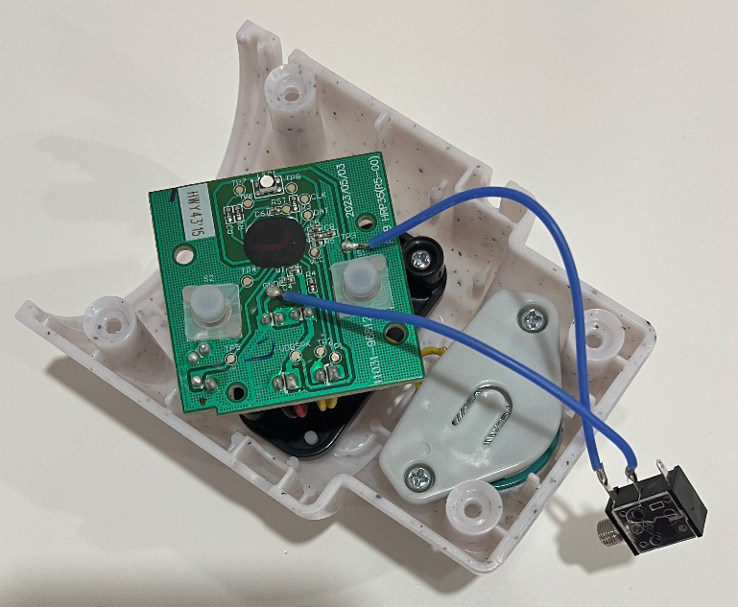  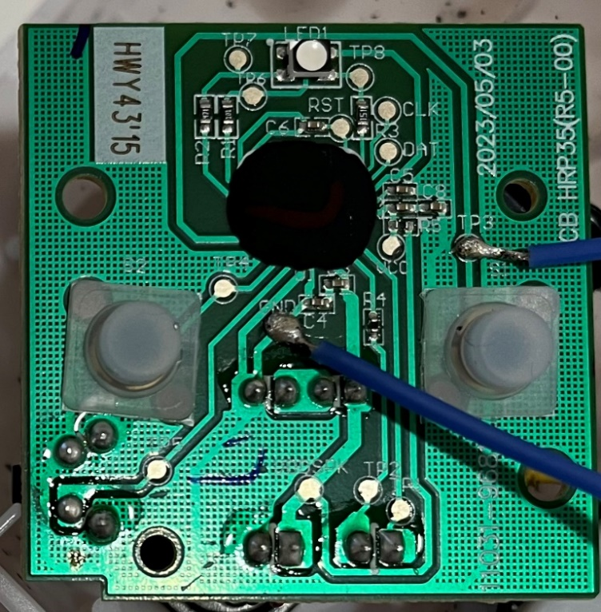

- Solder the second mono jack to the PCB.  Depending on which PCB matches the one in your toy, follow the corresponding instructions.  Option 1 (board labelled 2023/05/03):  Solder one wire to the connection labelled TP4 and the other wire to the solder point that follows the line running through GND (see image to the right). Position and solder the wires so the silicone button is between them.  Option 2 (board labelled 2025/09/01):  Solder one wire to the connection labelled CLK1 and the other wire to the solder point just below GND1 and above F1 (see image to the right). Position and solder the wires so the silicone button is between them. | Option 1:  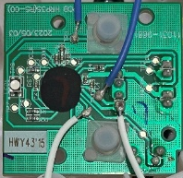  Option 2:  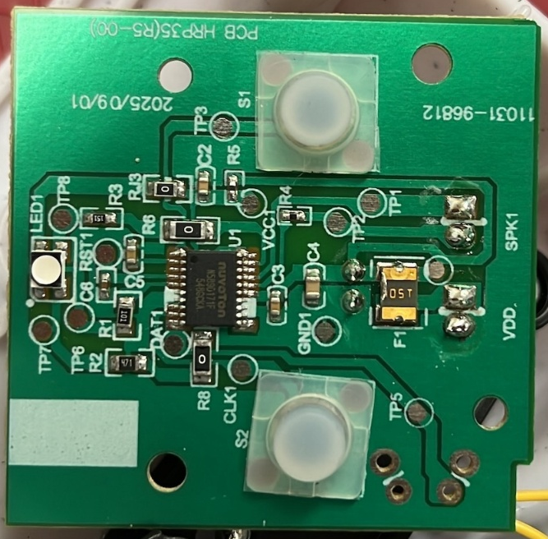
- It is now time to test the toy. Insert batteries into the battery compartment and an assistive switch into each mono jack. One input controls the ABC songs, and the other controls the 123 songs. Test to make sure that the toy can be controlled using both the original buttons on the front and the assistive switches.  Note:  - If the toy does not turn on, please check the soldered connections.  - If the toy continuously repeats the song when the switch is released, the connection is shorted. Check for areas of touching solder and separate using a soldering iron. | 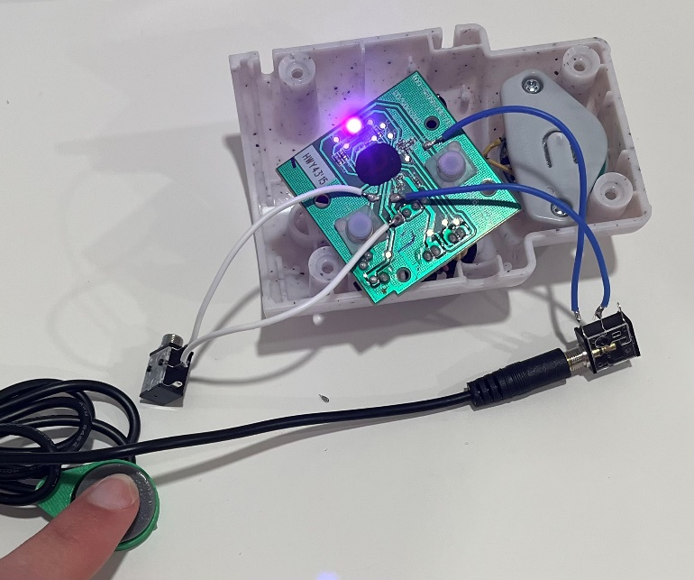
- Using a ¼” drill bit, drill two holes into the back of the cup, on the inside of the top two screw holes. Remove any loose plastic. | 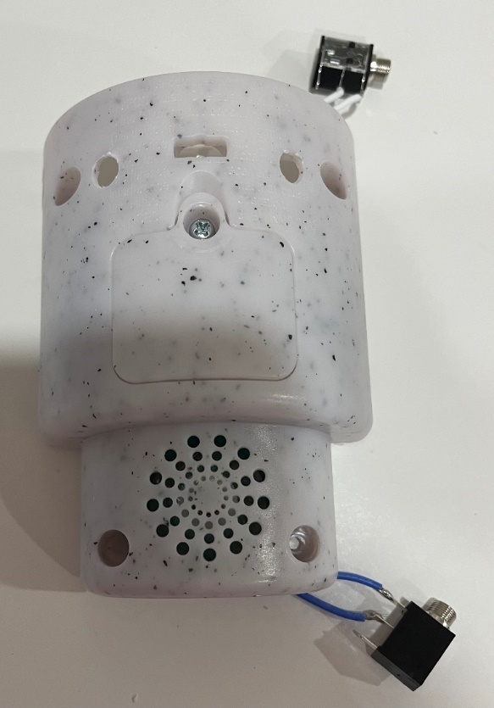
- Insert the PCB back into the front half of the cup using the two screws set aside earlier. Make sure the new inputs are on the left and right sides of the toy. | 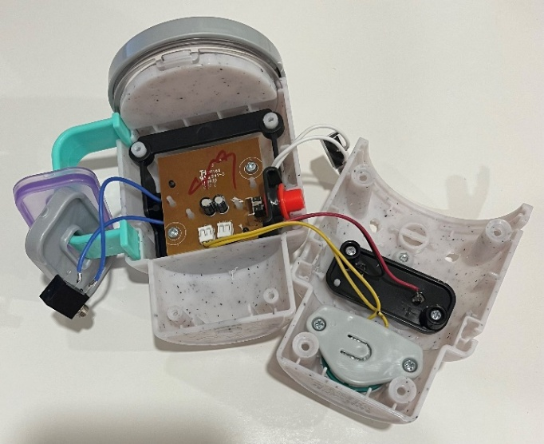
- Remove the retaining rings from the mono jacks and push the mono jacks through the holes from the inside. Reinstall the retaining rings on the outside of the toy and tighten to secure. Re-assemble the cup using the 4 screws set aside earlier. | 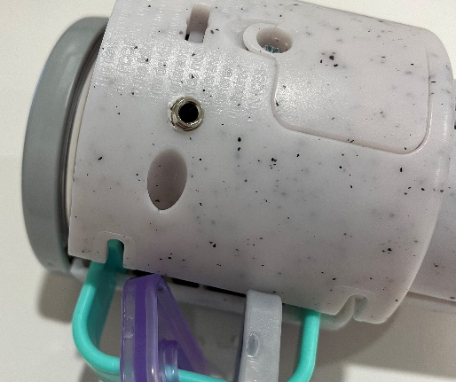  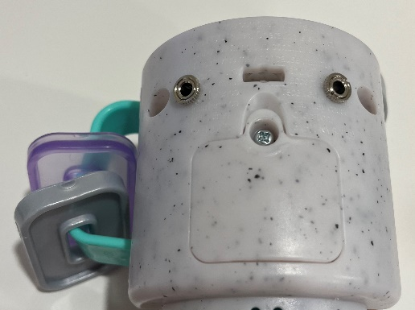
- Test the toy again. If it is still working properly, repackage the toy with packaging tape and the adapted toy is complete!  Note: Press and hold the red button on the side for 4 seconds to switch the toys language between English and French. Check to make sure this function still works, if not, re-open the toy and check the positioning of the red button. | 

