# Required Components

|  |  |
| --- | --- |
|  | **BOM**   1. ½-in PVC pipex 8ft 2. ¼-20 Pipe Connector x20 3. ¼-20 1 inch hurricane bolts x 20 4. ¼-20 20mm furniture screw inserts x1 5. ¼-20 1-1/2 Thumb screw x1 6. Foam tubing x 50cm 7. Tubing End Cap Plug x4 8. 5 point harness seat belt x1 9. Fastening tape x1 metre 10. Plant support twine x1 metre 11. HDPE Sheet x1 |

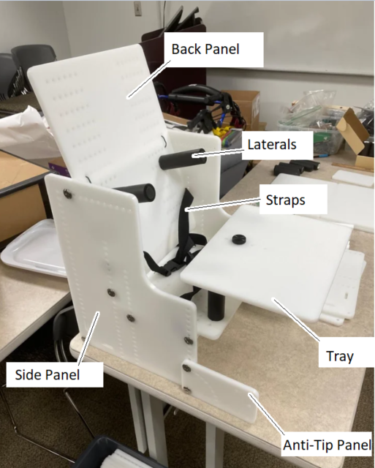

# Required Tools

* CNC Router
* Hammer
* Tape measure
* Screwdriver
* Scissors
* Saw
* Sandpaper

# Required Personal Protective Equipment (PPE)

* Eye Protection

# Assembly Instructions

## Step 1

Cut the PVC pipe for the supports. You will need to cut

* 5x 11.5 in piece for the frame
* 6x 3.875 in piece for laterals and head supports
* 1x 4.125 in piece for abdicator.

After cutting, sand off any burrs.

## Step 2

Cut the main body out of the sheet plastic, or plywood if the plastic is hard to source. Use a CNC router and the DXF files provided. The grid of holes in the design are simply there to allow the laterals to be adjustable. A "quick-and-dirty" version could forget all the holes and add them in as the child grows.

## Step 3

Drill two 0.375 inch holes in two of the 11.5 inch pipes, 2 inches from each end. These will become the hinge pipes for the seat base and back. Keeping the holes straight here will save grief later.

## [Step 4](https://www.youtube.com/watch?v=EUsNI3QqX5g)

[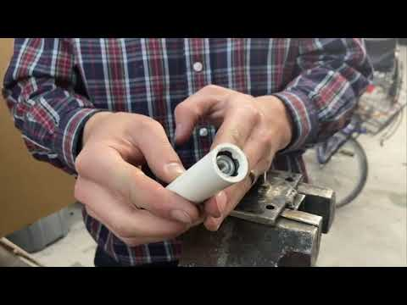](https://www.youtube.com/embed/EUsNI3QqX5g?feature=oembed)

Pound in the barbed inserts into one end of the 3.875 inch pipes.

Pound in the caps into other end of the 3.875 inch pipes.

Place the foam over the PVC pipe and trim it to cover the pipe entirely, none of the pipe should be showing.

## Step 5

Pound in the barbed inserts into both ends of the 4.125 inch pipe.

Cut foam to length as in step 4. Note in the attached picture, the foam is too short, there should be none of the pipe still showing.

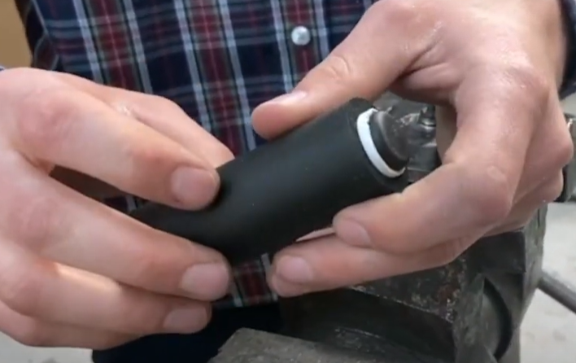

## Step 6

Pound in the barbed inserts into both ends of all the 11.5 inch pipes.

Twist in the thread inserts into the two 11.5 inch hinge pipes.

## [Step 7](https://www.youtube.com/watch?v=JkeG7XiT2Fk)

[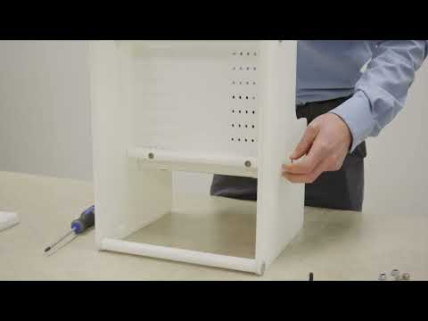](https://www.youtube.com/embed/JkeG7XiT2Fk?feature=oembed)

Following the instructions in the video, Connect the hinge pipe to the seat back and bottom using the bolts.

Connect the two sides together using the other 11.5 inch pipes and bolts. Don't snug tight yet.

## Step 8

Add the seat base and back using more bolts.

## Step 9

Add the laterals.

Loop the seat belt around the seat base and back. Once you have the belt in the correct spot/height, feel free to tighten all the bolts and it will stop the belt from moving around.

If desired, add the anti tipper/foot rest mount onto the front of the chair. (rectangle plastic added on the front)

## Step 10

Use the knob to secure the tray into the abductor.

Add twist ties onto the top of the seat back if needed to stop from rocking forward.

Add straps through the back and bottom of the chair using the slots to secure it to a chair if desired.

## Step 11

The overall height from floor to seat bottom can be adjusted by moving the seat bottom and seat back up and down.

The seat depth can be adjusted by repositioning where the hinge pipe bolts onto the seat base.

The seat back angle can be adjusted by moving the support pipe near the top of the seat back forward or back.

The seat base angle can be adjusted by moving the pipe near the front up or down.

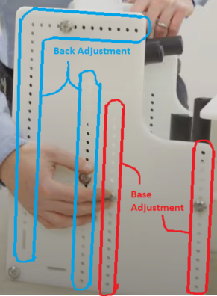

Any of the laterals can be repositioned by unscrewing and bolting in a new hole.

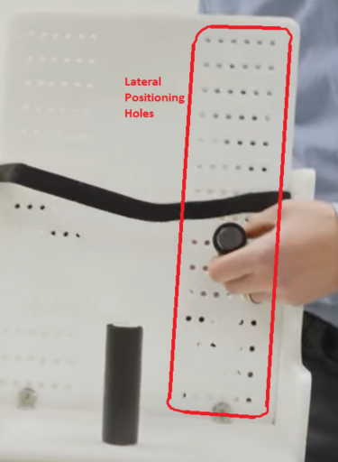

The anti-tipper/foot mount has an arc of holes in it. If the child is put into a reclined position and their feet need something to sit on, you can raise and rotate the anti-tipper/foot mount to the appropriate position. From there, you will need to add on your own support, whether you use more sheet plastic or more pieces of PVC pipe to go between the foot mounts.

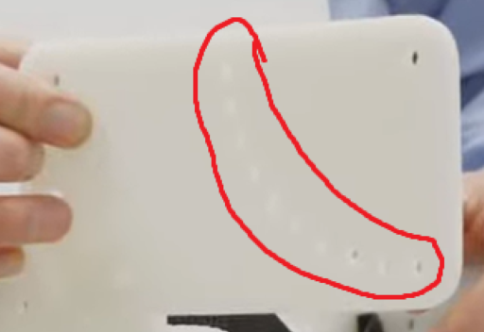

If the child needs a 5 point harness instead of a chest belt and lap belt, we have one listed on the parts list that was inexpensive. Wrap the straps around the seat back and secure the straps to whatever is appropriate (lateral bolt, pvc pipe, etc).