## Introduction

ATP's, PT's, and OT's working with children with physical disabilities often need an appropriate seating system to provide support to enable the kiddo to engage with their environment and participate in strengthening exercises. In the past we measured each child and built it, usually out of Tri-Wall, to their size to ensure a good fit. The benefits of this new design is the chair is more durable/easier to clean than Tri-Wall, and is adjustable. It resembles Swiss cheese to allow placement of laterals virtually anywhere. It can work as a chair or floor sitter. It can incline forward 5 degrees, or lay all the way back flat. At the time we are writing this, the cost came in around $100/chair for 7 chairs that we made. This isn't going to work for every kiddo, but we leave it up to you to adapt it further for your unique situation.

## Features

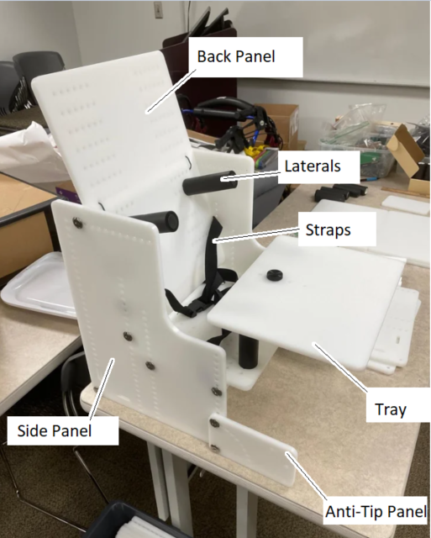

## Usage

The overall height from floor to seat bottom can be adjusted by moving the seat bottom and seat back up and down.

The seat depth can be adjusted by repositioning where the hinge pipe bolts onto the seat base.

The seat back angle can be adjusted by moving the support pipe near the top of the seat back forward or back.

The seat base angle can be adjusted by moving the pipe near the front up or down.

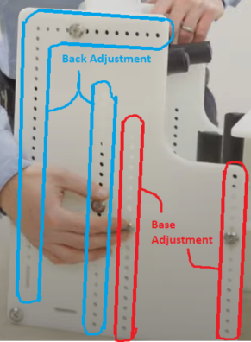

Any of the laterals can be repositioned by unscrewing and bolting in a new hole.

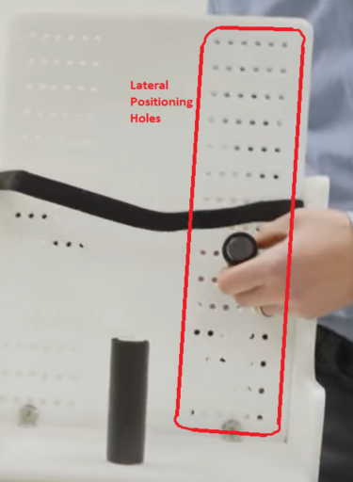

The anti-tipper/foot mount has an arc of holes in it. If the child is put into a reclined position and their feet need something to sit on, you can raise and rotate the anti-tipper/foot mount to the appropriate position. From there, you will need to add on your own support, whether you use more sheet plastic or more pieces of PVC pipe to go between the foot mounts.

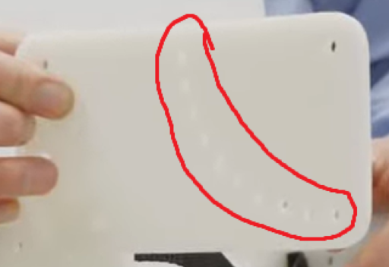

If the child needs a 5 point harness instead of a chest belt and lap belt, we have one listed on the parts list that was inexpensive. Wrap the straps around the seat back and secure the straps to whatever is appropriate (lateral bolt, PVC pipe, etc.)

## Compatibility

This device is designed for children with physical disabilities, and is sized as such.

## Specifications

Body of the chair

* 16in tall
* 11.5in wide
* 11.5in long

Tray

* 4.125in above the seat
* 9in long
* 11.5in wide

## Cleaning

The device can be wiped clean with a damp cloth