# 3D Printing Summary

|  |  |  |  |  |
| --- | --- | --- | --- | --- |
| **Configuration** | **Total Print Time (min)** | **Total Number of Components** | **Typical Total Mass (g)** | **Typical Number of Print Setups** |
| **Joystick Enclosure** | 60 | 2 | 7 | 1 |

# 3D Printing Settings

|  |  |  |  |  |  |  |  |
| --- | --- | --- | --- | --- | --- | --- | --- |
| **Print File Name** | **Qty** | **Total Print Time (hr:min)** | **Mass (g)** | **Infill (%)** | **Support**  **(Y/N)** | **Layer Height/ Nozzle Diameter(mm)** | **Notes (orientation, special settings, etc.)** |
| Joystick_Enclosure_Bottom_35.stl | 1 | 0:40 | 5 | 20 | N | 0.2/0.4 | Print in given orientation. |
| Joystick_Enclosure_Top.stl | 1 | 0:20 | 2 | 20 | N | 0.2/0.4 | Print in given orientation. |

# Customization Options

Users may request their choice of print colour.

# Post-Processing

Inspect that all parts are smooth, and edges are non-sharp. Use sandpaper as necessary.

# Examples of Quality Prints

**Photos of Enclosure Top**

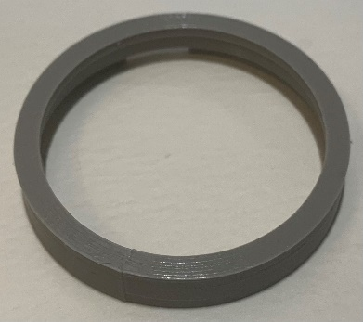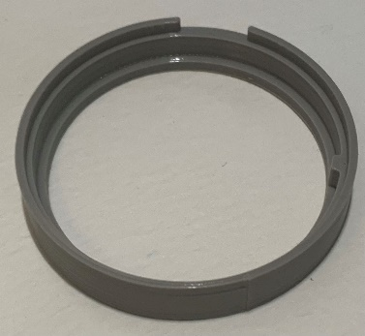

**Photos of Enclosure Bottom**

