# Required Components

|  |  |
| --- | --- |
| A photo of the components required to build the Touchpad Joystick. | **BOM**   1. Enclosure Base 2. Enclosure Top 3. Cirque Capacitive Sensor 4. QT PY Micro Controller 5. 5cm long 22AWG wire x7 |

# Required Tools

* Soldering Iron
* Solder
* Wire Strippers
* Flush Cutter
* Glue

# Required Personal Protective Equipment (PPE)

* Safety Glasses
* Fume Extractor or a well-ventilated space

# Assembly Instructions

## Step 1: Prepare Wires

Cut seven lengths of wire approximately 5 cm long and strip approximately 1cm off each end.

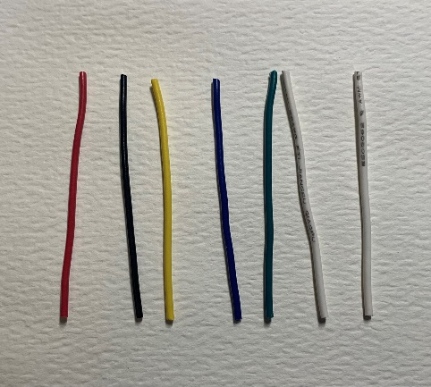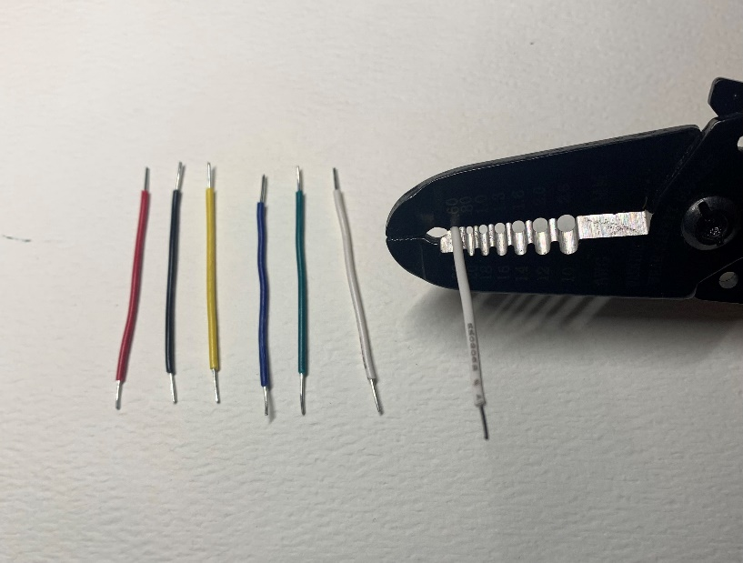

## Step 2: Solder the Capacitive Sensor Connections

Solder each wire to one of the contacts on the back of the capacitive sensor as specified in the table and image below. Ensure the wires and solder only touches their specified contact point and does not bridge to any others. Snip any excess wire.

|  |  |
| --- | --- |
| **Wire #** | **Contact Label on Sensor** |
| 1 | DR |
| 2 | S0 |
| 3 | SCK |
| 4 | SS |
| 5 | SI |
| 6 | VDD |
| 7 | GND |

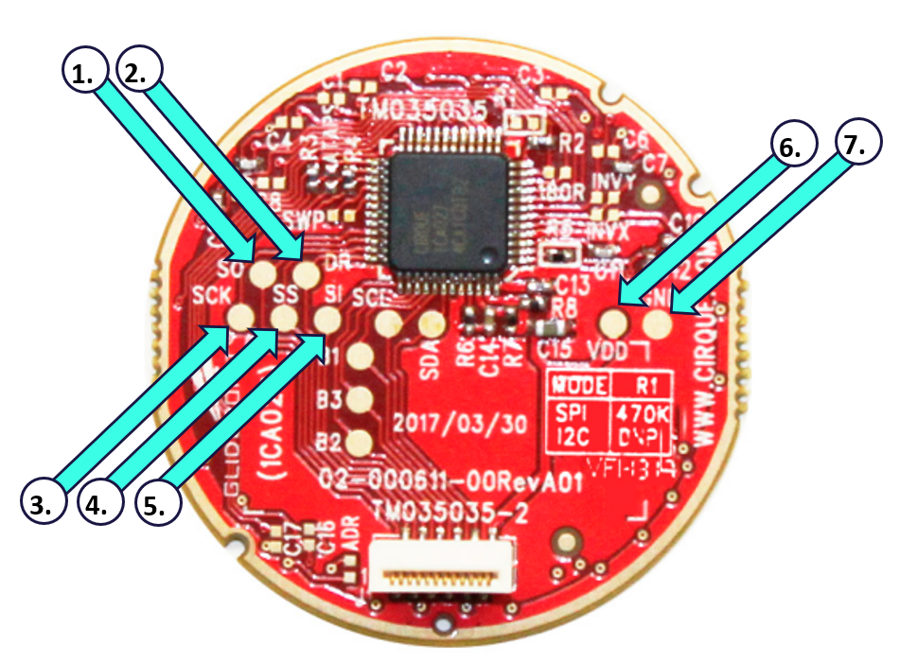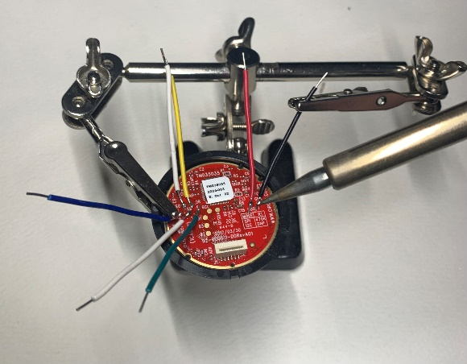

**2.**

**1.**

## Step 3: Solder the Controller Connections

Take note of the wire numbers from Step 2 and solder them to the controller pins as specified in the table and images below. When soldering, feed the wires though the top of the controller and snip the excess from the bottom once secure.

|  |  |
| --- | --- |
| **Wire #** | **Pin on Controller** |
| 1 | A1 |
| 2 | MI |
| 3 | SCK |
| 4 | A0 |
| 5 | MO |
| 6 | 3V |
| 7 | GND |

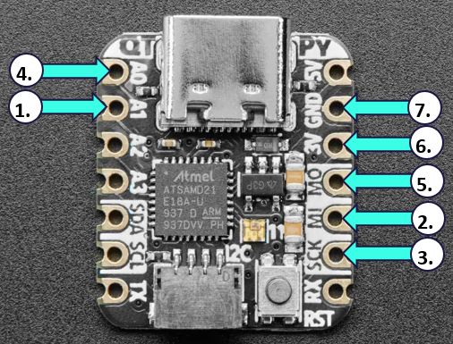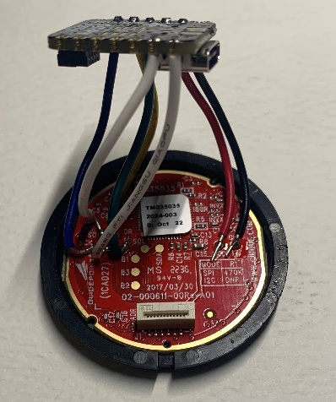

## Step 4: Install into Enclosure

Press the controller into the enclosure base, making sure to align the USB port with the cut-out on the side. Then press the sensor into the enclosure top by alighting their outer notches. The two halves of the enclosure can now be pressed together and secured with a dab of glue.

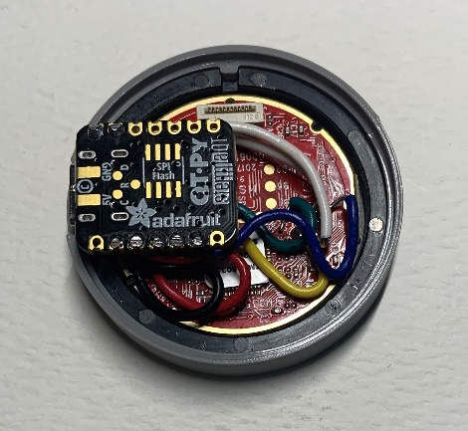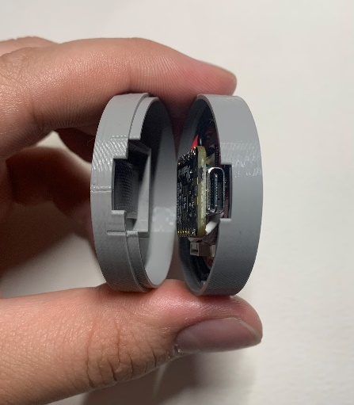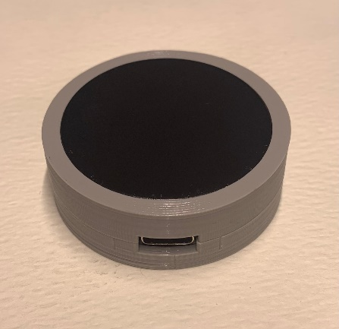

# Firmware Instructions

## Step 1: Download Firmware

The latest version of the firmware can be found in the [GitHub repository](https://github.com/nelsonii/JoystickSoftware/tree/main/7MM_Joystick_GlidePoint_MKII). Save the file with a “.ino” extension at the end of the file name.

## Step 2: Download / Open Arduino IDE

Download and install the latest version of the Arduino IDE: <https://www.arduino.cc/en/software>

## Step 3: Set Board

With the Arduino IDE open, select the Adafruit QT Py board. To do this, click on **Tools** 🡪 **Board** 🡪 Select Adafruit QT Py M0 (SAMD21)

## Step 4: Connect Device

Use the USB cable connect the device to a computer and allow a few seconds for it to initialize.

## Step 5: Open Firmware

Open the device firmware and click “OK” to create a sketch folder if prompted.

## Step 7: Install Libraries

This device requires the Adafruit_NeoPixel and Adafruit_TinyUSB libraries. To install these libraries:

Click **Tools** 🡪 **Manage Libraries** 🡪 Search “Adafruit_NeoPixel” and then “Adafruit_TinyUSB” 🡪 click **Install** for each one, respectively**.**

## Step 6: Select the Port #

The corresponding port number to the connected controller must be selected: Click **Tools** 🡪 **Port** 🡪 **COM ##** (this number will vary for each user).

## Step 7: Upload Code

Click the right arrow on the top left of the Arduino IDE to upload the code. Once the upload is complete, a message saying “Upload Successful” will show at the bottom left of the Arduino IDE.

## Testing using an Xbox Adaptive Controller

1. Connect the Xbox Adaptive Controller (XAC) using a USB C cable to the computer.
2. Plug the joystick into either the left or right USB joystick ports.
3. If using Windows, open “Set up USB Game Controllers” from the Control Panel. You can find this by searching your computer in the search bar next to the Windows icon.
4. Select the Xbox Adaptive Controller from the list of controllers and go to “Properties”.
5. Move your joystick by touching the trackpad and observe the movement of the cross hatch in the “Axes” window. Ensure it moves in the proper directions when you move the joystick (the USB cable exit points in the up/forward direction). If not, open the joystick and check your connections or modify the directions in the code.

Alternatively, you could use the XAC with Steam or an Xbox itself to test that moving the joystick results in the corresponding movements on the controller.