## Introduction

The Touchpad Joystick is a small USB Cirque Glidepoint touchpad that functions as a gaming joystick. The activation surface is 35mm in diameter and is touch sensitive. It plugs into USB and can be used to play games with the Xbox Adaptive Controller

## Features

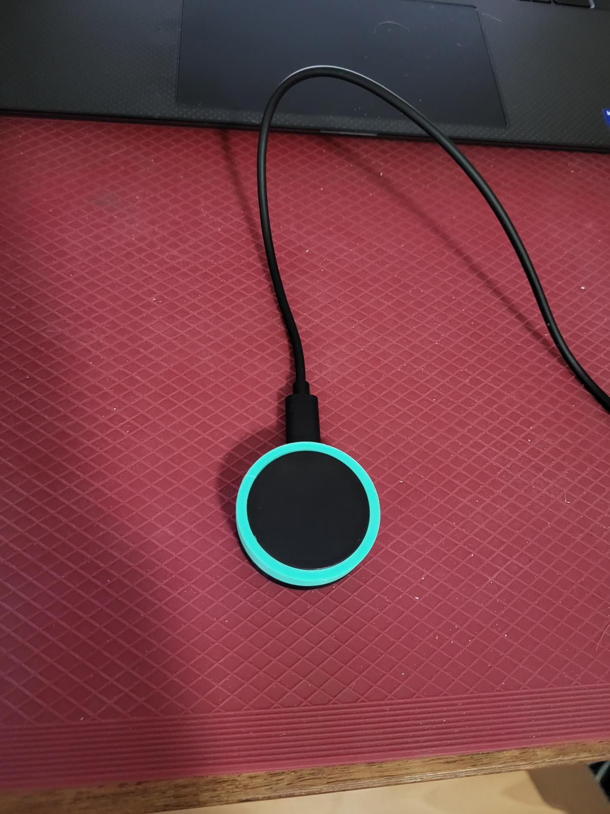

Forward Direction

Cirque Glidepoint Trackpad

USB Cable

## Usage

To use this joystick, simply plug the USB cable into the host device. The forward direction is where the USB cable exits the joystick itself. The joystick is touch sensitive and the joystick speed is proportional to the distance your finger is from the centre of the touchpad. Removing your finger from the touchpad will return the joystick to neutral.

## Compatibility

This joystick is compatible with the XAC and with PC. To add buttons, you can use 3rd party software such as [Joystick Gremlin](https://github.com/WhiteMagic/JoystickGremlin) to combine switch inputs or keyboard keys with the joystick into a virtual gamepad.

## Specifications

|  |  |
| --- | --- |
| Diameter | 45 mm |
| Height | 16 mm |
| Diameter of Activation Surface | 35 mm |
| Weight | 30 grams |

## Cleaning

Use a damp cloth to wipe down the surface of the device. Do not use hot water as this may cause the 3D printed components to warp. Do not submerge the device in any liquid. (Water, disinfectant, etc.)