# 3D Printing Summary

|  |  |
| --- | --- |
| **Metrics** | **V1.0** |
| Total Print Time (min) | 181 |
| Total Number of Components | 3 |
| Typical Total Mass (g) | 20 |
| Typical Number of Print Setups | 1 |

# 3D Printing Settings

|  |  |  |  |  |  |  |  |
| --- | --- | --- | --- | --- | --- | --- | --- |
| **Print File Name** | **Qty** | **Total Print Time (hr:min)** | **Mass (g)** | **Infill (%)** | **Support(Y/N)** | **Layer Height/ Nozzle Diameter(mm)** | **Notes (orientation, special settings, etc.)** |
| Slide-on Trigger Attachment.stl | 1 | 1:38 | 11 | 20 | N | 0.2/0.4 | * Print in default STL orientation |
| Shoulder Trigger Extender.stl | 1 | 0:43 | 5 | 20 | N | 0.2/0.4 | * Print in default STL orientation |
| Shoulder Bumper Extender.stl | 1 | 0:40 | 4 | 20 | N | 0.2/0.4 | * Print in default STL orientation |

# Customization Options

* Any of the 3 parts can be printed in separate colours to customize the Trigger Extenders

# Post-Processing

* Any sharp edges should be sanded down/filed off.

# Examples of Quality Prints

**Photos of Slide-on Trigger Attachment.stl**

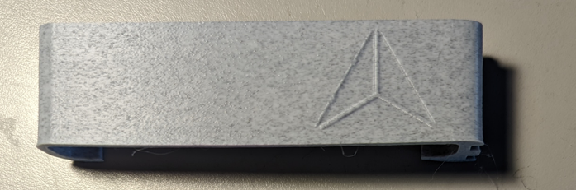

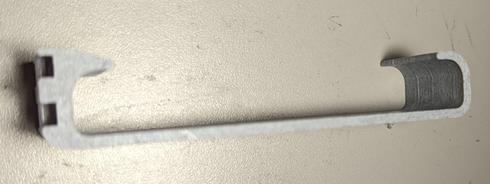

**Photos of Shoulder Trigger Extender.stl**

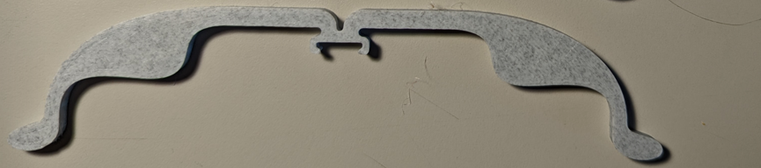

**Photos of Shoulder Bumper Extender.stl**

