## Introduction

The Trigger Extender for Joy-Con Controller is an aid designed to make it easier to use the triggers and bumpers on the Nintendo Joy-Con Grip

## Features

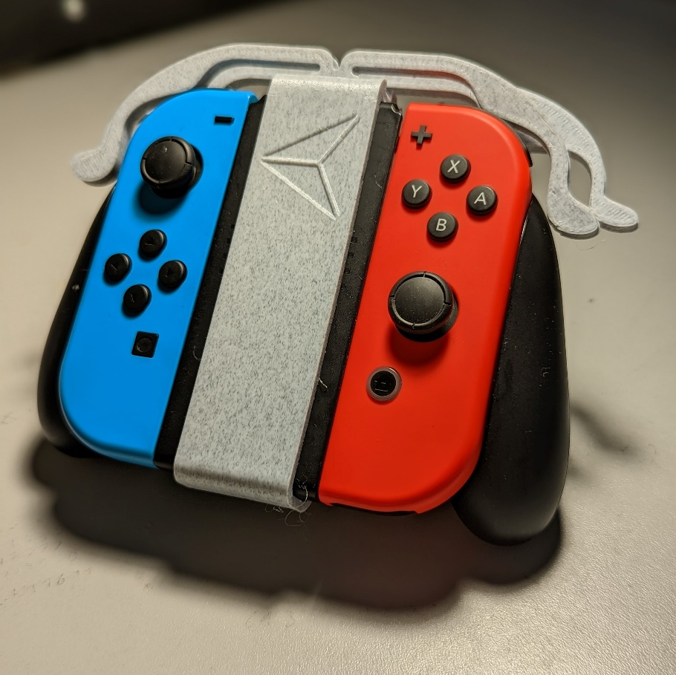

## Usage

Once the device is assembled as per the Assembly Guide, pressing on the bumper and trigger extensions will press the respective bumper and trigger buttons.

## Compatibility

This device is designed to connect to the official Nintendo Joy-Con Grip.

## Specifications

The completed assembly weighs approximately 20 grams

## Cleaning

The device can be wiped clean with a damp cloth.