# 3D Printing Summary

|  |  |
| --- | --- |
| **Metrics** |  |
| Total Print Time (min) | 30 |
| Total Number of Components | 2 |
| Typical Total Mass (g) | 3.76 |
| Typical Number of Print Setups | 1 |

# 3D Printing Settings

|  |  |  |  |  |  |  |  |
| --- | --- | --- | --- | --- | --- | --- | --- |
| **Print File Name** | **Qty** | **Total Print Time (hr:min)** | **Mass (g)** | **Infill (%)** | **Support(Y/N)** | **Layer Height/ Nozzle Diameter(mm)** | **Notes (orientation, special settings, etc.)** |
| Bottom_Case.stl | 1 | 0:12 | 1.56 | 20 | N | 0.2/0.4 | Print in default orientation shown below. |
| Top_Case.stl | 1 | 0:18 | 2.20 | 20 | N | 0.2/0.4 | Print in default orientation shown below. |

## Default Orientation

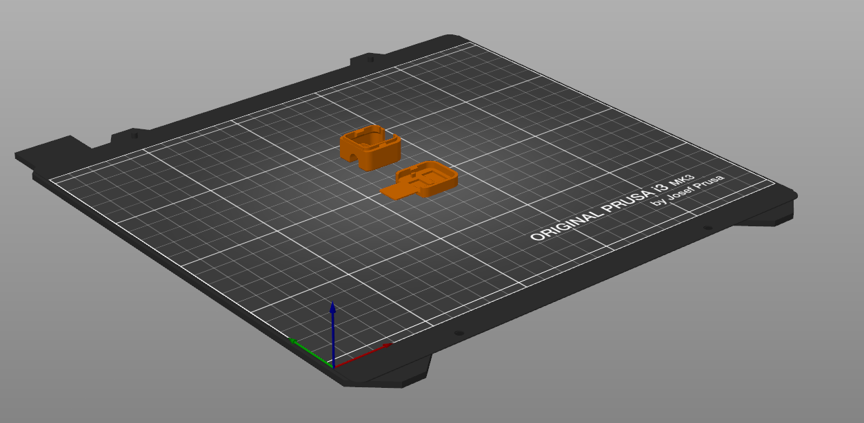

# Examples of Quality Prints

The below photos are examples of the 3D printed components that are determined to meet the quality necessary for the device to function.

**Photos of Top Case**

**Photos of Bottom Case**

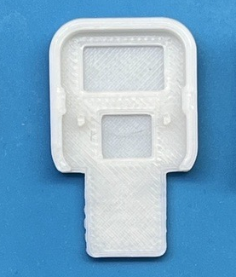

**Photos of Assembly**

Photo of assembled top and bottom case with good quality print
