# Introduction

The USB Switch Tester is a device used to test the functionality of an assistive switch with a 3.5 mm connection. This device allows users to determine if they successfully assembled their switch adapted device and make sure that all the components are working. The existing switch tester device such as Simple Switch Tester require a power source which adds to the cost over time.

The USB Switch Tester is intended to use the existing USB power sources or USB power adapters which are very common as the power source. USB power adapters are available in most households and can be purchased locally.

This device is intended to be used by users of assistive switches or disability professionals to confirm the assistive switch is functional.

# Research

Existing Commercial Options

|  |  |
| --- | --- |
| Title | Single Switch Tester |
| Link | <https://www.ablenetinc.com/technology/single-switch-tester> |
| Author | AbleNet |
| License |  |
| Cost | $55 USD |
| Notes | Discontinued? |

DIY designs

|  |  |
| --- | --- |
| Title | Simple Switch Tester |
| Link | <https://makersmakingchange.com/project/simple-switch-tester/> |
| Author | MakersMakingChange |
| License | Attribution-ShareAlike 4.0 International |
| Cost | $11 - $25 CAD |
| Test Build (Y/N) | Y |
| Add to Library (Y/N) | n/a |
| Notes | Battery powered |

# Requirements

## Goals

|  |  |
| --- | --- |
| **ID** | **Description** |
| G01 | Cost Effective (Low cost comparing to alternative options) |
| G02 | Easy to use |
| G03 | Easy to assemble |
| G04 | Minimal size |

## Functional Requirements

|  |  |
| --- | --- |
| F01 | The device shall have one input channel. |
| F02 | The device shall have a visual feedback element via a LED to notify the user about the switch activations. |
| F03 | The device latency shall not exceed 50 milliseconds. |
| F04 | The device shall not consume more than 20 mA of current from the USB port. |
| F05 | The device shall have a USB Type A PCB connector. |

## Non-functional Requirement

|  |  |
| --- | --- |
| NF01 | Shall look professional with tight tolerance on case size. |
| NF02 | The device shall weigh less than 25 grams. |

## Constraints

|  |  |
| --- | --- |
| C01 | Shall be able to be built as a single unit for ≤ $30 CAD |
| C02 | Shall be easily manufacturable by a moderately skilled maker |

# Conceptual Design

## Through hole

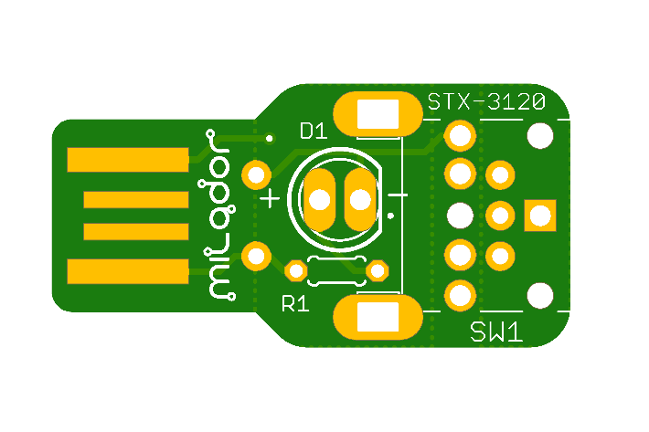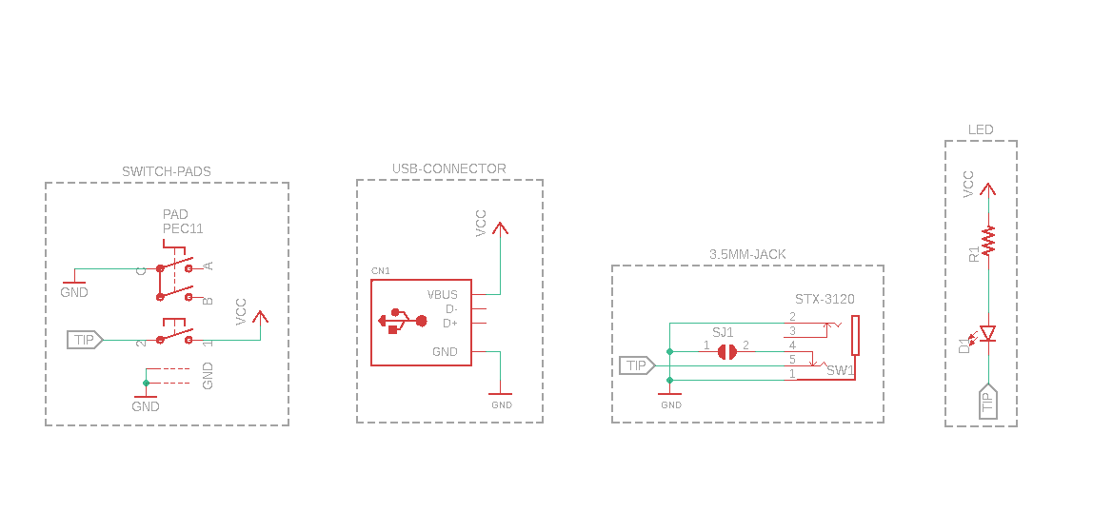

* Units: 5
* PCB Price: US $2.0
* Components: US $7.65 Or CAD $10.25
* Digikey shipping : US $6 or CAD $8
* Shipping :
  + Economical Global Direct Line
    - No tracking : US $3.70
    - 10-18 business days
    - Taxes will be levied at the check-out point for the order with an intrinsic value ≥15.5USD.Last mile service is provided by Canada Post.
  + Global Direct Line Saver
    - US $10.57
    - 8-15 business days
    - The last mile delivery service is provided by Canada Post.
* Total all : US $17.35 or CAD $23.25 or CAD $3.47 per unit

## SMT

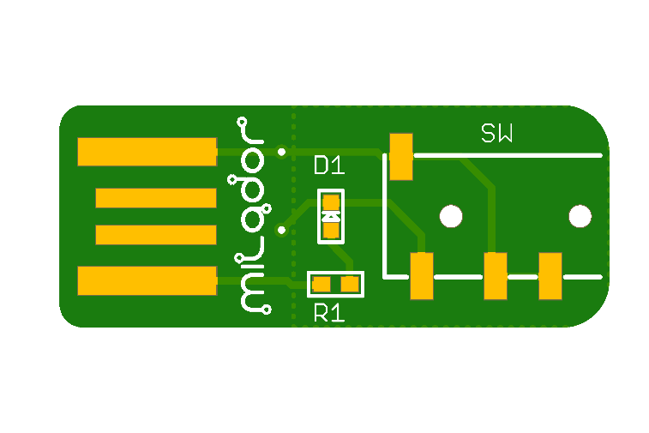

* Units: 5
* PCB Price: US $2.0
* SMT Price
  + Setup fee US $8.00
  + Stencil US $1.50
  + Panel US $0.00
  + Large Size US $0.00
  + Components US $0.72
  + Extended components fee
    - US $3.00
  + SMT Assembly
    - US $0.06
* Total Assembly and PCB: US $15.28
* Shipping :
  + Economical Global Direct Line
    - No tracking : US $3.70
    - 10-18 business days
    - Taxes will be levied at the check-out point for the order with an intrinsic value ≥15.5USD.Last mile service is provided by Canada Post.
  + Global Direct Line Saver
    - US $10.57
    - 8-15 business days
    - The last mile delivery service is provided by Canada Post.
* Total all : US $18.98 or CAD $25.5 or CAD $5.1 per unit

|  |  |  |
| --- | --- | --- |
| **Concept** | **Through Hole** | **SMT** |
| Units | 5 | 5 |
| PCB Cost | US $2 | US $2 |
| Total Assembly Cost | Volunteers time | US $15.28 |
| Components Cost | US $7.65 | US $3.72 |
| Components Shipping Cost | US $6 | None |
| Most affordable shipping Cost (Economical Global Direct Line) | US $3.70 | US $3.70 |
| Total Cost | US $17.35 or CAD $23.25 | US $18.98 or CAD $25.5 |
| Total Per Unit Cost | CAD $3.47 | CAD $5.1 |