## Introduction

This USB Switch Tester is a device that allows someone to confirm their assistive switch with a 3.5 mm plug is functional. This convenient device can be plugged into USB Type-A ports with power (for example, a laptop) and assistive switches can be plugged in to the 3.5 mm jack on the USB switch tester. When the assistive switch is pressed down, the LED on the device will light up indicating that the assistive switch is working. If the assistive switch is not working, the LED on the USB Switch Tester will not light up. This device will be helpful to disability professionals or individuals who use assistive switches to check to make sure their devices are in working condition.

This is NOT a switch interface but rather a simple device to confirm your assistive switch is working properly.

## Features

The USB Switch Tester features an LED light, USB plug, 3D printed casing, and a 3.5 mm port as shown in the photo below.

**LED light** – Lights up when a working assistive switch is pressed.

**3.5 mm port** – Location where assistive switches with a 3.5 mm plug will be inserted.

**USB plug** – Allows device to be inserted into a powered USB port.

**3D printed casing** – hard outer shell that protects the internal electrical components.

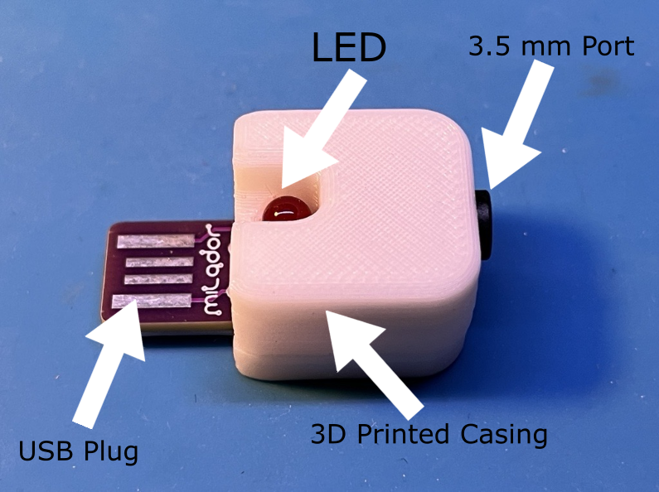

## Usage

This device requires a USB port that has power coming from it and an assistive switch to test. The setup should look similar to the one shown in the photo below. With these materials, follow the below steps:

1. Plug the USB Switch Tester into the powered USB port (see compatibility section to see powered USB ports).
2. Plug in the assistive switch that you would like to test
3. Press down on the assistive switch
   1. If the LED on the USB Switch Tester **lights up**, the assistive switch is functional
   2. If the LED on the USB Switch Tester **does not light up**, the assistive switch is not working
4. Unplug the assistive switch from USB Switch Tester and repeat steps above if you want to test another assistive switch

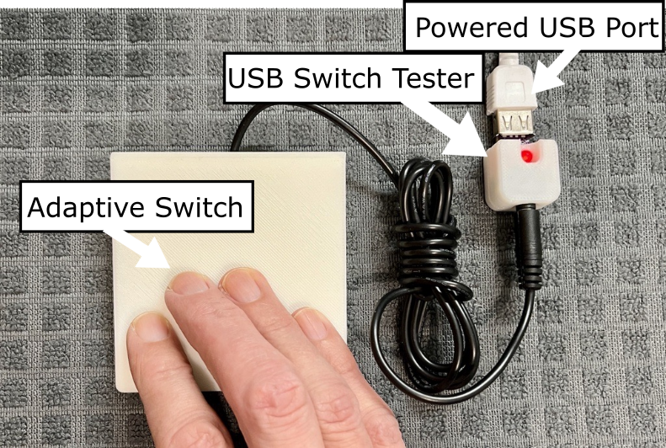

## Compatibility

This device needs to be plugged into a powered USB source. There are many options for this as the device does not draw more than 20 mA of current from the power source. The USB Switch Tester can be plugged into any power source with USB Type-A port such as laptops, USB block chargers, etc.

In the example photo below, the USB Switch Tester is plugged into a USB block charger that is connected to an outlet.

Tester device being plugged into a powered USB port and adaptive switch plugged into the tester. The adaptive switch is being pressed down with the red LED being lit up.

The powered USB port is a block charger plugged into an outlet

## Specifications

|  |  |  |  |
| --- | --- | --- | --- |
| **Dimensions (mm)** | | | **Mass (g)** |
| Length | Width | Height |
| 33 | 17 | 13 | 7 |

## Cleaning

The USB Switch Tester can be wiped down with sanitizing cleaners or gently scrubbed with a soft-bristled brush. Do not subject the device to high heat as this may damage the 3D-printed material.