# 3D Printing Summary

|  |  |
| --- | --- |
| **Metrics** | **\*Configuration 1\*** |
| Total Print Time (hr:min) | 12:08 |
| Total Number of Components | 8 |
| Typical Total Mass (g) | 90 |
| Typical Number of Print Setups | 5 |

# 3D Printing Settings

|  |  |  |  |  |  |  |  |
| --- | --- | --- | --- | --- | --- | --- | --- |
| **Print File Name** | **Qty** | **Total Print Time (hr:min)** | **Mass (g)** | **Infill (%)** | **Support(Y/N)** | **Layer Height/ Nozzle Diameter(mm)** | **Notes (orientation, special settings, etc.)** |
| Transmitter_Lid.stl | 1 | 2:29 | 16 | 20 | N | 0.2/0.4 | * Print in orientation given in STL |
| Transmitter_Base.stl | 1 | 1:18 | 9 | 20 | N | 0.2/0.4 | * Print in orientation given in STL * Allow to cool to room temperature before removing from print bed |
| Reciever_Lid.stl | 1 | 2:12 | 20 | 20 | N | 0.2/0.4 | * Print in orientation given in STL |
| Reciever_Base.stl | 1 | 5:47 | 44 | 20 | N | 0.2/0.4 | * Print in orientation given in STL |
| Transmitter_Button.stl | 2 | 0:02 | 0.2 | 20 | N | 0.2/0.4 | * Print in orientation given in STL |
| Transmitter_Cover.stl | 2 | 0:09 | 0.5 | 20 | N | 0.2/0.4 | * Print in orientation given in STL * Trim any brim or elephants foot from bottom |

# Customization Options

* Each different section of the device can be printed in any colour PLA.
* The Fusion files for the device are provided, so images and text can be added to the device.

# Post-Processing

* Use a hobby knife to remove any sharp edges, elephants foot, or stringing.

# Examples of Quality Prints

**Photos of Transmitter_Lid.stl**

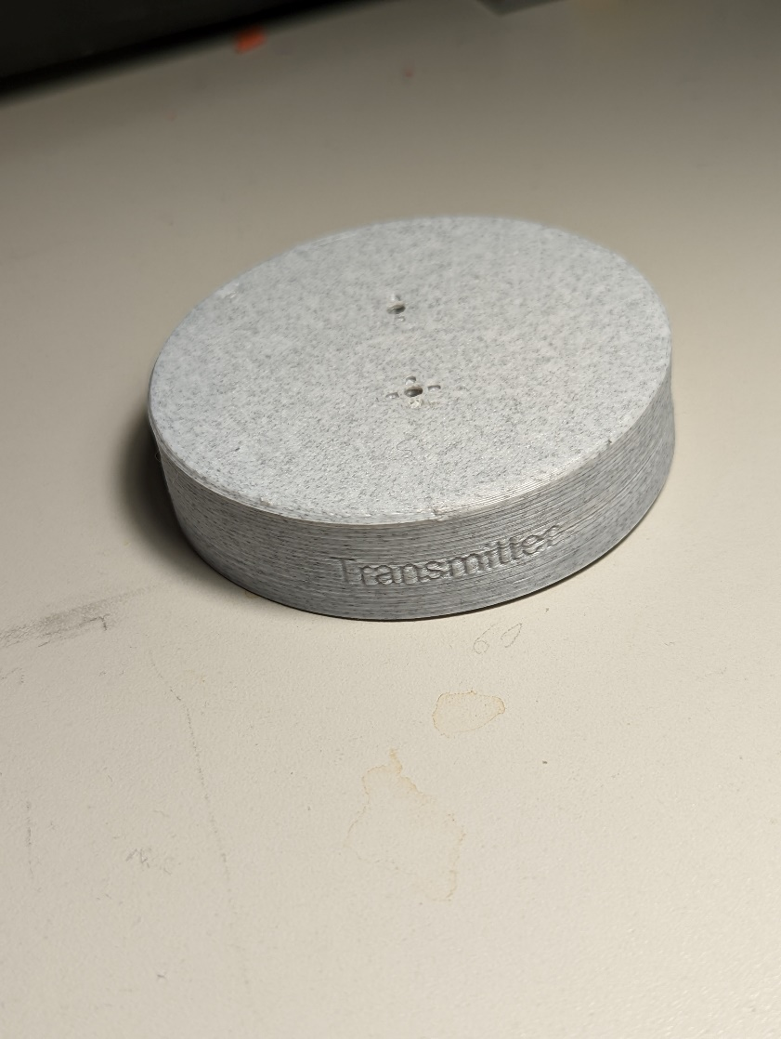

**Photos of Transmitter_Base.stl**

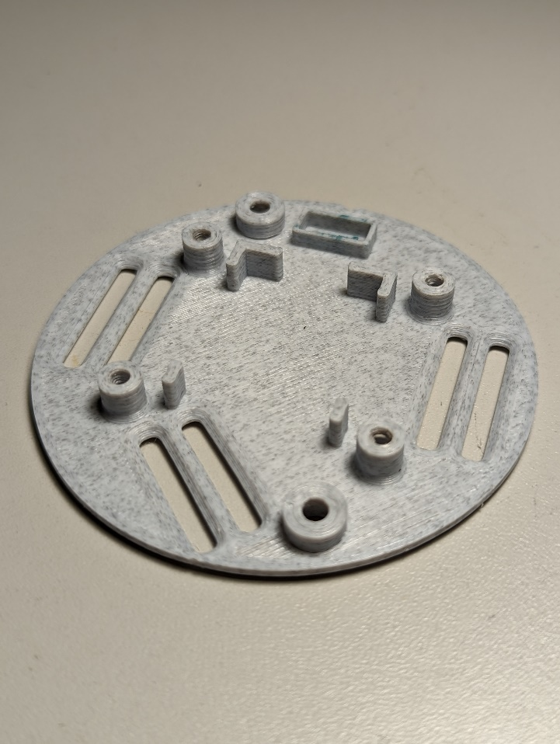

**Photos of Receiver_Lid.stl**

**Photos of Receiver_Base.stl**

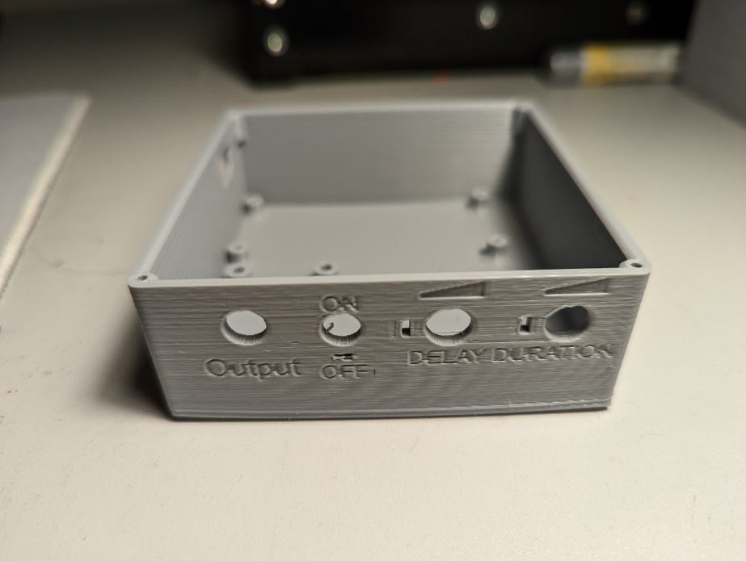

**Photos of Transmitter_Cover.stl**

**Photos of Transmitter_Button.stl**

