## Introduction

The Wearable Clap Switch is a hand mounted device that activates a switch operated device with a clap of the hands. The sensitivity of the clap detection, the duration of the activation, and the delay between activations can all be set by a secondary user.

## Features

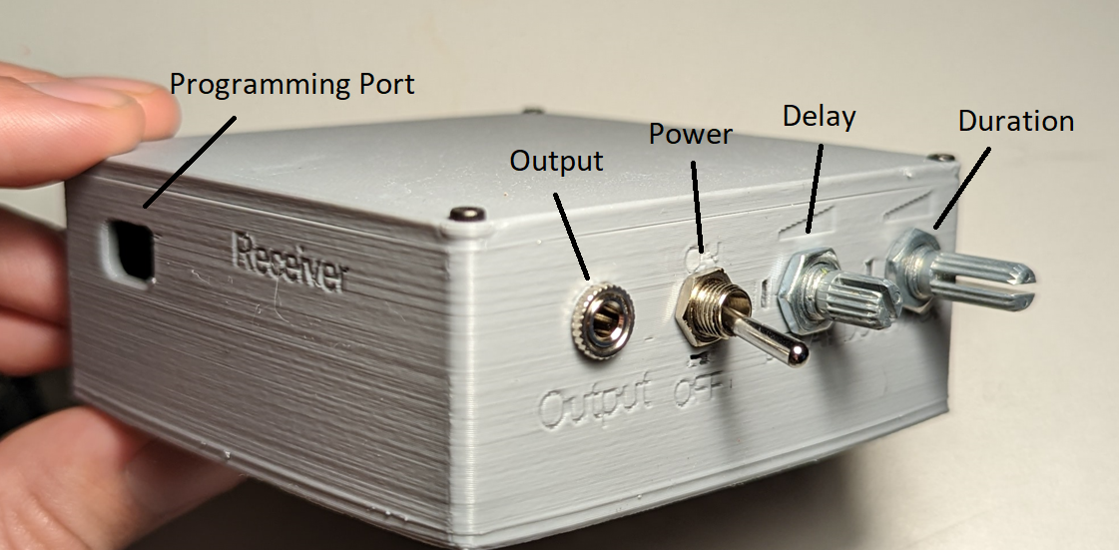

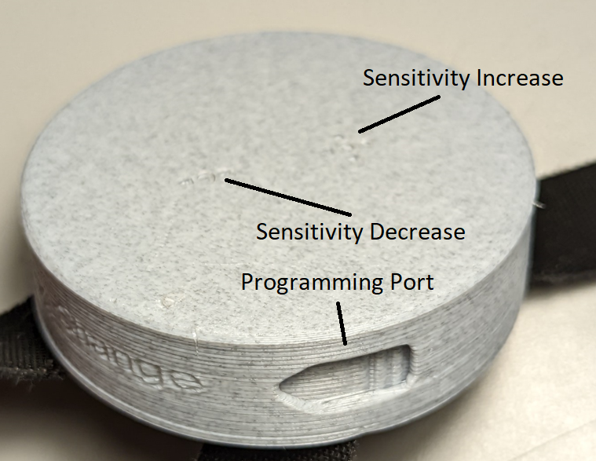 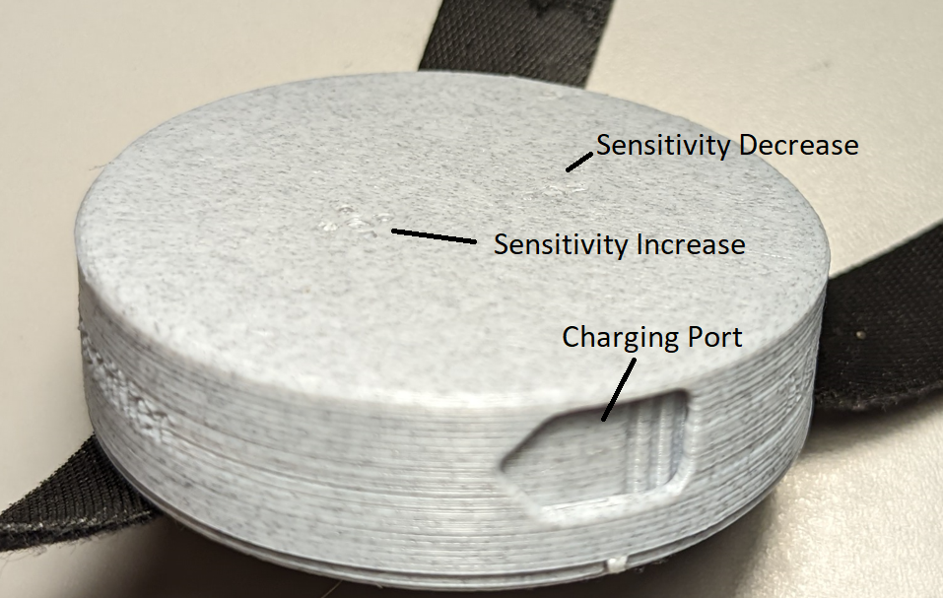

## Usage

**Transmitter**

To activate the transmitter, slide the power switch on the bottom of the transmitter. The transmitter will start looking for a connection, and if a receiver is broadcasting, the two will connect. Once the two have connected, the transmitter will send a signal to the receiver whenever it detects a clap.

The sensitivity of the clap detection can be adjusted with the two buttons on the top of the case, as the sensitivity increases, the number of LEDs in the circle that are illuminated will increase, and the opposite will happen as the sensitivity decreases.

To charge the transmitter, open the port nearest the power switch, and use tweezers to unplug the JST connector and pull it out of the enclosure. It can then be plugged into the charging board, which connects to a Micro USB connector to charge the battery. The light on the charging board will go from red to green when the battery is fully charged.

**Receiver**

To active the receiver, flip the toggle switch from off to on. The receiver will start looking for a connection, and if the transmitter is broadcasting, the two will connect. Once they have connected, the receiver will power a relay to activate the mono jack.

To change how long the jack stays activated, adjust the potentiometer labeled Duration. To change the cooldown between activations, adjust the potentiometer labeled Delay.

To charge the receiver, plug a USB C connector into the port on the side of the case. The light on the inside will go from red to green when it is fully charged.

## Compatibility

The Wearable Clap Switch is compatible with any switch enabled device.

## Specifications

**Transmitter**

Weight: 45g

Dimensions: Diameter 70mm, height 20mm

**Receiver**

Weight: 119g

Dimensions: 85x85x35mm

## Cleaning

The device can be wiped clean with a damp cloth.