## Introduction

The Wheelchair Bluetooth Joystick Adapter is a device that enables a user of a powerchair to use their wheelchair joystick that outputs an HID mouse to act as an HID gamepad.

## Features

Micro USB-B

Power

International Electrotechnical Commission (IEC). Power symbol. 2002 | MoMA

Micro USB-B

Data

HDMI

## Initial Bluetooth pairing and connection

1. Connect your Wheelchair Bluetooth Joystick Adapter (WBJA) to the display provided using the [HDMI to HDMI cable] and the [HDMI to HDMI mini adapter].
2. Plug in the display to power using the [power cable included with the display].
3. Connect the [USB hub] to WBJA via [USB-A female to USB micro male adapter] plugged into the data port marked with A black background with a black square

   Description automatically generated
4. Plug in a [USB mouse] into the [USB hub].
5. Plug the [USB-B micro power cable] into the WBJA in the power port marked with International Electrotechnical Commission (IEC). Power symbol. 2002 | MoMA and plug the other end into a power outlet.
6. If a login window appears, login using: **Username:** player **Password:** bluestick (if you need to login, attach a USB keyboard to the USB hub)
7. Click on Bluetooth button icon on top right of Raspberry Pi taskbar.

[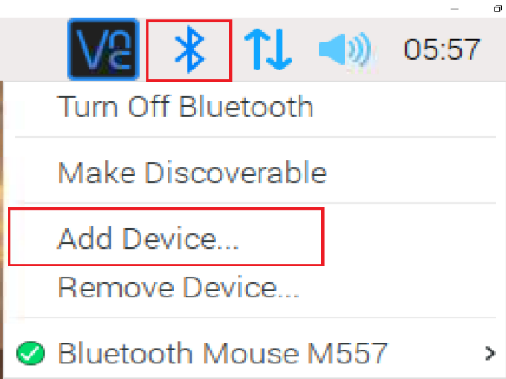](https://github.com/milador/RaspberryPi-Joystick/blob/master/Resources/Images/BT_Pair_Open.PNG)

1. Click on Add Device
2. Select your BT wheelchair Bluetooth mouse module and Click on Pair button

[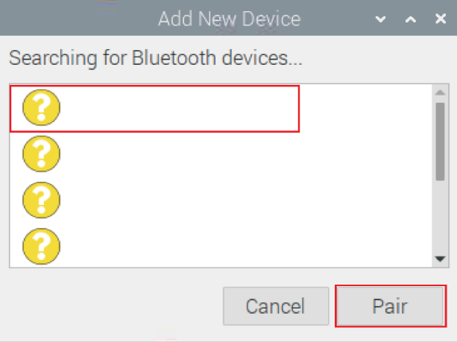](https://raw.githubusercontent.com/milador/RaspberryPi-Joystick/master/Resources/Images/BT_Pair_Add.PNG)

1. Restart WBJA again once your module is successfully paired (either through the User Interface or by unplugging and plugging it back in)
2. Login to your Raspberry Pi again if prompted.
3. Wait 30 seconds for it to initialize.
4. Move wheelchair joystick to initiate the connection if they are already paired.

## Usage

See Appendix A for hardware connection diagrams.

1. Plug in your Wheelchair Bluetooth Joystick Adapter (WBJA) to the host device (such as XAC, PC, etc) using a [micro USB-B male to USB-A male cable] via the micro USB-B data port on the WBJA marked with A black background with a black square

   Description automatically generated.
2. Power your Bluetooth enabled input device (Bluetooth Keyboard/mouse or Wheelchair Bluetooth module)
3. Power your Wheelchair Bluetooth Joystick Adapter by plugging the [USB-B micro power cable] into the WBJA in the power port marked with International Electrotechnical Commission (IEC). Power symbol. 2002 | MoMA and plug the other end into a power outlet.
4. Wait 30 to 60 seconds for it to initialize.
5. You should be able to use your keyboard/mouse/wheelchair Bluetooth module as a joystick at this point.

## Compatibility

The gaming platform must be identified as the adapter is not compatible with all the systems/consoles and additional components may be required.

|  |  |  |  |
| --- | --- | --- | --- |
| Platform | Compatibility | Additional Hardware | Tested |
| Windows | Yes | None | Yes |
| Mac | Yes | MAGIC NS 2, MAGIC-S PRO 2 | None |
| Android | Yes | None | None |
| Xbox | Yes | Xbox Adaptive Controller | Yes |
| Nintendo Switch | Yes | MAGIC NS, MAGIC NS 2, MAGIC-S PRO, MAGIC-S PRO 2, Magic-S Ultimate | None |
| PS3 | Yes | MAGIC NS 2, MAGIC-S PRO, MAGIC-S PRO 2, Magic-S Ultimate | None |
| PS4 | Yes | MAGIC NS 2, MAGIC-S PRO, MAGIC-S PRO 2, Magic-S Ultimate | None |
| PS5 | None | None | None |

For a list of compatible Wheelchair Bluetooth Modules, see Appendix B.

## Cleaning

The Wheelchair Bluetooth Joystick Adapter can be wiped down with a damp cloth. Do not submerge the device. Do not expose to high heat.

## Appendix A

Hardware Connection Diagrams

* Windows and Android

* Mac,Nintendo Switch, PS3, and PS4

* Xbox

## Appendix B – Wheelchair Compatibility

The Wheelchair Bluetooth Module is an essential component of the project and it’s important to make sure the module is compatible with the rest of system.

The model of wheelchair joystick and Bluetooth module need to be identified and confirmed its compatibility according to the following tables:

**Table 1: Bluetooth Enabled Joystick Options**

|  |  |  |
| --- | --- | --- |
| Joystick Model | Wheelchair Brand | Bluetooth enabled |
| Q-Logic 2 | Quantum Rehab | Integrated Bluetooth Mouse |
| Q-Logic 3 | Quantum Rehab | Integrated Bluetooth Mouse |
| LiNX REM400 | Golden Technologies  Drive Medical  Invacare  Merits Health USA | Integrated Bluetooth Mouse |
| R-Net Joystick Module w/Bluetooth ( CJSM & PJSM) | Permobil,Quickie | Integrated Bluetooth Mouse |

**Table 2: Bluetooth enabled interface options**

|  |  |  |
| --- | --- | --- |
| Interface Model | Wheelchair Brand | Bluetooth enabled |
| Q-Logic EX Enhanced Display | Quantum Rehab | Integrated Bluetooth Mouse |
| R-net OMNI 2 | Permobil,Quickie | Integrated Bluetooth Mouse |
| LiNX REM500 Touch Screen | Golden Technologies  Drive Medical  Invacare  Merits Health USA | Integrated Bluetooth Mouse |

**Table 3: Bluetooth Addon Modules**

|  |  |  |
| --- | --- | --- |
| Module Model | Wheelchair Brand | Joystick Model |
| R-net Bluetooth Mouse Module | Permobil,Quickie | R-Net Remote Color Joystick |

The wheelchair distributor can provide additional information if the user is not able to provide necessary information.