# Introduction

The Willow is a magnetic low force joystick that allows a user with limited arm strength to control a computer, gaming console, smart phone, or tablet.

This Quickstart Guide is meant to briefly introduce the functions and use of the Willow. For more detailed information, please consult the User Guide.

# Features

Willow Interface Cable

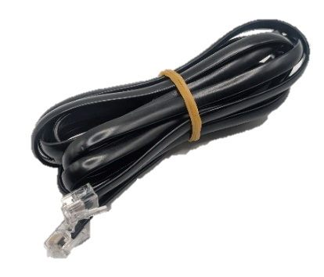

USB-C to USB-A Cable

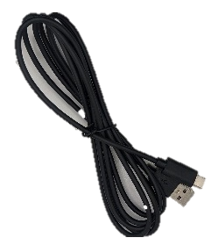

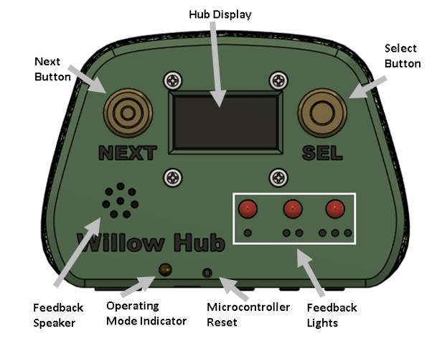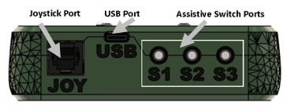

Cable Port

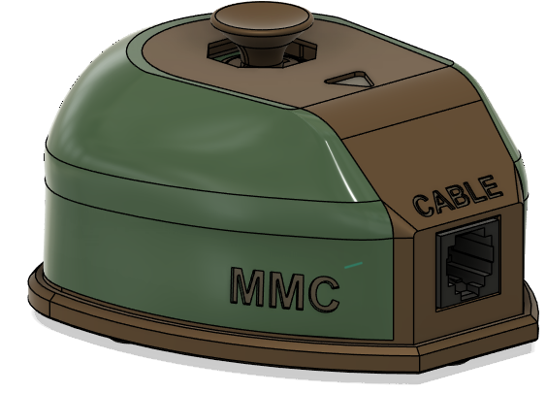

Orientation Marker

Topper

|  |  |  |  |  |
| --- | --- | --- | --- | --- |
|  | Operating System | Compatibility per Mode | | |
| USB Mouse | Wireless Mouse | USB Gamepad3 |
| Phone/Tablet | Android | Checkmark with solid fill 1 | Checkmark with solid fill | Checkmark with solid fill1 |
| iOS2 | Checkmark with solid fill | Checkmark with solid fill |  |
| iPadOS | Checkmark with solid fill | Checkmark with solid fill |  |
| Windows | Checkmark with solid fill | Checkmark with solid fill | Checkmark with solid fill |
| Desktop | macOS | Checkmark with solid fill | Checkmark with solid fill |  |
| Linux | Checkmark with solid fill | Checkmark with solid fill |  |
| Windows | Checkmark with solid fill | Checkmark with solid fill | Checkmark with solid fill |
| 1 Only with devices with USB OTG HID (Universal Serial Bus On-The-Go Human Interfere Device)  2 Only for iOS13+ and iPadOS.  3The Willow is also compatible with devices such as the Xbox Adaptive Controller in Gamepad mode. | | | | |

# Setting up the Willow

The following are the general steps needed to setup your Willow Joystick:

1. Mount Willow Joystick
   1. Mounting adaptors are available
2. Mount Willow Hub
   1. Hub stand is available
3. Connect Willow Interface Cable
4. Optional: Connect assistive switches to Willow Hub
5. Connect the Willow Hub to the Host Device
6. Once powered, wait until device initializes before moving joystick.

Cursor Setup on iOS Devices

Open your device’s ***Settings*** > ***Accessibility*** > ***Touch*** > ***AssistiveTouch*** >Turn it on.

## Optional: Connecting Assistive Switches

|  |  |
| --- | --- |
| A diagram of the willow hub showing the hub switch connections | Up to 3 assistive switches can be connected to the Willow Hub for user inputs.  The ports on the Hub for assistive switches are labeled S1, S2, and S3 and are standard 3.5 mm switch ports. |

## USB Connections

**For direct USB connection** **to the host device,** connect the appropriate USB cable from the Willow Hub into the host device. Use an adapter if necessary.

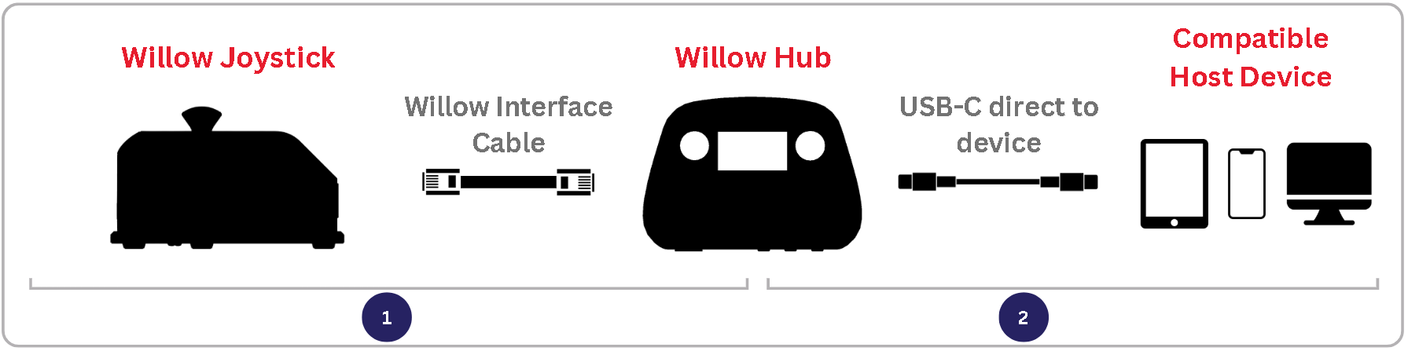

**For connection to the host device with an external power source,** plug a power splitting adapter into the host device and connect the Willow Hub and external power source to the splitter. Use an Adapter if necessary. **Required for iOS USB connection.**

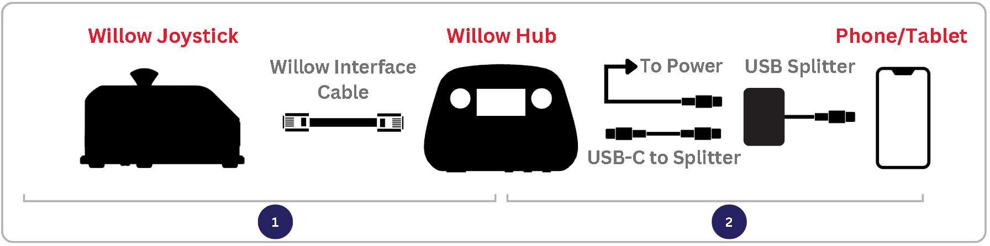

## Wireless Connections

For wireless connection to the host device, plug the Willow Hub directly into any power source using the appropriate adapter as required. Change the operating mode to BT Mouse through the Hub Menu (See Input Mapping and Settings Menu Options). Find “Willow” in the host device Bluetooth menu to pair and connect.

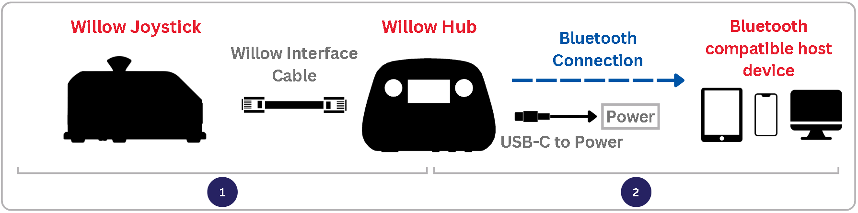

## Input Mapping

| Interchangeable Willow Inputs | | Duration | Hub Menu | Mouse | Gamepad |
| --- | --- | --- | --- | --- | --- |
| Assistive Switches | **Hub Buttons** |
| S1 | **Select** | < 1 sec | Select | Left click | Button 1 |
| 1-3 sec | - | Start Drag Mode | Button 3 |
| > 3 sec | Exit Hub Menu | Enter Hub Menu | Enter Hub Menu |
| S2 | **-** | < 1 sec | - | Middle Click | Button 5 |
| 1-3 sec | - | N/A | Button 6 |
| > 3 sec | - | Perform Center Reset | Perform Center Reset |
| S3 | **Next** | < 1 sec | Next | Right click | Button 2 |
| 1-3 sec | - | Start Scroll Mode | Button 4 |
| > 3 sec | - | Middle Click | Button 5 |
| S1 + S3 | **Next + Select** | < 1 sec | Exit Hub Menu | Enter Hub Menu | Enter Hub Menu |
| Joystick | | - | - | Cursor movement | Joystick movement |

## Settings Menu Options

The Hub Display grants access to a menu for calibrating, changing operating modes, adjusting settings, and resetting the Willow device. See Input Mapping for how to access and navigate the menu.

|  |  |  |  |
| --- | --- | --- | --- |
| Menu Option | Submenu | Function | Notes |
| Exit Menu | Confirm exit menu | Exits settings menu |  |
| Calibration | Center Reset | Performs center reset | Do if experiencing drift |
| Full Calibration | Performs joystick calibration | Do if experiencing cursor issues |
| Mode | Operating mode options | Changes Operating Mode | Options are USB Mouse, BT Mouse, Gamepad |
| Cursor Speed | Increase/Decrease | Changes the cursor speed | Levels from 0 to 10, default 5  - Test speed on host device while in menu by moving joystick |
| More | Sound | Turns sound on or off | Default on |
| Restart Device | Restarts the Willow |  |
| Factory Reset | Resets to default settings |  |

## Cleaning the Willow

|  |  |
| --- | --- |
| **Cleaning the Willow Joystick**   * Wipe with a damp cloth * Don’t use abrasive cleaning materials * Don’t soak the Willow Joystick in any cleaning solutions * Don’t immerse the Willow Joystick | **Cleaning the Willow Hub**   * Wipe plastic enclosure with a damp cloth * Don’t scrub or press down on the Hub Display * Don’t use abrasive cleaning materials * Don’t soak the Willow Hub in any cleaning solutions * Don’t immerse the Willow Hub |

## Troubleshooting Cursor Issues

If you are experiencing cursor drift (cursor is moving on device when joystick is not being moved), perform a center reset in one of the following ways:

|  |  |
| --- | --- |
| Option A: Trigger Center Reset  Either by:   * Navigating through the Hub menu to: **Calibrate > Center Reset** * Using a very long press of assistive switch 2 | Option B: Turn it off and then on again.  Do not touch the joystick until “Ready to use” is displayed on the Hub Display.   * Disconnect/Reconnect Willow to power. * Restart the device through the Hub Menu. * Use a paperclip to push the reset pin on the Hub. |

If the issue persists, contact the maker of your device or Makers Making Change at [info@makersmakingchange.com](mailto:info@makersmakingchange.com)