# What is a topper?

A topper is any support, grip, or other structure added to the joystick to make it easier and more comfortable to use the joystick. Toppers can be made of a variety of materials and be customized to the user.

The Willow Joystick has a modular topper that can be easily swapped. It comes with five different topper options, as well as the design files to create your own custom topper.

# What styles of toppers are there?

There are currently five different styles of toppers for the Willow: a goalpost topper, a concave topper, a convex topper, a stick topper, and a mouldable plastic topper.

|  |  |  |  |  |
| --- | --- | --- | --- | --- |
| **Goalpost** | **Concave** | **Convex** | **Stick** | **Mouldable Plastic** |
| A photo of the goalpost topper printed in gold | A photo of the concave topper printed in gold | A photo of the convex topper printed in gold | A photo of the stick topper printed in gold | A photo of the mouldable plastictopper printed in gold |

# What topper will be best for me?

## Goalpost Topper

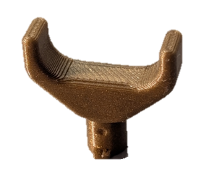The Goalpost Topper has a flat bar at the top, with side walls on either side. These walls keep the user’s finger aligned with the up/down direction of the joystick and stop it from sliding off the sides.

There are three different sizes of goalpost topper, with different widths between the two posts. The small topper has a distance of 12mm, the medium topper has a distance of 15mm, and the large topper has a distance of 20mm. For all three toppers, the distance between the top of the joystick and the surface that the users finger rests on is 7.5mm.

## Concave Topper

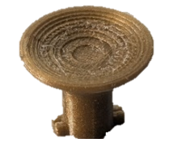The Concave Topper has a small cup-like indent at the top, ideal for a user’s finger to rest in and move freely in any direction. The diameter of the cup is 16mm, and the distance between the top of the joystick and the surface that the users finger rests on is 5mm.

## Convex Topper

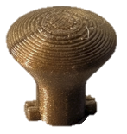The Convex Topper has a domed top that rises up, instead of dipping down like the concave topper. It is ideal for use with two fingers, or with one finger if retainment/alignment is not a concern. The topper has a diameter of 15mm and the top of the dome sits 7.5mm above the top of the joystick.

## A photo of the stick topper printed in goldStick Topper

The Stick Topper is a tube with a rounded top. It has four fins at the base to allow the secondary user to grip it and more easily apply force to turn the gutter lock. It aims to mimic the topper found on the joystick mechanisms used in devices such as the [Oak Joystick](https://www.makersmakingchange.com/s/product/oak-compact-joystick/01tJR00000092x3YAA). The diameter of the stick is 7mm and the distance from the top of the stick to the top of the joystick is 22.5mm.

## Mouldable Plastic Topper

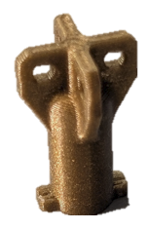The Mouldable Plastic Topper is designed for use with mouldable plastic pellets to create a custom shaped topper. The fins on the topper provide a surface for the plastic to grip onto once it has cooled and been shaped into the ideal topper. The width of the 3D printed fins is 12.5mm and the distance from the top of the fins to the top of the joystick is 12.5mm, but the final dimensions depend on the shape of the heat moulded plastic.

When adding plastic pellets, try to use the minimum amount possible to avoid adding weight to the topper. Adding too much may cause the joystick to have difficulty centering. Making the topper taller will also cause issues centering.

## Custom Topper

If none of the existing topper options are suitable for the user’s needs, the Fusion 360 file to make a custom topper is included in the design files, named Template Topper.f3d. The custom topper file has the correctly sized tabs and stem to interface with the gimbal in the joystick. There is a dot on two sides of the topper to indicate the up/down direction of the joystick when locked into the gimbal. This dot can be used to orient the topper when designing a custom topper that needs to be in a certain direction when installed, such as the goalpost topper. There are two dots instead of one since the topper can be inserted into the gimbal in one of two orientations, so either dot could be the one facing the up direction of the joystick.

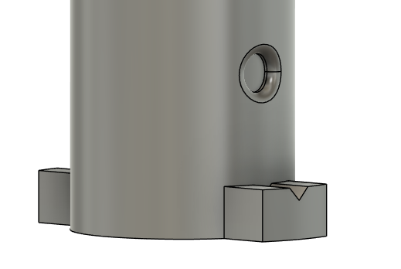

When designing a topper, make sure to include a feature that allows the user to apply enough force when twisting to fully lock the topper in place. The stick topper has the four ‘fins’ because just having the stick itself did not allow the user to lock the topper in place.

# Topper Sizing Printout

|  |  |  |
| --- | --- | --- |
| **Concave Topper** | **Convex Topper** | **Mouldable Topper** |
| A scale image of the concave topper | A scale image of the convex topper | A scale image of the mouldable topper |
| **Stick Topper** | **Template Topper** |  |
| A scale image of the stick topper | A scale image of the template topper |  |
| **Small Goalpost Topper** | **Medium Goalpost Topper** | **Large Goalpost Topper** |
| A scale image of the small goalpost topper | A scale image of the medium goalpost topper | A scale image of the large goalpost topper |