**Title**

Blister Pack Opener

**Subtitle**

The Blister Pack Opener is designed to help users with arthritis or limited hand strength open blister packs of pills.

## Device Details

### Overview

The Blister Pack Opener is designed to help users with arthritis or limited hand strength open blister packs of pills.

### Usage

To use, place the blister pack so the flat side is over the hole, and the pill is facing the pin. Squeeze the handle so that the pill is popped out of the blister pack so that the pill pops out into the pocket in the handle.

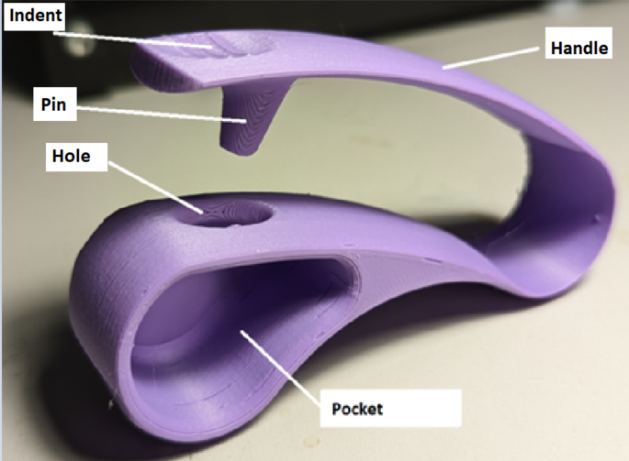

### Cost

<$1

#### Skills Required

* 3D Printing

#### Time Required

* 3D printing time: 2h58min

#### Tools

* 3D Printer

### Attribution

* Design and documentation by Neil Squire Society/Makers Making Change