## Introduction

The Blister Pack Opener is designed to help users with arthritis or limited hand strength open blister packs of pills.

## Features

## Usage

To use, place the blister pack so the flat side is over the hole, and the pill is facing the pin. Squeeze the handle so that the pill is popped out of the blister pack so that the pill pops out into the tube in the handle.

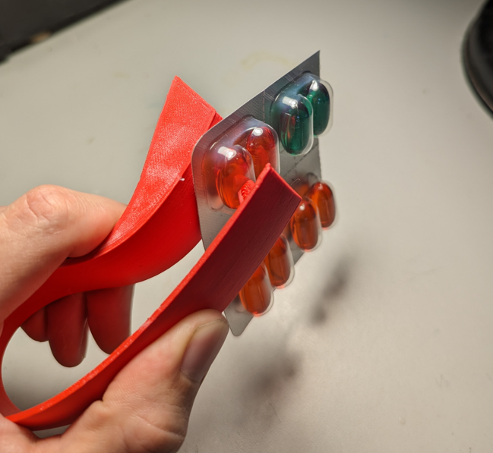

## Compatibility

The device works with any pill that fits in a 20x15mm oval.

## Specifications

Length: 11.5cm

Width: 6cm

Height: 3cm

Weight: 20g

## Cleaning

The device can be wiped clean with a damp cloth.