## Introduction

The Switch Adapted Bubble Toy is an adapted toy that has a 3.5 mm jack. To activate the device, an assistive switch with a 3.5 mm plug can be plugged into the jack on the bubble blower. The Switch Adapted Bubble Blower may be beneficial to someone who may have difficulty pressing the original small activation button due to its size, location, or required activation force.

## Features

Bubble Blower and Bubbles

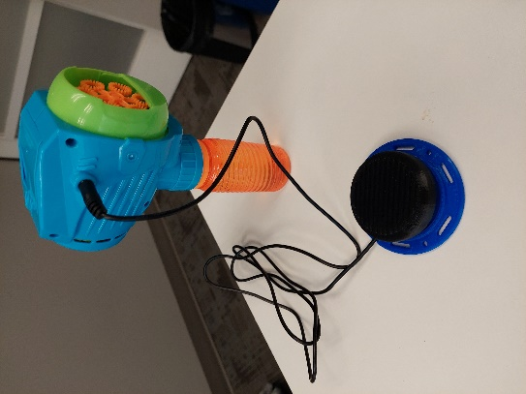

Bubbles

Bubble Blower Fan

3.5 mm Jack

## Usage

Step 1: Attach an assistive switch to the 3.5 mm switch jack.

Step 2: Press switch to activate the bubbles.

## Compatibility

The bubble machine is compatible with assistive switches that use a 3.5 mm cable connection.

## Specifications

|  |  |  |  |
| --- | --- | --- | --- |
| **Length (mm)** | **Height (mm)** | **Width (mm)** | **Mass (g)** |
| 110 mm | 210 mm | 50 mm | 143 g |

## Cleaning

The device can be wiped down with sanitizing cleaners. Do not wash the toy in high heat as it may cause it to melt or break.