# 3D Printing Summary

|  |  |  |
| --- | --- | --- |
| **Metrics** | **Regular Toppers** | **Shorter Y Topper** |
| Total Print Time (min) | 24 | 23 |
| Total Number of Components | 4 | 4 |
| Typical Total Mass (g) | 4 | 4 |
| Typical Number of Print Setups | 1 | 1 |

# 3D Printing Settings

## Regular Toppers

|  |  |  |  |  |  |  |  |
| --- | --- | --- | --- | --- | --- | --- | --- |
| **Print File Name** | **Qty** | **Total Print Time (hr:min)** | **Mass (g)** | **Infill (%)** | **Support (Y/N)** | **Layer Height/ Nozzle Diameter(mm)** | **Notes** |
| Switch button topper - A | 1 | 0:06 | 1 | 20 | Y | 0.2/0.4 |  |
| Switch button topper - B | 1 | 0:06 | 1 | 20 | Y | 0.2/0.4 |  |
| Switch button topper - X | 1 | 0:06 | 1 | 20 | Y | 0.2/0.4 |  |
| Switch button topper - Y | 1 | 0:06 | 1 | 20 | Y | 0.2/0.4 |  |

# Shorter Y Topper

|  |  |  |  |  |  |  |  |
| --- | --- | --- | --- | --- | --- | --- | --- |
| **Print File Name** | **Qty** | **Total Print Time (hr:min)** | **Mass (g)** | **Infill (%)** | **Support (Y/N)** | **Layer Height/ Nozzle Diameter(mm)** | **Notes** |
| Switch button topper - A | 1 | 0:06 | 1 | 20 | Y | 0.2/0.4 |  |
| Switch button topper - B | 1 | 0:06 | 1 | 20 | Y | 0.2/0.4 |  |
| Switch button topper - X | 1 | 0:06 | 1 | 20 | Y | 0.2/0.4 |  |
| Switch button topper – Y - smaller | 1 | 0:05 | 1 | 20 | Y | 0.2/0.4 |  |

|  |  |  |  |  |  |  |  |
| --- | --- | --- | --- | --- | --- | --- | --- |
| **Print File Name** | **Qty** | **Total Print Time (hr:min)** | **Mass (g)** | **Infill (%)** | **Support(Y/N)** | **Layer Height/ Nozzle Diameter(mm)** | **Notes** |
| Switch button topper | 1 | 0:04 | 1 | 20 | Y | 0.2/0.4 |  |

# Customization Options

* The toppers can be printed in any colour.
* There are two options for the Y topper. One matches the size of the rest of the toppers, while the other is slightly shorter so that the Joy-Cons can be attached to the Switch while it is in the dock.
* A STEP file of a blank topper is included so custom toppers can be designed.

# Post-Processing

* Remove all supports
* Use a hobby knife to trim any sharp edges

# Examples of Quality Prints

**Photo of Switch button topper - A**

**Photo of Switch button topper – B**

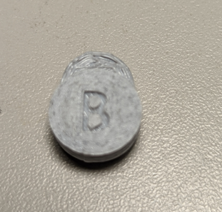

**Photo of Switch button topper – X**

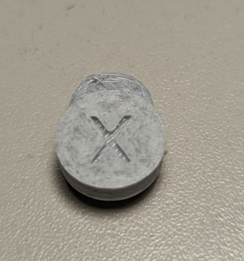

**Photo of Switch button topper – Y**

**Photo of Switch button topper – Y – smaller**

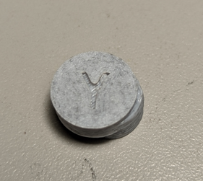

**Photo of Switch button topper**

