## Introduction

Button extenders that make the buttons on a Joy-Con bigger and further apart.

## Features

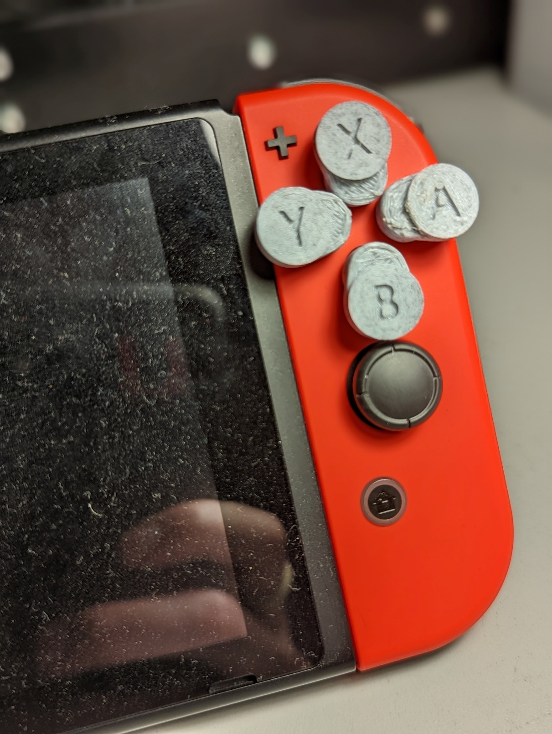

## Usage

To use the button toppers, they need to be glued onto the buttons on the Joy-Con. This is permanent, and risks damaging the Joy-Con buttons if the toppers are removed.

Once attached, the buttons can be used as normal.

## Compatibility

The device is compatible with Nintendo Switch Joy-Con.

## Specifications

Each button weighs <1gram

## Cleaning

The device can be cleaned by wiping with a damp cloth