# 3D Printing Summary

|  |  |
| --- | --- |
| **Metrics** | **Configuration 1** |
| Total Print Time (min) | 884 |
| Total Number of Components | 5 |
| Typical Total Mass (g) | 99 |
| Typical Number of Print Setups | 3 |

# 3D Printing Settings

|  |  |  |  |  |  |  |  |
| --- | --- | --- | --- | --- | --- | --- | --- |
| **Print File Name** | **Qty** | **Total Print Time (hr:min)** | **Mass (g)** | **Infill (%)** | **Support(Y/N)** | **Layer Height/ Nozzle Diameter(mm)** | **Notes (orientation, special settings, etc.)** |
| Handle.stl | 2 | 6:32 | 47 | 20 | Y | 0.2/0.4 | * Requires support * Print in orientation given in STL |
| Knob.stl | 2 | 0:20 | 2 | 20 | N | 0.2/0.4 | * Print in orientation given in STL |
| Pin.stl | 1 | 0:10 | 1 | 20 | N | 0.2/0.4 | * Print in orientation given in STL |

# Customization Options

* The device can be printed in any colour that the user wants

# Post-Processing

* Remove all supports from the handle pieces
* Use a hobby knife and sandpaper to remove any rough edges

# Examples of Quality Prints

**Photos of Handle**

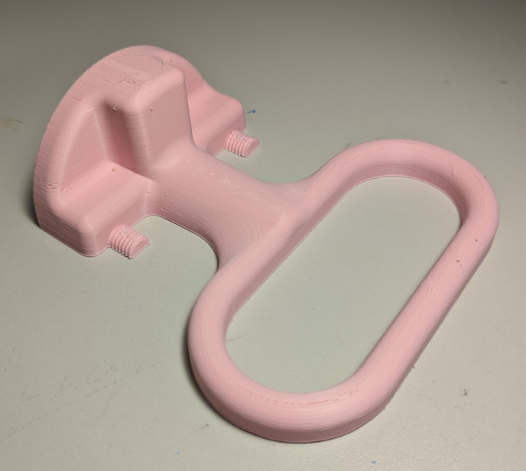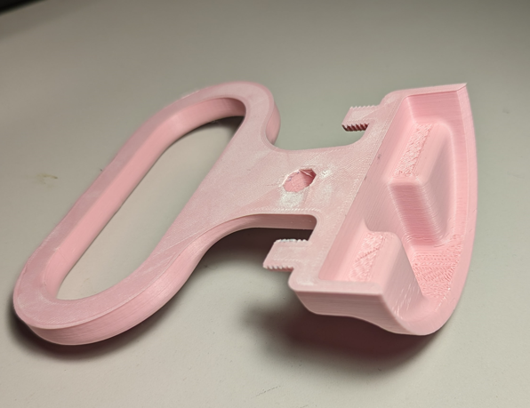

**Photos of Knob**

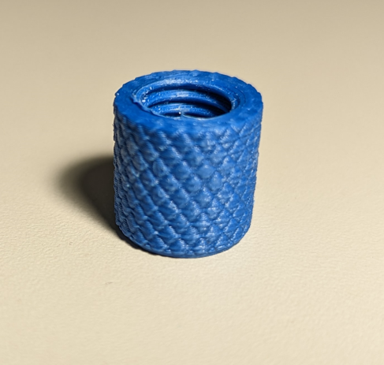

**Photos of Pin**

