## Introduction

Some people with limited grip strength/limited hand function have difficulty opening the gas cap on their vehicle. There are several commercial and DIY options available for opening vehicle gas caps, but most focus on grip strength issues, with limited options available for users with limited hand function.

## Features

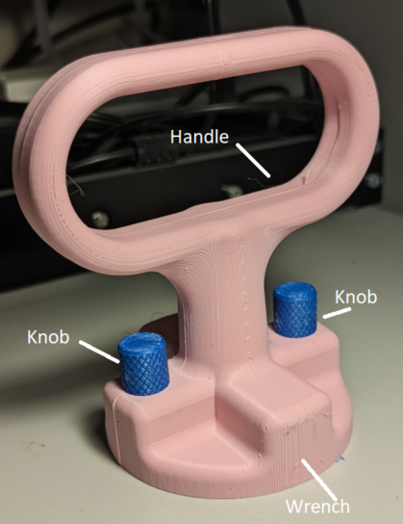

## Usage

To use, place the + shaped end of the gas cap opener over the gas cap on the car. The handle on the opener can then be turned to either tighten or loosen the cap, as normal.

## Compatibility

The gas cap opener is compatible with every gas cap with a handle width of less than 2cm and a length of less than 8cm.

## Specifications

The handle is 5cm by 10cm, the overall device is 12.5cm tall, and has a wrench diameter of 8.5 cm.

The device weighs 70g

## Cleaning

Wipe device clean with damp cloth.