## Introduction

The Grip for Double Joy-Cons is a grip that holds both Joy-Cons in a more comfortable angle than the Joy-Con grip that comes with the Switch.

## Features

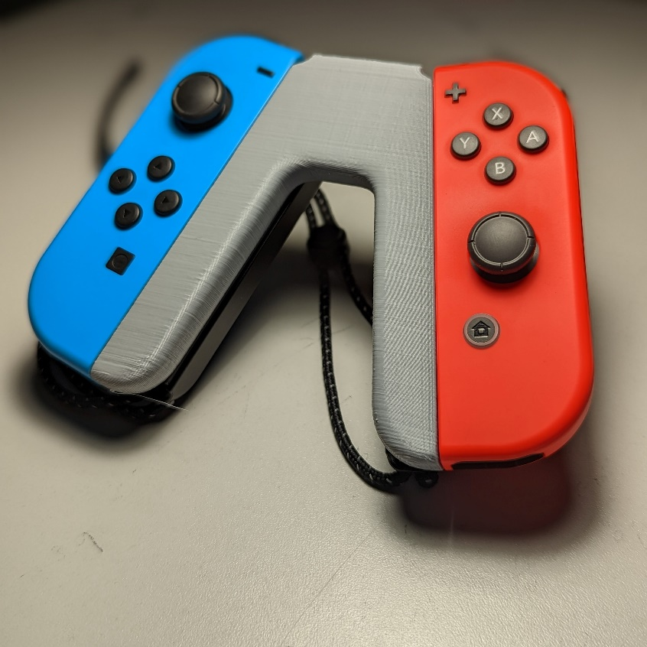

The grip has two rails on the side for attaching Joy-Cons, and two rails on the back to attach bumpers.

## Usage

To use, slide both Joy-Cons into the slots on the side of the 3D printed part.

## Compatibility

This device is compatible with the Nintendo Switch Joy Cons.

## Specifications

The grip weighs 22 grams

## Cleaning

The device can be wiped clean with a damp cloth.