# 3D Printing Summary

|  |  |
| --- | --- |
| **Metrics** | **\*Configuration 1\*** |
| Total Print Time (min) | 16:44 |
| Total Number of Components | 3 |
| Typical Total Mass (g) | 120 |
| Typical Number of Print Setups | 3 |

# 3D Printing Settings

|  |  |  |  |  |  |  |  |
| --- | --- | --- | --- | --- | --- | --- | --- |
| **Print File Name** | **Qty** | **Total Print Time (hr:min)** | **Mass (g)** | **Infill (%)** | **Support(Y/N)** | **Layer Height/ Nozzle Diameter(mm)** | **Notes (orientation, special settings, etc.)** |
| single_joycon_grip_button.stl | 1 | 0:34 | 3 | 20 | Y | 0.2/0.4 | * Requires support * Print in orientation given in STL |
| single_joycon_grip-.stl | 1 | 8:08 | 59 | 20 | Y | 0.2/0.4 | * Requires support * Print in orientation given in STL |
| single_joycon_grip+.stl | 1 | 8:02 | 58 | 20 | Y | 0.2/0.4 | * Requires support * Print in orientation given in STL |

# Customization Options

* The grips and buttons can be printed in any colour.

# Post-Processing

* Remove all supports
* Sand areas where supports were removed to remove roughness

# Examples of Quality Prints

Quality print example of the grip for the left Joy-Con, assembled with buttons


**Photos of single_joycon_grip_button**

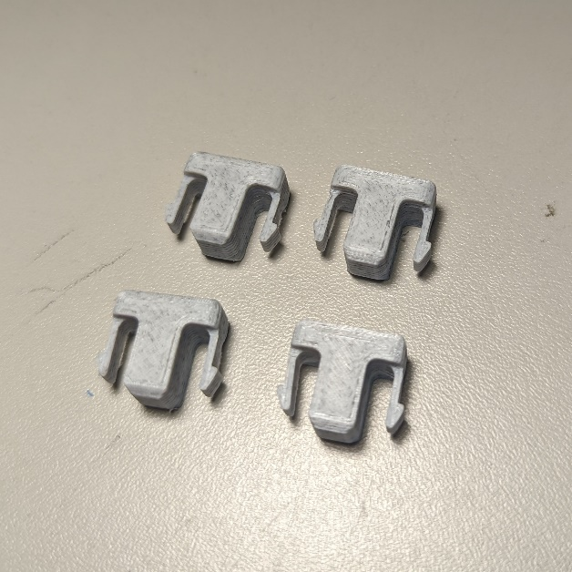

**Photos of single_joycon_grip-**

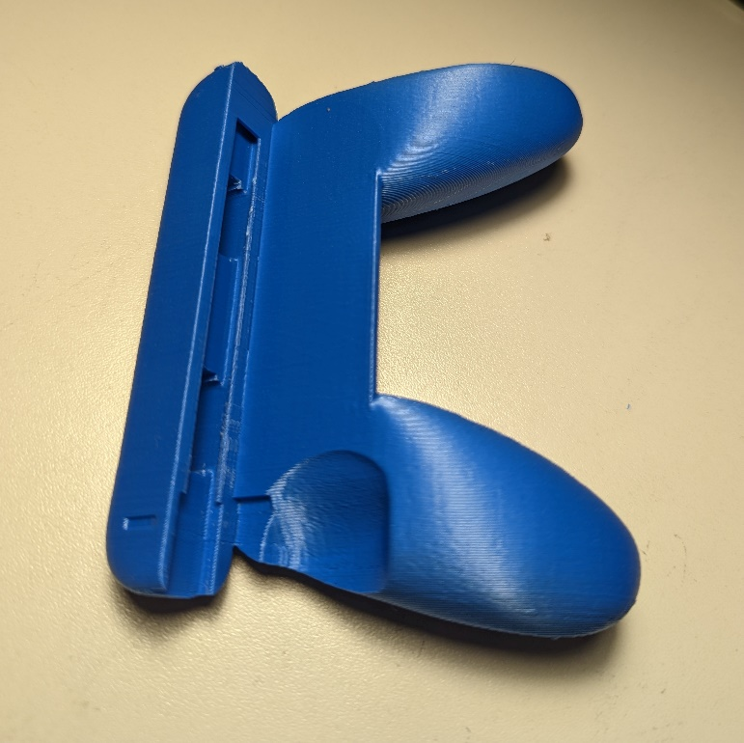

**Photos of single_joycon_grip+**

