## Introduction

The Grips for Joy-Con -Single are aides designed to make it easier to hold and use a Joy-Con Controller in the single Joy-Con Configuration

## Features

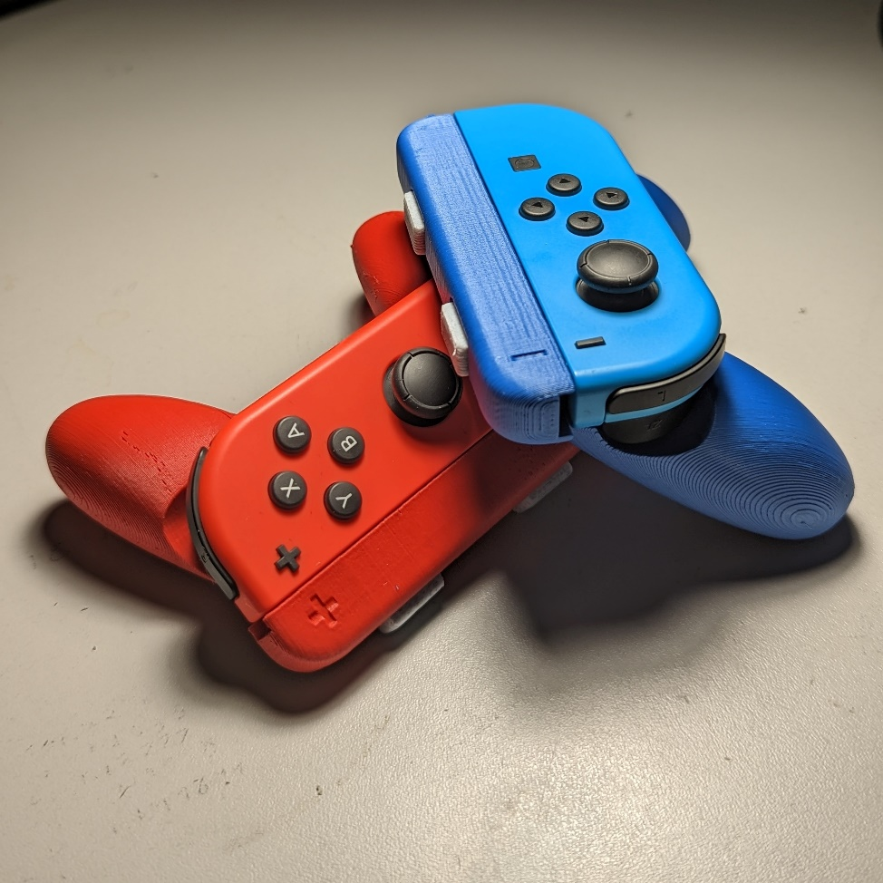

## Usage

Once the device is assembled as per the Assembly Guide, it can be used like a standard game controller.

## Compatibility

This device is designed to work with the official Nintendo Joy-Cons

## Specifications

Each completed grip weighs roughly 36 grams

## Cleaning

The device can be wiped clean with a damp cloth.