# Introduction

This project was originated in consultation with a mouth painter who was looking for a way to independently swap paintbrushes and temporarily but them down to rest. At the time, they were relying on a care aid to initially position the brush so they could grip it in their mouth with their lips and teeth.

# Research

Initial research did not uncover any suitable commercial or pre-existing DIY options. Most commercial options are intended to keep the brush in a vertical position, and do not provide easy access to the handle.

A more recent search did yield a horizontal brush holder (e.g., <https://genevafineart.com/collections/all-items/products/brush-holder>, $120) but this is expensive and would be difficult to mount at the proper height.

# Requirements

## Goals

|  |  |
| --- | --- |
| G01 | Provide a means for user to independently place down and swap between several paintbrushes. |

## Functional Requirements

|  |  |
| --- | --- |
| F01 | The stand must have space for a minimum of 4 brushes. |
| F02 | The stand must be mounted securely. |
| F03 | The stand must be easily repositionable to adjust for height. |
| F04 | The stand must enable user to put down a brush while gripping it with their mouth. |
| F05 | The stand must enable the user to retrieve a brush by gripping it with their mouth. |
| F06 | Brushes must be adequately spaced to provide clearance for ventilator. |

## Non-functional Requirements

|  |  |
| --- | --- |
| NF01 | Design must be maker-friendly. |

## Constraints

|  |  |
| --- | --- |
| C01 | Design must be released open-source. |

# Detailed Design

## Brush Slot Spacing

A spacing of 60 mm between the brushes was found to be a good compromise between keeping the brushes close together and allowing enough room between them so they can be easily grasped without interfering with the ventilator. A painter that doesn't use a ventilator may be able to have the brushes spaced closer together.

## Number of Slots

The user requested to have access to at least 3-4 brushes.

## Slot Size

A semi-circular slot with a radius of 8 mm was chosen to accommodate most paint brush handles.

## Mounting

One of the most important functional requirements is that the brush stand is quick and easy to setup and can be adjusted to the right position. A 1/4"-20 UNC tee insert nut was selected as a cost-effective and maker-friendly method of adding a modular mounting connection point. This connection point can be used with a variety of commercially available camera mounting equipment, including an articulating arm, or “Magic Arm”.

The mounting configuration for the user was chosen based on the availability of magic arms from related projects, as well as the requirement to have a non-permanent connection to the working surface.

* 3D printed C-Clamp Adapter (i.e., <https://makersmakingchange.com/project/c-clamp-threaded-adapter/>)
* Off-the-shelf C-Clamp (e.g., <https://www.homedepot.ca/product/bessey-bessey-2-1-2-inch-900-lb-drop-forged-c-clamp-with-1-3-8-inch-throat-depth/1000816966>)
* Off-the-shelf Articulating Magic Arm (e.g., <https://www.amazon.ca/Koolehaoda-Adjustable-Articulating-Compatible-Microphones/dp/B08PC21P2D>)

# V0.1

The initial prototype of the design had five slots, spaced apart by 22 mm. Each slot was a semi-circular with a diameter of 16 mm. The brush is supported by two 10 mm wide sections separated by 90 mm center-to-center.

Figure : Initial Prototype

Assembly

The T-Nut is pressed into the stand from the top, and then the cap is glued into place.

# V0.2

Based on feedback from the user, the spacing between brushes was increased from 22 mm to 60 mm and the number of slots was reduced from five to four. Instead of two discrete supports the support was made continuous to make it easier to rest the brushes.

This version was also intended to be more aesthetically stylish.

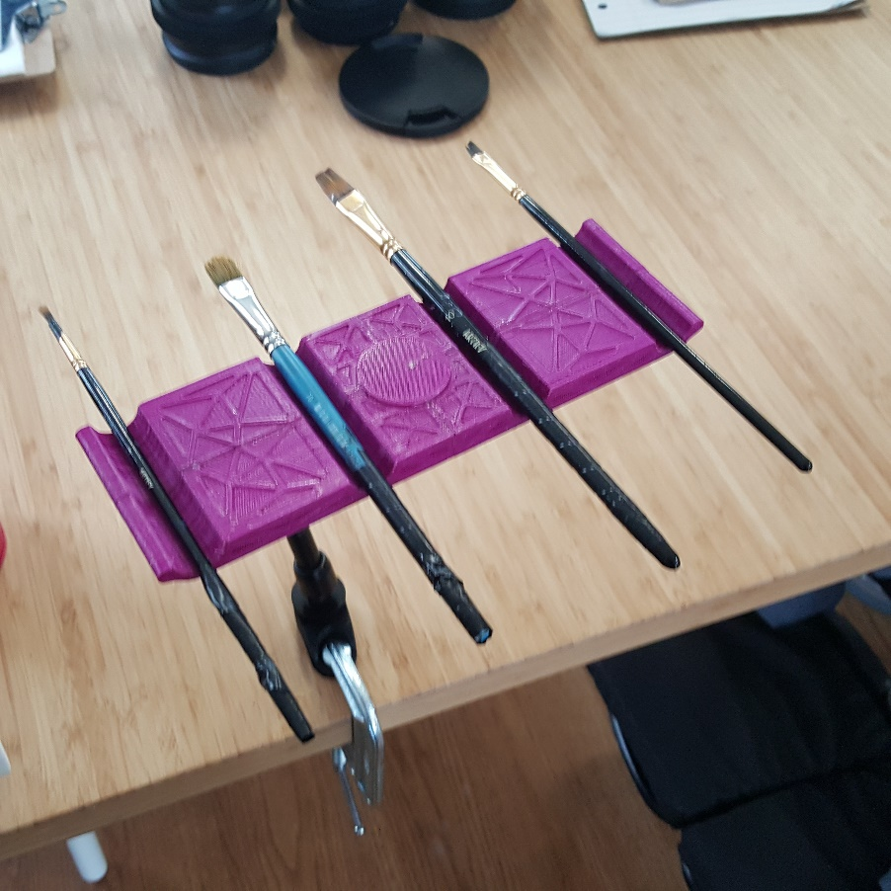

Figure : Version 0.2