# Overview

This document contains the necessary information to build the Horizontal Paintbrush Stand.

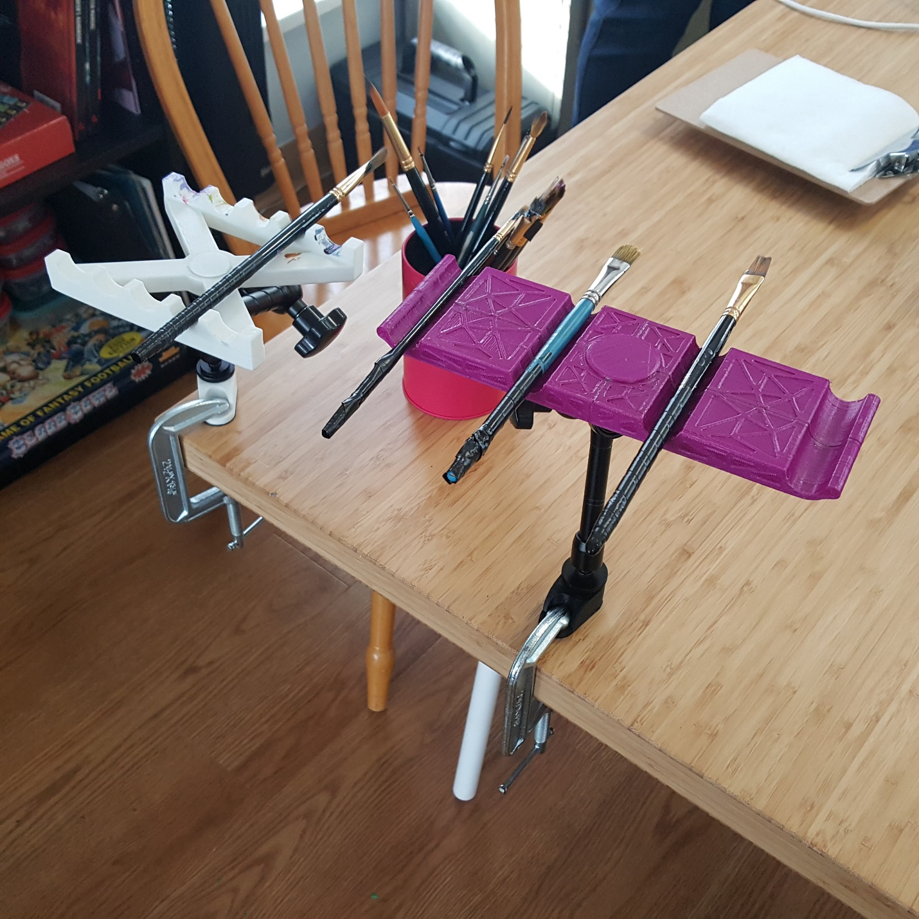

Figure : Horizontal Paintbrush Stands. Variant A on the left, Variant B on the right. Show mounted with a magic arm, a C-Clamp, and a C-Clamp Adapter.

Contents

Overview 1

Maker Checklist 4

Maker To Do List 4

Items to Give to User 4

Customization Guide 5

3D Printing Guide 6

3D Printing Summary 6

3D Printing Settings – Variant A 6

3D Printing Settings – Variant B 6

Post-Processing 6

Assembly Guide – Variant A 7

Required Components 7

Required Personal Protective Equipment (PPE) 7

Assembly Instructions – Variant A 8

Step A.1 8

Step A.2 9

Assembly Guide – Variant B 10

Required Components 10

Required Personal Protective Equipment (PPE) 10

Assembly Instructions – Variant B 11

Step B.1 11

Step B.2 11

Step B.3 12

Step B.4 13

Quality Check 14

Mounting Options 15

Magic Arm + C-Clamp 15

Materials Required 15

Instructions 15

Loc-Line + C-Clamp 16

Materials Required 16

Instructions 17

# Maker Checklist

This list provides an overview of the steps required to build and deliver the device to a user.

## Maker To Do List

* Read through the Maker Guide to become familiar with required components, tools, supplies, and safety gear and overall assembly steps.
* Talk to User about customization options
  + Variant A or B
  + Color
  + Number of brush slots
  + Brush slot spacing
  + Mounting Options
* Update Design if necessary
* Provide requestor with estimated cost of material and shipping.
* Order hardware components
* 3D Print components
* Gather tools, supplies, and safety equipment.
* Assemble the device
* Quality check the device
* Print “User Guide”

## Items to Give to User

* Assembled, tested brush stand
* “User Guide”

# Customization Guide

# 3D Printing Guide

## 3D Printing Summary

|  |  |  |
| --- | --- | --- |
| **Metrics** | **Variant A** | **Variant B** |
| Total Print Time (min) | 3h14m | 9h45m |
| Total Number of Components | 2 | 12 |
| Typical Total Mass (g) | 42 | 85 |
| Typical Number of Print Setups | 1 | 1 |

## 3D Printing Settings – Variant A

|  |  |  |  |  |  |  |  |
| --- | --- | --- | --- | --- | --- | --- | --- |
| **Print File Name** | **Qty** | **Total Print Time (hr:min)** | **Mass (g)** | **Infill (%)** | **Support(Y/N)** | **Layer Height/ Nozzle Diameter(mm)** | **Notes (orientation, special settings, etc.)** |
| _A_Base.stl | 1 | 3h12m | 42 | 20 | N | 0.2/0.4 |  |
| _A_Cap.st | 1 | 0h3m | 1 | 20 | N | 0.2/0.4 |  |

## 3D Printing Settings – Variant B

|  |  |  |  |  |  |  |  |
| --- | --- | --- | --- | --- | --- | --- | --- |
| **Print File Name** | **Qty** | **Total Print Time (hr:min)** | **Mass (g)** | **Infill (%)** | **Support(Y/N)** | **Layer Height/ Nozzle Diameter(mm)** | **Notes (orientation, special settings, etc.)** |
| _B_Base1.stl | 2 | 4h25m | 39 | 20 | N | 0.2/0.4 |  |
| _B_Base2.stl | 2 | 4h25m | 39 | 20 | N | 0.2/0.4 |  |
| _B_Nut_Insert.stl | 1 | 0h35m | 6 | 20 | N | 0.2/0.4 |  |
| _B_Cap.stl | 1 | 0h9m | 2 | 20 | N | 0.2/0.4 |  |
| _B_Pin.stl | 6 | 0h9m | 2 | 20 | N | 0.2/0.4 | Better to print separate |

## Post-Processing

* Remove any burrs. May be painted if desired.

# Assembly Guide – Variant A

## Required Components

|  |
| --- |
|  |
| **BOM**   1. 3D Printed Base A 2. 3D Printed Cap A 3. ¼”-20 UNC Tee Nut Insert, 5/16” long |

## Required Personal Protective Equipment (PPE)

* n/a

## Assembly Instructions – Variant A

### Step A.1

Insert the Tee Nut into the top of the Base. Use a ¼”-20 Washer and bolt to tighten and secure the Tee Nut into the Base. Nut Holder.

|  |
| --- |
|  |
|  |

### Step A.2

Add the Cap to cover the Tee Nut.

|  |
| --- |
|  |
|  |

# Assembly Guide – Variant B

## Required Components

|  |
| --- |
|  |
| **BOM**   1. 2X Base B.1 2. 2X Base B.2 3. 1X Nut Insert 4. 1X Cap B 5. 6X Pins 6. 1X Tee Nut 7. Superglue |

## Required Personal Protective Equipment (PPE)

* Eye protection (Superglue)
* Protective Gloves (Superglue)

## Assembly Instructions – Variant B

### Step B.1

Using 4 pins for alignment, use superglue to attach the sides of the bases together.

|  |
| --- |
|  |
|  |

### Step B.2

Insert and glue the 2 remaining pins with the nut insert to secure the two halves.

|  |
| --- |
|  |
|  |

### Step B.3

Insert the Tee Nut from the top. Use a ¼”-20 Washer and bolt to tighten and secure the Tee Nut into the Nut Holder.

|  |
| --- |
|  |
|  |

### Step B.4

Add the Cap to cover the Tee Nut.

|  |
| --- |
|  |
|  |

# Quality Check

1. Ensure the Tee Nut is installed correctly.
2. Check to make sure there are no sharp edges on the stand.

# Mounting Options

There Horizontal Brush Stand has a ¼”-20 UNC female thread on the bottom, so it is compatible with a variety of commercial and DIY mounting options.

## Magic Arm + C-Clamp

The Magic Arm / Articulating Arm provides a convenient way to adjust the position and orientation of the stand and can be locked in place with a single knob. Using the C-Clamp and C-Clamp Adapter is a cost-effect way of providing a sturdy, non-permanent connection to a table or other work surface. The size of the C-clamp can be chosen to accommodate different table thicknesses.

### Materials Required

Magic Arm

* <https://www.amazon.ca/Koolehaoda-Adjustable-Articulating-Compatible-Microphones/dp/B08PC21P2D>

C-Clamp

* <https://www.homedepot.ca/product/bessey-2-1-2-inch-drop-forged-c-clamp-with-1-3-8-inch-throat-depth/1000816966>

C-Clamp Adapter

* <https://makersmakingchange.com/project/c-clamp-threaded-adapter/>

### Instructions

1. Remove any unneeded hardware from the Magic Arm until just the male thread is left on both side.
2. Connect one side of the Magic Arm to the Paintbrush Stand. A locking washer or thread locker can be used to form a more reliable connection.
3. Connect the other end of the Magic Arm to the C-Clamp Adapter. A locking washer or thread locker can be used to form a more reliable connection.
4. Position the C-Clamp Adapter in an appropriate place on the work surface and use the C-clamp to clamp it in place. To provide better grip or protect the surface, a thin piece of rubber or DYCEM non-slip mat can be used.

## Loc-Line + C-Clamp

### Materials Required

1/2” Loc-Line Modular Hose (Enough segments to achieve desired length)

* <https://www.bulkreefsupply.com/loc-line-modular-hose-segments.html> (CAN)
* <https://www.amazon.ca/Loc-Line-Coolant-Component-Copolymer-Segment/dp/B006R9ORIY> (CAN)
* <https://www.modularhose.com/> (USA)

1/2” Loc-Line Double Socket (SKU 90614)

* <https://www.bulkreefsupply.com/loc-line-double-socket.html>, SKU 202755 (CAN)
* <https://www.modularhose.com/Loc-Line-90614> (USA)

1/2” Loc-Line Flat Surface/Fixed Mount

* <https://www.amazon.ca/Loc-Line-Coolant-Component-Acetal-Copolymer/dp/B006T5JOV6> (CAN)
* <https://www.modularhose.com/Loc-Line-51895?quantity=1&custcol_item_colors=8>, SKU 51895-Blk (USA)

½” Loc-Line Modular Hose Assembly Pliers (Optional)

* <https://www.modularhose.com/Loc-Line-60533?quantity=1&custcol_item_colors=8> (USA)1/2” Loc-Line Hose Assembly Pliers (Optional)
* <https://www.amazon.ca/Loc-Line-78004-Hose-Assembly-Pliers/dp/B0025PUF1M> (CAN)

¼”-20 UNC SHCS x

C-Clamp

* <https://www.homedepot.ca/product/bessey-2-1-2-inch-drop-forged-c-clamp-with-1-3-8-inch-throat-depth/1000816966>

C-Clamp Camera Mount Adapter

* <https://makersmakingchange.com/project/c-clamp-threaded-adapter/>

### Instructions

1. Attach the ½” Loc-Line Flat Surface/Fixed Mount to the bottom of the Horizontal Brush Stand using a ¼”-20 UNC screw and a ¼” lock washer.
2. Attach the ½” Loc-Line Double Socket to the ½” Loc-Line Flat Surface / Fixed Mount.
3. Attach the other ½” Loc-Line Flat Surface/Fixed Mount to a C-Clamp Camera Mount Adapter using a ¼”-20 UNC screw and a ¼” lock washer.
4. Determine how many ½”