## Introduction

The Horizontal Paintbrush Stand has a series of spaced horizontal slots to allow several paintbrushes to be rested and swapped between. The stand has a female 1/4"-20 UNC connection on the bottom so the stand can be mounted and adjustably positioned using commercially available camera mounting equipment.

## Features

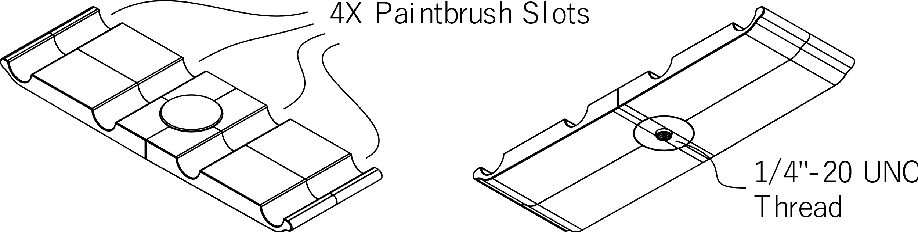

## Usage

Connect a compatible mounting solution to the threaded portion on the bottom of the stand and position it appropriately.

## Compatibility

This stand is compatible with a variety of commercial and DIY mounting systems that use a ¼”-20 thread, such as camera tripod mounts. For example, a magic arm and a 3d printed C-Clamp Adapter make an easily adjustable solution that can mount to a table.

## Specifications

* 208 mm Long x 65 mm Wide x 21 mm Deep
* 4 Brush Slots; 60 mm Spacing
* ¼”-20 UNC Mounting

## Cleaning

The stand can be wiped down with a damp cloth. Do not subject to high temperatures such as a dishwasher.