# 3D Printing Summary

|  |  |
| --- | --- |
| **Metrics** |  |
| Total Print Time (hr:min) | 7:17 |
| Total Number of Components | 2 |
| Typical Total Mass (g) | 51 |
| Typical Number of Print Setups | 2 |

# 3D Printing Settings

|  |  |  |  |  |  |  |  |
| --- | --- | --- | --- | --- | --- | --- | --- |
| **Print File Name** | **Qty** | **Total Print Time (hr:min)** | **Mass (g)** | **Infill (%)** | **Support**  **(Y/N)** | **Layer Height/ Nozzle Diameter(mm)** | **Notes (orientation, special settings, etc.)** |
| Mouthpiece_Holder_v1.stl | 1 | 6:49 | 47 | 20 | Y | 0.2/0.4 | * Print in orientation given in STL |
| Magnet_Cover_for_  Mouthstick_Holder_v1 | 1 | 0:28 | 4 | 20 | N | 0.2/0.4 | * Print in orientation given in STL |

# Customization Options

* The device can be printed in any colour the user would like

# Post-Processing

* Remove all supports
* Remove sharp edges with a hobby knife and sandpaper

# Examples of Quality Prints

**Photos of Mouthpiece_Holder_v1**

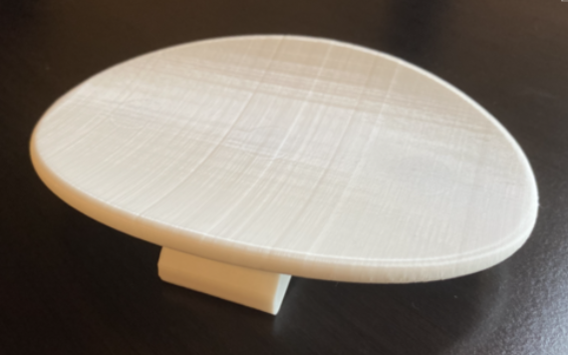

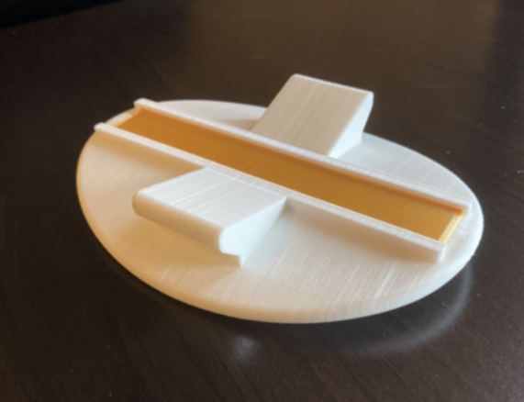

**Photos of Magnet_Cover_for_Mouthstick_Holder_v1**

