## Introduction

This magnetic tool holder is designed to allow someone to place a mouthstick (or another tool) on the holder and then retrieve it whenever they need it again.

## Features

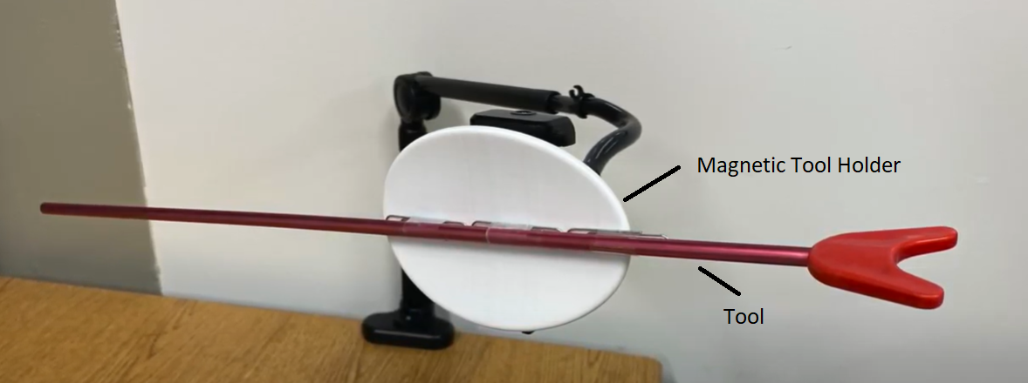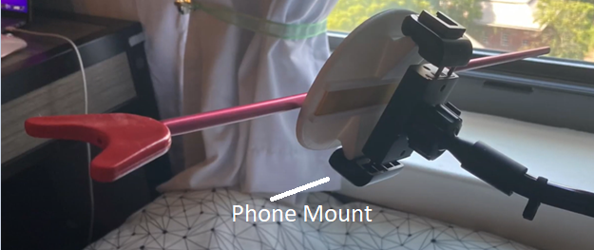

## Usage

To use, insert three neodymium magnets in the slots on the back of the tool holder and cover them with the magnet cover. Insert the tool holder in a phone mount. At this point, any magnetic item under the weight of a pair of scissors can be placed against the holder and have it stay in place.

Paperclips or other small magnetic items can be attached to non-magnetic items to the holder.

## Compatibility

This toolholder will hold any magnetic item under the weight of a pair of scissors, and is mounted on a standard phone holder.

## Cleaning

The device can be wiped clean with a damp cloth.