## Introduction

The Milk Carton Opener is an aid for people with limited grip strength to make it easier to open screwcap lids such as those found on aseptic carton packages like Tetra Pak® milk and juice cartons. The flat side of the aid is intended for larger caps aid has two sides for opening

## Features

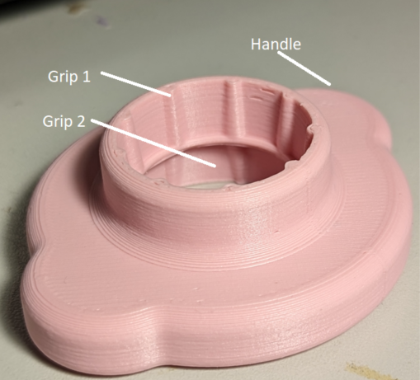

## Usage

To use the device, place the hole in the device over the lid of the carton. Each side of the device has a different sized lid, so if it does not fit in one side, try the other. This will provide a larger grip for the user on the lid of the carton so less grip force is required to open the lid.

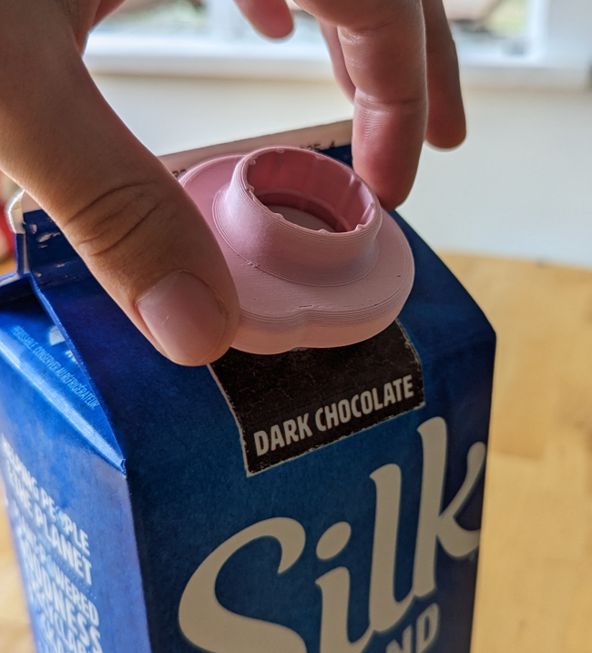

## Compatibility

This device is compatible with two sizes of cardboard tetra pack lids.

## Specifications

Size: 55x65x20mm

Weight: 11g

## Cleaning

The device can be wiped clean with a damp cloth.

## Care

Do not expose the service to high heat (e.g., dishwasher)