## Introduction

## The Multi Row Playing Cards Holder is an assistive device for holding playing cards. This fully 3D-printed device aims to assist those with limited hand dexterity by giving them an alternate means of holding their playing cards. Users can place their cards into the tabletop holder which will discreetly display their cards during gameplay.

## Features

This device has 4 rows of slots for holding playing card and on the back side is a handle to carry it from.

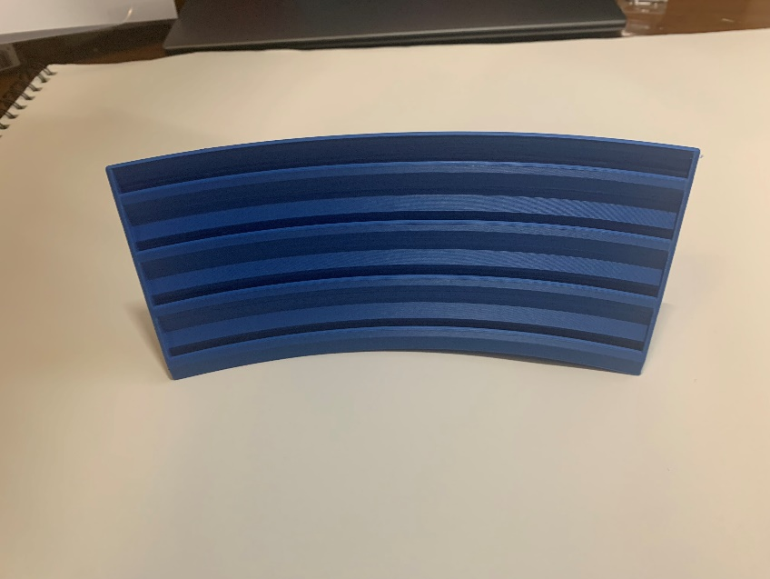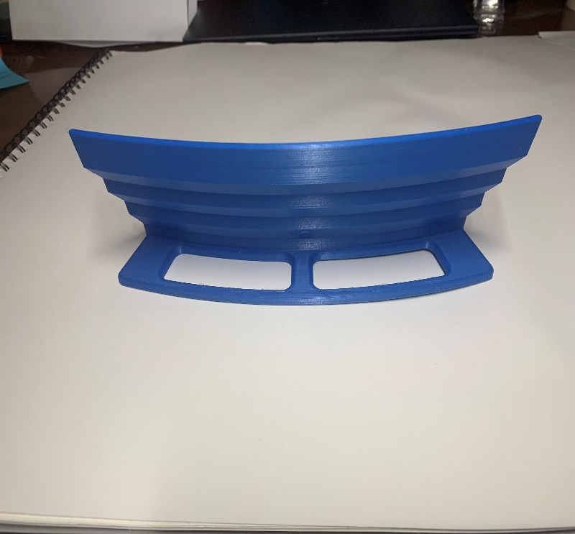

## Usage

Place the Playing Cards Holder on a flat surface and face it away from other players. Cards can then be place among the four rows to be displayed during game play.

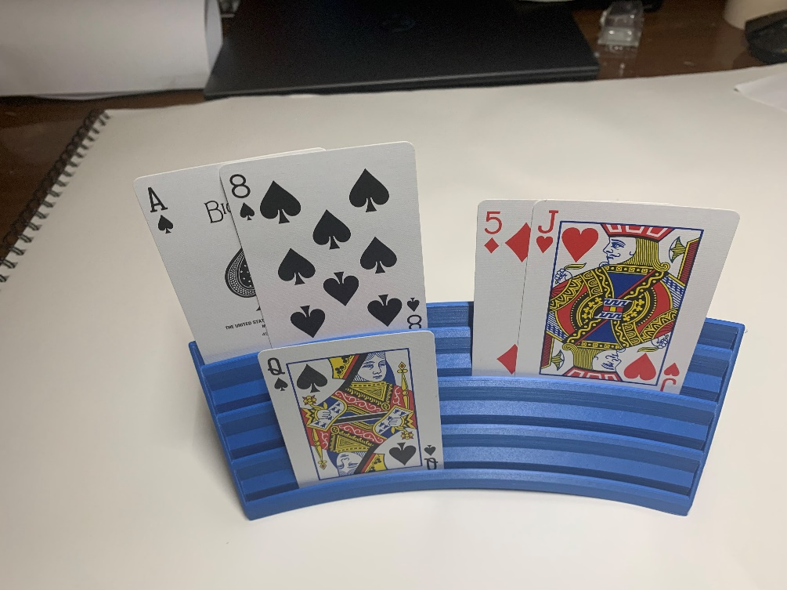

## Compatibility

This cards holder is intended to be used with standard sized playing cards. Larger cards can be used but will decrease the maximum number of cards that can be displayed.

## Specifications

|  |  |  |  |  |  |  |
| --- | --- | --- | --- | --- | --- | --- |
| **Dimensions (mm)** | | | | | | **Mass (g)** |
| Height | Base Width | Card Slot Length | Card Slot Width | Handle Length | Handle  Width |
| 75 | 40 | 200 | 2 | 150 | 23 | 64 |

## Cleaning

The Playing Cards Holder can be wiped down with sanitizing cleaners or gently scrubbed with a soft-bristled brush and mild soapy water. Do not subject the device to high heat as this may damage the 3D-printed material.