## Introduction

## The Single Row Playing Cards Holder is an assistive device for holding playing cards. This fully 3D-printed device aims to assist those with limited hand dexterity by giving them an alternate means of holding their playing cards. Users can place their cards into the tabletop holder which will discreetly display their cards during gameplay.

## Features

This device has a long narrow slot to hold a variety of playing cards. Its wide base design makes this holder resistant to tipping over.

The front view of a green 3D printed single row playing cards holder. 
The side view of a green 3D printed single row playing cards holder. 


## Usage

Place the device on a flat surface and face it away from other players. Cards can then be place in the holding slot to be displayed during game play.

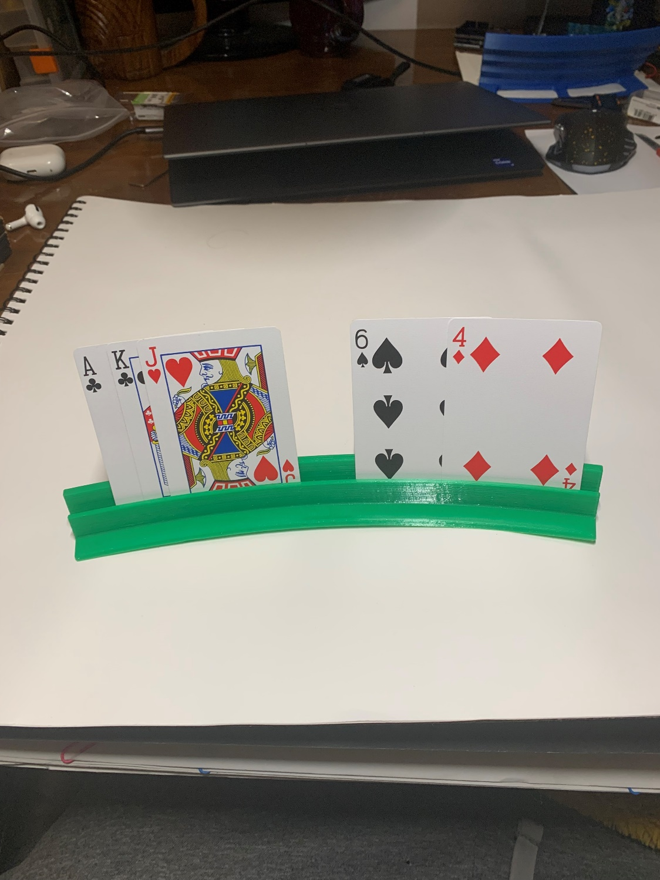

## Compatibility

This cards holder is intended to be used with standard sized playing cards. Larger cards can be used but will decrease the maximum number of cards that can be held.

## Specifications

|  |  |  |  |  |
| --- | --- | --- | --- | --- |
| **Dimensions [mm]** | | | | **Mass [g]** |
| Height | Length | Base Width | Slot Width |
| 22 | 250 | 27 | 2.5 | 35 |

## Cleaning

The Playing Cards Holder can be wiped down with sanitizing cleaners or gently scrubbed with a soft-bristled brush and mild soapy water. Do not submerge or subject the device to high heat as this may damage the 3D-printed material.