# 3D Printing Summary

|  |  |
| --- | --- |
| **Metrics** |  |
| Total Print Time (min) | 308 |
| Total Number of Components | 4 |
| Typical Total Mass (g) | 33 |
| Typical Number of Print Setups | 4 |

# 3D Printing Settings

|  |  |  |  |  |  |  |  |
| --- | --- | --- | --- | --- | --- | --- | --- |
| **Print File Name** | **Qty** | **Total Print Time (hr:min)** | **Mass (g)** | **Infill (%)** | **Support(Y/N)** | **Layer Height/ Nozzle Diameter(mm)** | **Notes (orientation, special settings, etc.)** |
| Grip Handle.stl | 1 | 3:44 | 26 | 20 | Y | 0.2/0.4 | * Requires support * Print in orientation given in STL |
| Grip Insert.stl | 1 | 0:15 | 2 | 20 | N | 0.2/0.4 | * Print in orientation given in STL |
| insert.stl | 1 | 0:27 | 2 | 20 | Y | 0.2/0.4 | * Requires support * Print in orientation given in STL |
| spoon attachment.stl | 1 | 0:32 | 3 | 20 | Y | 0.2/0.4 | * Requires support * Print in orientation given in STL |

# Customization Options

* The device can be printed in any colour the user would like.

# Post-Processing

* Remove support material
* Remove any sharp edges using a hobby knife or sandpaper

# Examples of Quality Prints

**Photos of Grip Handle.stl**

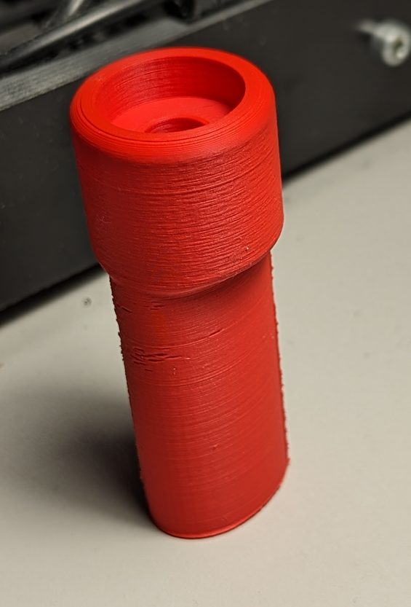

**Photos of Grip Insert.stl**

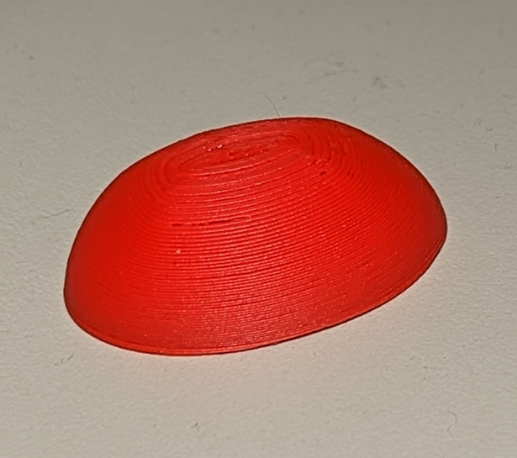

**Photos of insert.stl**

**Photos of spoon attachment.stl**

