## Introduction

A device for those who have difficulties with tremors when eating. It uses both passive stabilization and weights to dampen the effect of hand tremors.

## Features

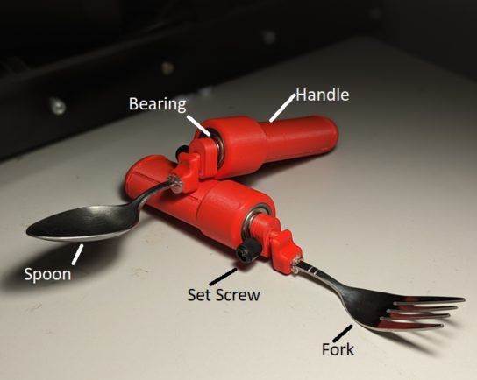

## Usage

Attach either the spoon or fork attachment to the handle using the set screw. The device can then be used as a normal spoon or fork.

## Compatibility

The device is compatible with any spoon or fork that has a cross section of 9x2.5mm or less.

## Specifications

Handle has a length of 90mm, and a diameter of 30mm. The entire device has a weight of 60 g.

## Cleaning

The device can be wiped clean with a damp cloth. The section with the fork/spoon can be detached for easier cleaning.