# Introduction

The Switch Adapted Whale Bubble Blower is an adapted “Balnore Bubble Machine” that can be activated with a 3.5mm switch. This adaptation is intended for users who have difficulty activating the button on the side of the bubble machine.

# Research

## Existing Commercial Options

|  |  |
| --- | --- |
| Title | Bubble Machine Adapted Reward |
| Link | <https://specialneedstoys.com/can/bubble-machine-reward.html?gclid=EAIaIQobChMI5e-txMqI_AIVQsqUCR2HBAfTEAQYASABEgJoc_D_BwE> |
| Vendor | TFH Special Needs Toys |
| Cost | $99.37 |
| Notes | Different option for a switch adapted bubble blower. |

|  |  |
| --- | --- |
| Title | Switch Adapted Toy Bubble Machine |
| Link | <https://www.amazon.ca/Switch-Adapted-Machine-Adaptive-Special/dp/B086VW7FCB> |
| Vendor | Amazon |
| Cost | $122.08 |
| Notes | Different option for a switch adapted bubble blower. |

## DIY Designs

|  |  |
| --- | --- |
| Title | How to Switch Adapt a Bubble Machine for my Special Needs Daughter |
| Link | <https://www.youtube.com/watch?v=7yFP0-Qda6c> |
| Author | ParentXP |
| License | Not stated |
| Cost | £17.00 ($28.11 CAD) |
| Notes | Bubble blower shown and pricing from the UK |

# Requirements

## Goals

|  |  |
| --- | --- |
| G01 | Make a Balnore Bubble Blower more accessible by adapting it to be used with an assistive switch. |

## Functional Requirements

|  |  |
| --- | --- |
| F01 | The toy can be operated with a 3.5mm assistive switch. |

## Non-functional Requirement

|  |  |
| --- | --- |
| NF01 | The toy is easy to adapt so that others can do it themselves with our assembly manual. |

## Constraints

|  |  |
| --- | --- |
| C01 | Cost less than $50 so it is less expensive than commercially available options. |

# Ideation

This bubble blower was chosen because bubble blowers are popular toys for people of all ages and abilities. This bubble blower is also smaller than other options currently available on our website making it cheaper and easier to ship to users.

# Detailed Design

The below photo shows all connections for the 3.5mm mono jack. On the left (circled with a dashed blue line) is the connection between the mono jack and the white wire, which has been wrapped with electrical tape and is being supported with a screw driver to make it more visible. On the left (circled by a solid black line) is the connection of the mono jack to the battery pack. Also on the left (surrounded by a solid black square) is the mono jack with soldered connections, and the hole for the mono jack drilled in the case of the toy.

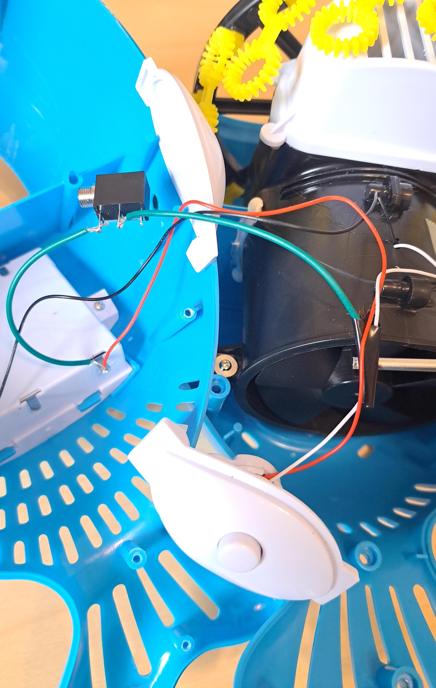

The photo below shows the reassembled toy and an assistive switch. The 3.5mm mono jack can be seen above the white fin of the whale. The original switch is on the other fin of the whale. The end cost of the adaptation is less than $30.

