**Title**

Switch Adapted Whale Bubble Blower

**Subtitle**

A switch adapted whale shaped bubble blower that blows bubbles when an assistive switch is held.

## Device Specifications

Build Time:

 < 1hr

1-4 hr

 5-10hr

 >10hr

Cost:

 $0 - $10

 $11 - $25

 $26 - $50

 $51 - $100

 $101 - $250

 $250+

Stage: Recently Added

Skills: Soldering

Need: Agility/Dexterity

Disability: Mobility/Physical

Difficulty: Beginner

License: Attribution -ShareAlike 4.0 International

Usages: Recreation and Leisure

Type: Adapted Toy

Designer: Stephan Dobri – Makers Making Change

## Device Details

### Overview

The Switch Adapted Whale Bubble Blower is an adapted “Balnore Bubble Machine” that can be activated with a 3.5mm switch. This adaptation is intended for users who have difficulty activating the button on the side of the bubble machine.

### Usage

Pour bubble solution into the whale’s mouth. Plug an assistive switch into the 3.5mm mono jack on the side of the toy (circled in blue). Activate the toy by pressing the switch. When the toy is activated the bubble wands will spin and produce bubbles. If using a latching switch, one press will turn the toy on and another press will turn the toy off. If using a non-latching switch, the toy will be on while the switch is being held.

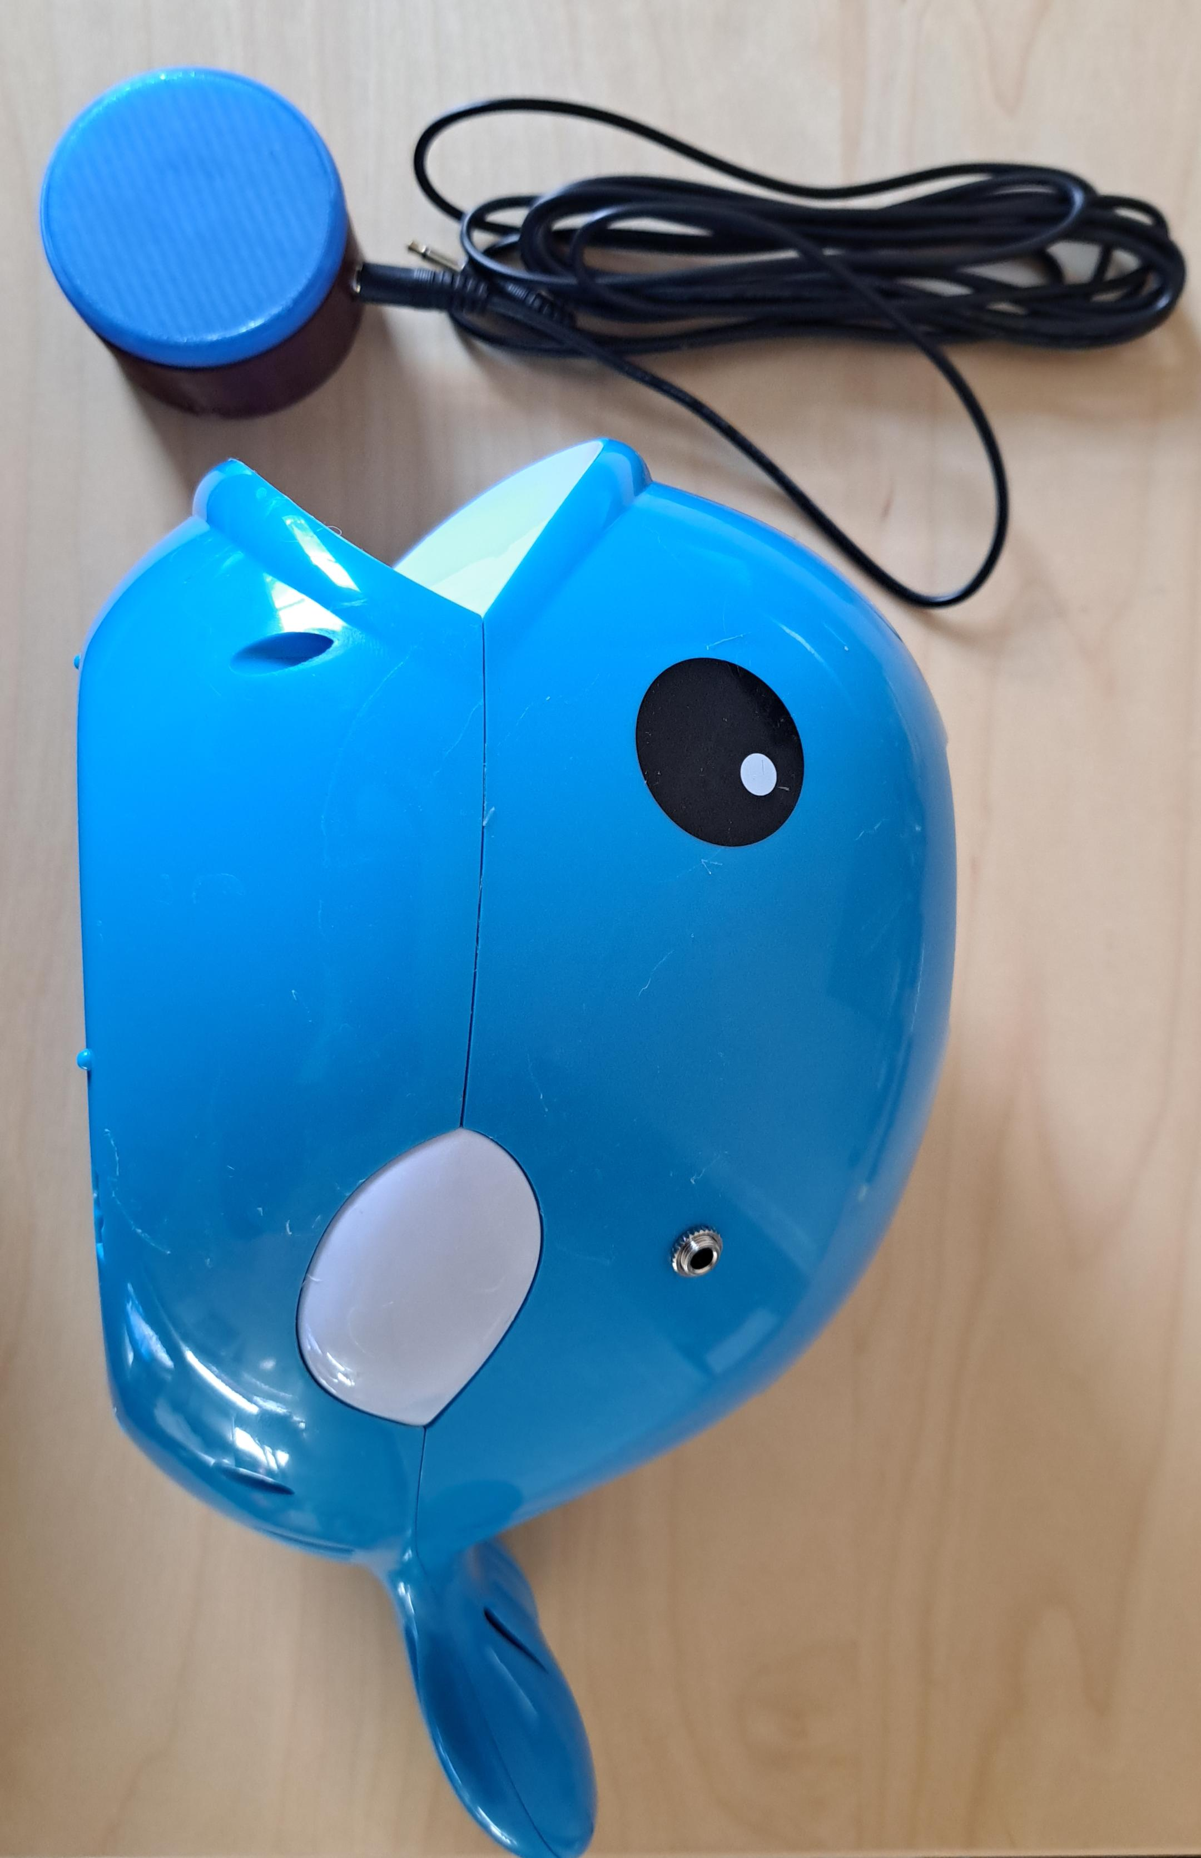

### Cost

The total cost for this switch adapted toy is around $28 CAD (excluding taxes and shipping). A more detailed cost breakdown is available in the Bill of Materials (BOM).

### Build Instructions

The necessary files required to switch adapt the toy are available on the linked GitHub repository. The build consists of a commercially available bubble blower and some electronic components. Refer to the file WhaleBubbleBlower_Maker_Guide.

#### Skills Required

* **Soldering**

#### Time Required

Assembly: <1 hour

#### Tools

* Drill and ¼” drill bit
* Soldering iron
* Solder
* Phillips screwdriver (included with the bubble blower)
* Wire cutters
* Wire strippers
* Ruler

#### Components

* **1x** [**Balnore Bubble Machine**](https://www.amazon.ca/Balnore-Machine-Automatic-Parties-Wedding/dp/B07MW21SJ6/ref=asc_df_B07MW21SJ6/?tag=googleshopc0c-20&linkCode=df0&hvadid=335949156370&hvpos=&hvnetw=g&hvrand=9779940604494029162&hvpone=&hvptwo=&hvqmt=&hvdev=c&hvdvcmdl=&hvlocint=&hvlocphy=9000711&hvtargid=pla-648235496051&psc=1)
* **1x** [**3.5mm mono jack**](https://www.digikey.ca/en/products/detail/switchcraft-inc/35RAPC2AV/772080)
* **22 AWG wire**

### Attribution

Toy adapted by Stephan Dobri – Makers Making Change

Documentation by Neil Squire / Makers Making Change