## Introduction

This Switch Adapted Whale Bubble Blower (“Balnore Bubble Machine”) is compatible with a 3.5mm assistive switch. This device may be beneficial to anyone who enjoys bubbles, or for teaching cause and effect with assistive switches.

## Usage

Pour bubble solution into the whale’s mouth. Plug an assistive switch into the 3.5mm mono jack on the side of the toy (circled in blue). Activate the toy by pressing the switch. When the toy is activated the bubble wands will spin and produce bubbles. If using a latching switch, one press will turn the toy on and another press will turn the toy off. If using a non-latching switch, the toy will be on while the switch is being held.

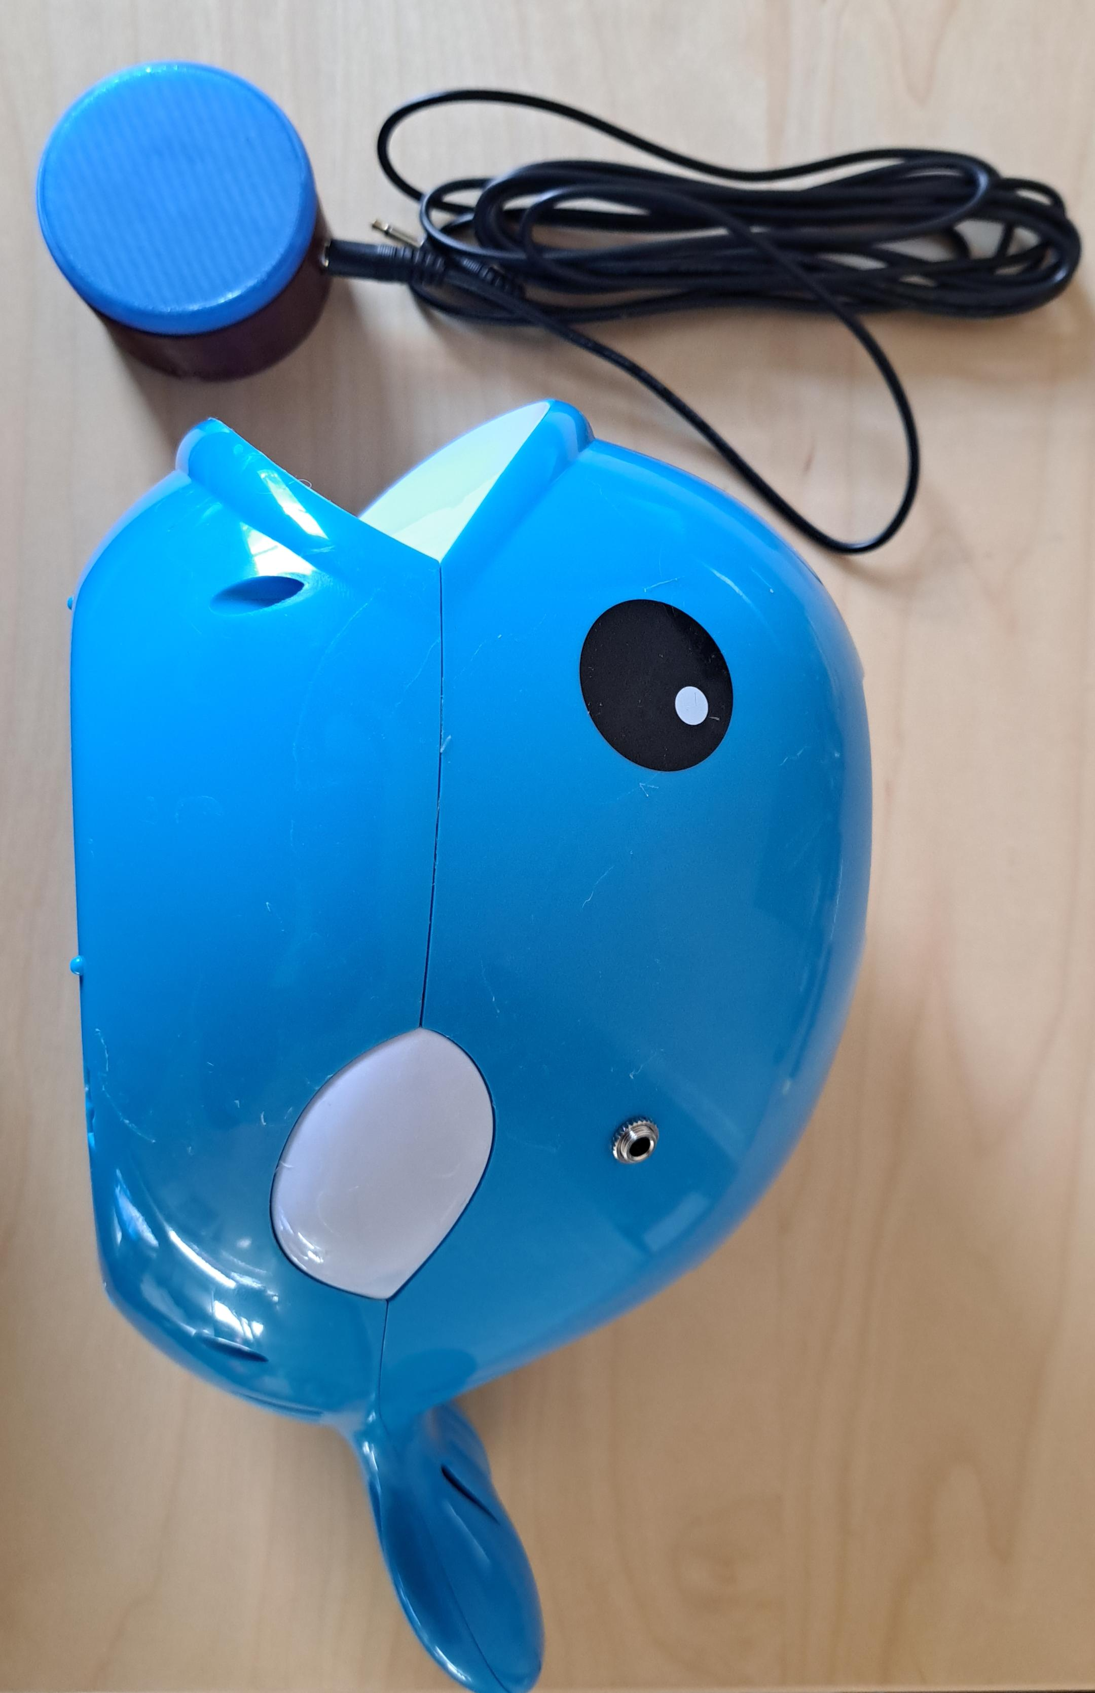

## Compatibility

This toy has been adapted to be operated with an assistive switch with a 3.5mm plug.

## Cleaning

After using the device, pour out any remaining bubble solution and rinse out the mouth of the whale (where the bubble solution sits). The body of the whale can be wiped down with any standard cleaning product that does not dissolve plastic. Do not get liquid inside the mono jack on the side of the whale.