# Introduction

Tactile maps are often used to teach people with visual impairments how to navigate their surroundings. These maps can represent specific indoor and outdoor locations, or represent general information, such as a type of road intersection. Orientation and Mobility (OM) specialists often use tactile maps with their clients, but diagraming tools they use are not given to clients to take home and learn from. We wanted to create general maps of different road intersections that OM specialists could use with clients to teach how to navigate various generic intersections.

The tactile maps are intended for users with visual impairments. The maps could be used independently by people with visual impairments to study different types of intersections and can be used by OM specialists with clients.

It is important to note these maps are not designed to be an independent navigational tool. They are intended to help teach common features of different types of road intersections to help users with visual impairment learn to recognize different intersections. Relying on the maps for navigation could cause potential harm to users, such as getting lost or misidentifying an intersection.

# Research

|  |  |
| --- | --- |
| Title | Touch Mapper |
| Link | <https://touch-mapper.org/en/> |
| Author | Samuli Pahaoja |
| License | Not stated, but open source |
| Cost | Cost of material, or starting at $29 USD for a printed map |
| Test Build (Y/N) | Y |
| Add to Library (Y/N) | N |
| Notes | Only outdoor maps are supported currently. Scale of maps are customizable, and maps can be printed in multiple parts. Maps do not include Braille labels or space for labels. |

|  |  |
| --- | --- |
| Title | Tactile Map Automated Production (TMAP) |
| Link | <https://lighthouse-sf.org/tmap/> |
| Author | Lighthouse for the Blind and Visually Impaired |
| License | Not listed |
| Cost | $26.25 USD for printed map, cost of materials if building own. |
| Test Build (Y/N) | N |
| Add to Library (Y/N) | N |
| Notes | Maps include Braille labels and legend. Maps designed to be embossed or printed on swell paper, not 3D printed. |

|  |  |
| --- | --- |
| Title | Picture Maker Wheatley Tactile Diagramming Kit |
| Link | <https://www.aph.org/product/picture-maker-wheatley-tactile-diagramming-kit/> |
| Author | Picture Maker |
| License | Not stated |
| Cost | $183 USD |
| Notes | Can quickly create tactile maps using pieces that attach to a felt background. Comes with various pieces that are simple shapes and high contrast colours. |

# Requirements

## Goals

|  |  |
| --- | --- |
| G01 | Create tactile maps of generic intersections (roundabouts, 4-way-stops, T-intersections, offset intersections, pedestrian crossings, and large intersections with corner islands) |
| G02 | Create representations of traffic signs/signals and common landmarks (bus stops, mailboxes) |
| G03 | Help users learn to navigate different intersections |

## Functional Requirements

|  |  |
| --- | --- |
| F01 | Features must be large enough and have enough space around them to be easily identified and differentiated through touch |
| F02 | Maps must be durable |
| F03 | Maps must accurately represent their respective intersections |
| F04 | Maps must include a legend to identify features such as traffic signs/signals |
| F05 | Maps should be simple to print in high contrast colours for users with partial sight |

## Non-functional Requirement

|  |  |
| --- | --- |
| NF01 | Maps must be easy to clean |
| NF02 | Maps must be easy to transport |

## Constraints

|  |  |
| --- | --- |
| C01 | Maps cannot contain too much information as they can become cluttered and difficult to interpret by touch |
| C02 | Maps must be low-cost |

# Ideation

First concepts involved working from maps built through Touch Mapper, or through adapting Touch Mapper to suit the needs of the users. This idea was abandoned as it required a strong background in Python coding to adapt Touch Mapper, and converting STLs to modifiable models was computationally expensive. Creating the maps entirely was deemed to be both faster and a more suitable option for meeting the requestor’s needs.

# Conceptual Design

## Concept 1: Individual Maps

Initially, maps were designed to be individual pieces representing a specific intersection. These maps were designed to teach users common features of each intersection type.

## Concept 2: Connectable Maps

The second concept was to make maps which could be connected to build out routes between places. These would allow users to plan how they could move from one place to another by identifying the number and types of intersections they would need to pass through.

It is important to note that the maps should be considered a rough guide only and should not be used alone for route planning and navigation. Misidentifying the type and number of intersections on a route could cause a user to get lost or potentially come in harms way from crossing an intersection incorrectly.

# Prototyping

The first two prototypes were created to test the size of maps, height of the features, colour contrast, and the inclusion of Braille labels on the map. The larger map was 17x17x0.6 cm, and the smaller map was 8.5x8.5x0.32 cm. The maps also included Braille labels identifying the type of intersection they represented. There were not tabs used to connect the maps together as they were different sizes. The two prototypes are shown below:

|  |
| --- |
|  |

# Testing

The two prototype maps were sent to Orientation and Mobility specialists at Vision Loss Rehab in Burnaby, British Columbia. The users preferred the size of the larger map and the height of the features on that map. They also did not like having the Braille label in the middle of the map, as they felt users could have trouble differentiating the Braille labels from a feature on the map. The users also preferred the maps printed with white on black to the maps printed black on white. The subsequent maps were created at the size of the larger map, and Braille labels were removed from the maps themselves.

The clearance required for the pieces that insert into the maps, and the Braille labels for the legends were also tested. A clearance of 0.2 mm on each dimension, and dog boning of the holes with a 2 mm cutting tool diameter were found to be sufficient for a tight fit that was still easily removable.

# Detailed Design

All the maps use the same parameters, which can be found in the Fusion 360 file: TactileMapsParameters. The parameters are pulled from this file into all the others, so if someone wants to update the same parameter in all maps, they can update the TactileMapsParameters file only. The parameters are listed in the table below for users who do not have Fusion 360. Many of the parameters are built off others, such as the sidewalkWidth being one third of the length of the model.

|  |  |  |
| --- | --- | --- |
| Parameter Name | Value (mm) | Description |
| baseHeight | 0.4 | Height of the base of the model |
| clearance | 0.2 | Clearance around parts that will fit together |
| dogbone | 2 | Cutter diameter for creating dogbone corners. |
| featureHeight | 1.6 | Height of features such as bus stops |
| length | 170 | Side lengths of base of model |
| lineHeight | 0.3 | Height of crosswalk lines |
| lineWidth | 3 | Width of crosswalk lines |
| orientorHeight | 2.4 | Height of the orientation indicator |
| orientorSize | 6 | Side length of orientation indicator square |
| pegDepth | sidewalkHeight/4 | Depth of pegs/holes to connect features to map base |
| pegSize | 6 | Side length of pegs/holes to connect features to map base |
| sidewalkHeight | 3.2 | Height of sidewalk/walking surface |
| sidewalkWidth | length/3 | Width of the sidewalk/walking surface |
| tabHeight | sidewalkHeight/4 | Height of tabs to secure adjacent maps together |
| tabLength | length/14 | Length of tab to secure adjacent maps together |
| tabWidth | length/10 | Width of tabs to secure adjacent maps together |

All the tactile maps have the road surface as the lowest surface, with any features raised above that. Painted pedestrian crossing lines are the second lowest feature and are raised to be felt by the user. Sidewalks and curbs are the third lowest feature, with curb cuts represented as gradual height increases and curbs as sudden changes in height (as they are in the real world). The features that can be slotted into the cut-outs on the sidewalks are the second highest level, allowing users to feel where and what a traffic sign may be. The highest feature on the map is a square in the top-right corner. This is used to orient the map and can represent North-East if planning a route. There are also tabs and cut-outs on the maps to connect and align them if they are being used together for route planning. All features are shown in the figures below.

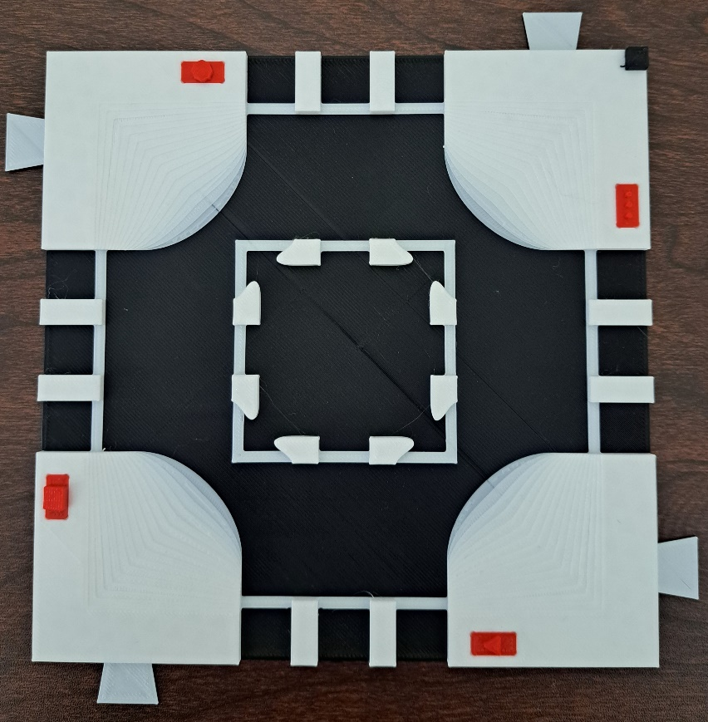

The tabs on the sides of the maps are used to connect maps together. One of the tabs (top left) is circled in red. There are red pieces representing a stop sign, stop light, yield sign, and mailbox added to the map. The stop sign piece is surrounded by a red square. These pieces can be interchanged among maps and positions on the maps. The orientation square in the top right is surrounded by a red triangle.

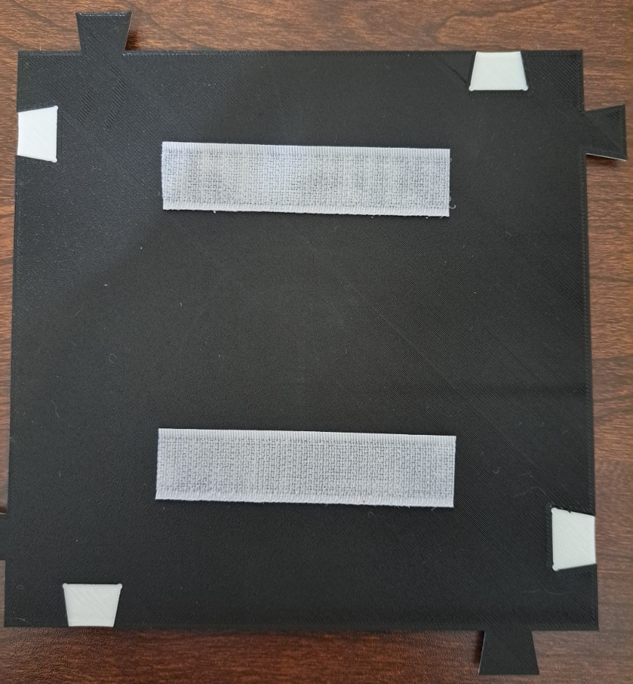

The bottom of the map shows the corresponding cut-outs for the tabs on the sides. The tabs fit into the cut-outs to prevent the maps from shifting while users run their fingers over them. The cut-out on the top left has been circled in red. There is also hook and loop tape attached to the bottom of the map to allow it to be mounted to another surface. The hook side of the tape has been connected to the map.

There is also a legend with Braille labels to help users identify different features such as traffic signs/signals.

From top to bottom the symbols represent a stop sign, a yield sign, a mailbox, a bus stop, a bike lane, a stop light, rail tracks, and a pedestrian crossing. The labels read: “stop”, “yield”, “mailbox”, “bus stop”, “bike lane”, “stop light”, “rail crossing”, and “pedestrian crossing”.

# Opportunities for Improvement

* Improving alignment/connection design
  + Current tabs can break easily
  + Current tabs could connect maps more securely
  + Could use bowtie shaped pieces to hold the maps together
* Including method to create custom maps for individual users (with Orientation and Mobility specialist consultation)
* Including space for 3D printed Braille labels for each map
* Create standard text tactile legend