**Title**

Tactile Maps

**Subtitle**

3D printed Tactile Maps for people with visual impairments. The general maps represent different intersections and common road signs.

## Device Specifications

Build Time:

 < 1hr

1-4 hr

 5-10hr

 >10hr

Cost:

 $0 - $10

 $11 - $25

 $26 - $50

 $51 - $100

 $101 - $250

 $250+

Stage:

* Recently added

Skills:

* 3D printing

Need:

* Orientation and mobility

Disability:

* Visual impairment

Difficulty:

* Easy

License:

* Attribution – ShareAlike 4.0 International

Usages:

* Orientation and mobility

Type:

* Assistive device

Designer:

* Stephan Dobri – Makers Making Change

## Device Details

### Overview

The Tactile Maps are designed to help users with visual impairments learn to navigate different types of intersections with various traffic signs and signals. Maps can be used separately as a learning tool for specific intersections and traffic signs and signals, or can be connected together to plan routes between locations.

The legend includes Braille labels for the different representations of traffic signs and signals.

### Usage

Use the map on a surface where it will not slide around as the user runs their hands over the map. If the map has hook and loop tape, the maps can be attached to any surface the hook side will attach to, including carpet or tactile map diagramming kit backboards. Insert the desired traffic sign/signal pieces into the spaces on the tactile maps being used. The pieces should fit snuggly into the cut-outs on the tops of the maps and not get knocked out when running your hand over the features. They should still be easy to remove and change different pieces.

There is a raised square in the top-right corner of the map to help users orient to the direction of the maps. For example, this corner could represent North-East.

A user will run their hands over the maps to feel the different road features, including crosswalk lines, sidewalks/pavement, and traffic signs/signals.

|  |
| --- |
| A user running their hand across the bottom of a tactile map representing a roundabout. The map has been attached to a carpet using hook and loop tape. |

If they are unsure what a feature represents, they can consult the legend if they read Braille. If they do not read Braille, the different signs and signals are shown below.

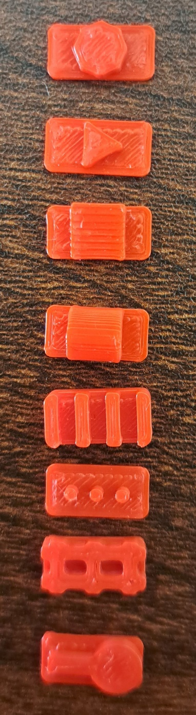

3D printed features that represent from left to right: Stop signs, yield signs, mailboxes, bus stops, bike lanes, stop signs, railroad tracks, and pedestrian crossings.

Maps can also be connected to represent a route between places in a city. For example, if someone had to walk through an offset intersection then to a pedestrian crossing, the two maps could be connected as shown below.

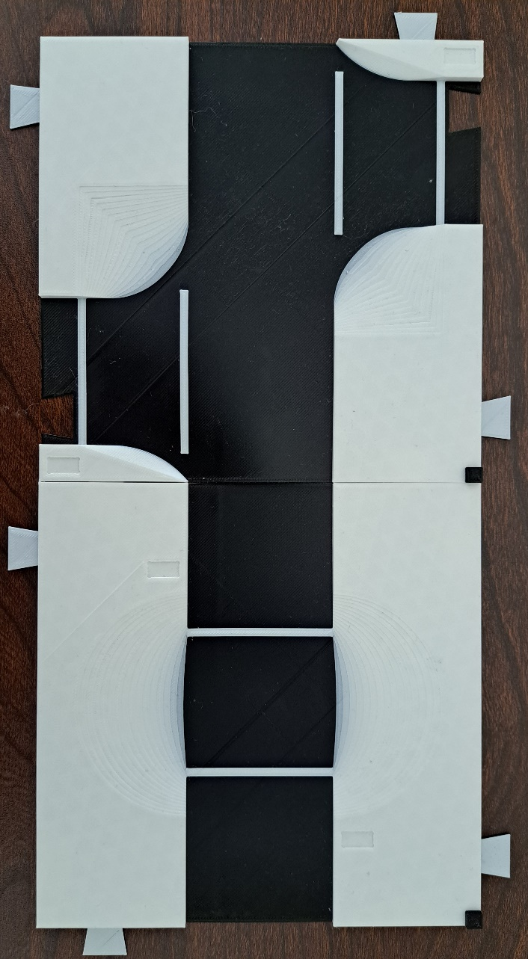

### Cost

Printing all six tactile maps, the legend, Braille labels, and feature pieces, and adding hook and loop tape to each map and the legend costs $13.00. If a user does not want hook and loop tape, or a different combination of maps and features the cost will change.

### Build Instructions

This build consists solely of 3D printing.

#### Skills Required

**3D printing**

#### Time Required

The total time to print all six maps, the legend, Braille labels, and feature pieces is 35 hours and 20 minutes. There is a detailed breakdown of how long each piece takes to print in the Bill of Materials (BOM), and Maker Guide.

Assembling the legend will take under five minutes.

#### Tools

**Scissors (optional)**

**Super glue (optional)**

#### Components

**Hook and loop tape (optional)**

#### 3D Printing

* Tactile maps legend
* Four way stop map
* Large intersection map
* Offset intersection map
* Pedestrian crossing map
* Roundabout map
* T-intersection map
* Bike lane piece
* Bike lane label
* Bus stop piece
* Bus stop label
* Mailbox piece
* Mailbox label
* Pedestrian crossing piece
* Pedestrian crossing label
* Rail crossing piece
* Rail crossing label
* Stop light piece
* Stop light label
* Stop sign piece
* Stop sign label
* Yield sign piece
* Yield sign label

### Design

### Attribution

This design was requested by employees of Vision Loss Rehab in British Columbia.

Original design by: Stephan Dobri – Makers Making Change under an Attribution – ShareAlike 4.0 International license.

The orientation indicator was based on the indicator used by [Touch Mapper](https://touch-mapper.org/en/).