## Introduction

These are 3D printed Tactile Maps for people with visual impairments. The general maps represent different intersections and common road signs and landmarks. The maps can be used to learn how to navigate different intersections and plan routes between places.

It is important to note these maps are not designed to be an independent navigational tool. They are intended to help teach common features of different types of road intersections to help users with visual impairment learn to recognize different intersections. Relying on the maps for navigation could cause potential harm to users, such as getting lost or misidentifying an intersection.

## Features

All the tactile maps have the road surface as the lowest surface, with any features raised above that. Painted pedestrian crossing lines are the second lowest feature and are raised to be felt by the user. Sidewalks and curbs are the third lowest feature, with curb cuts represented as gradual height increases and curbs as sudden changes in height (as they are in the real world). The features that can be slotted into the cut-outs on the sidewalks are the second highest level, allowing users to feel where and what a traffic sign may be. The highest feature on the map is a square in the top-right corner. This is used to orient the map and can represent North-East if planning a route. There are also tabs and cut-outs on the maps to connect and align them if they are being used together for route planning. All features are shown in the figures below.

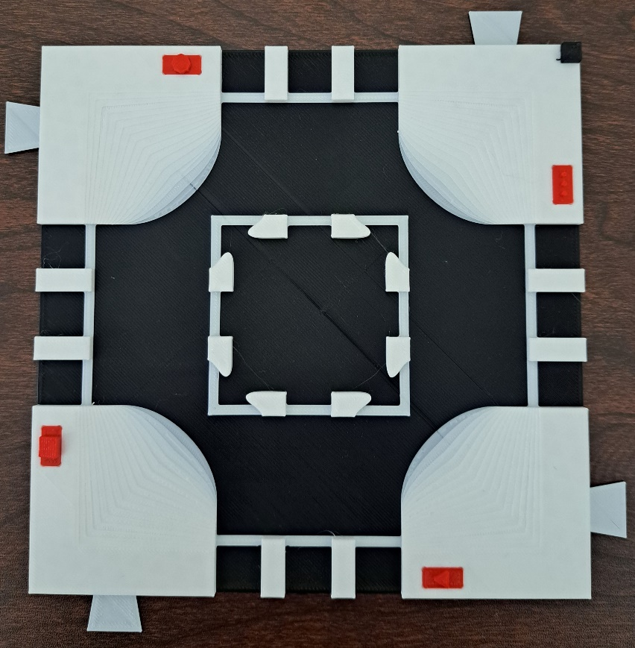

The tabs on the sides of the maps are used to connect maps together. One of the tabs (top left) is circled in red. There are red pieces representing a stop sign, stop light, yield sign, and mailbox added to the map. The stop sign piece is surrounded by a red square. These pieces can be interchanged among maps and positions on the maps. The orientation square in the top right is surrounded by a red triangle.

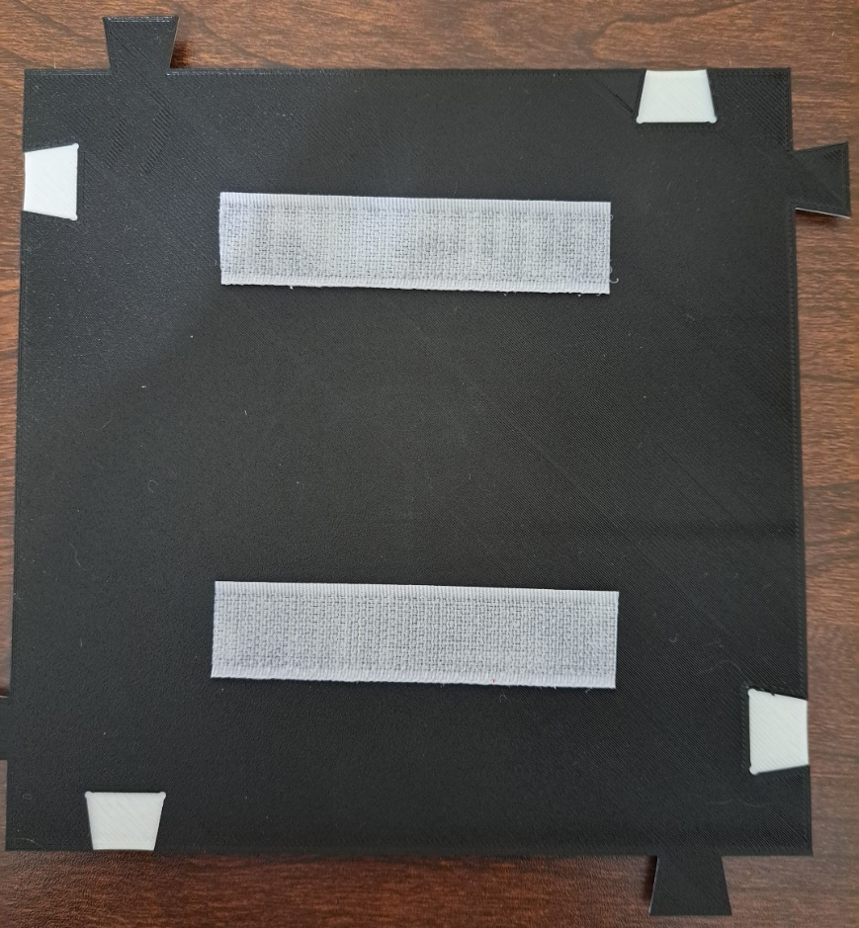

The bottom of the map shows the corresponding cut-outs for the tabs on the sides. The tabs fit into the cut-outs to prevent the maps from shifting while users run their fingers over them. The cut-out on the top left has been circled in red.

There is also a legend with Braille labels to help users identify different features such as traffic signs/signals.

## The legend and labels for the tactile maps. The Braille labels have been printed in red, the background in black, and the features in white.

From top to bottom the symbols represent a stop sign, a yield sign, a mailbox, a bus stop, a bike lane, a stop light, rail tracks, and a pedestrian crossing. The labels read: “stop”, “yield”, “mailbox”, “bus stop”, “bike lane”, “stop light”, “rail crossing”, and “pedestrian crossing”.

## Usage

Use the map on a surface where it will not slide around as the user runs their hands over the map. If the map has hook and loop tape, the maps can be attached to any surface the hook side will attach to, including carpet or tactile map diagramming kit backboards. Insert the desired traffic sign/signal pieces into the spaces on the tactile maps being used. The pieces should fit snuggly into the cut-outs on the tops of the maps and not get knocked out when running your hand over the features. They should still be easy to remove and change different pieces.

There is a raised square in the top-right corner of the map to help users orient to the direction of the maps. For example, this corner could represent North-East.

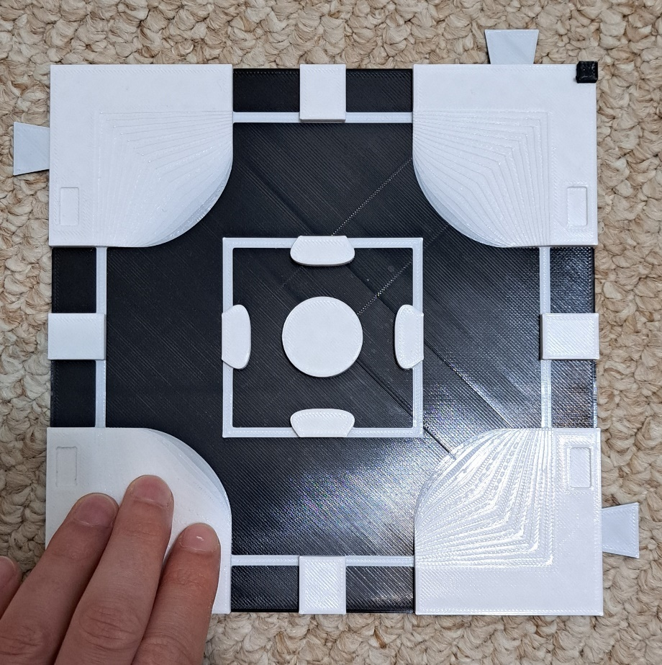

A user will run their hands over the maps to feel the different road features, including crosswalk lines, sidewalks/pavement, and traffic signs/signals. If they are unsure what a feature represents, they can consult the legend if they read Braille. If they do not read Braille, the different signs and signals are shown below.

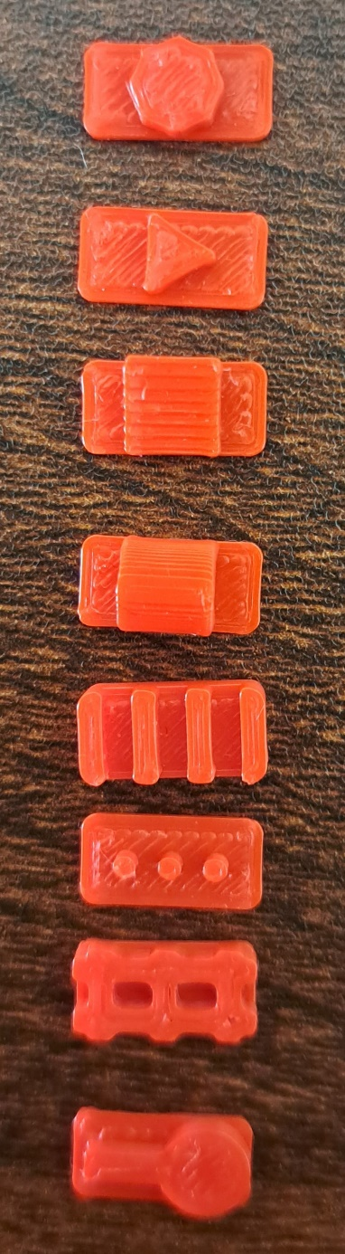

3D printed features that represent from left to right: Stop signs, yield signs, mailboxes, bus stops, bike lanes, stop signs, railroad tracks, and pedestrian crossings.

Maps can also be connected to represent a route between places in a city. For example, if someone had to walk through an offset intersection then to a pedestrian crossing, the two maps could be connected as shown below.

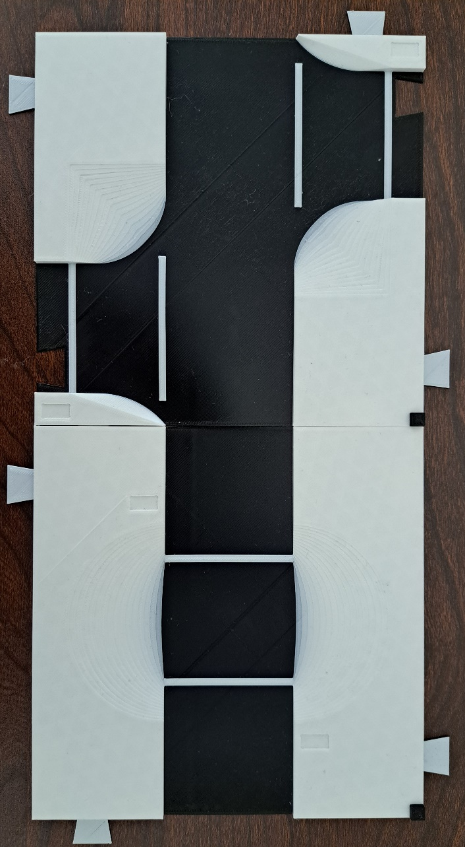

## Compatibility

If the tactile maps have hook and loop tape attached to them, they can be affixed to backings such as carpet or tactile map diagramming kits to keep them from sliding while in use.

## Specifications

The default map size is 17x17x0.6 cm. Each map weighs between 38 and 53 g. The pieces that can be placed on the maps are 1.2x0.6x0.24 cm and weigh 0.125 g each. The legend is 14.7x10x0.7 cm and weighs 28 g, including all the labels.

## Cleaning

All maps and pieces can be cleaned with any cleaning solution that will not degrade plastic.