# Introduction

The purpose of this project was to create a cost-effective, maker-manufacturable wireless connection between an assistive switch and a device that has a 3.5 mm jack. This may be useful for someone who would benefit from or would prefer not to use a wired switch and is looking to connect to a device with an existing 3.5 mm switch input. For example, a suitable device may include a switch adapted toy.

# Research

There are a few existing commercial options, however they are quite expensive.

### Commercial wireless switches:

|  |  |  |  |
| --- | --- | --- | --- |
| **Name** | **Picture** | **Price** | **Link** |
| Jelly Beamer Twist Transmitter with Original Receiver |  | $265 | [Jelly Beamer Twist Transmitter with Original Receiver | eSpecial Needs](https://www.especialneeds.com/shop/assistive-technology/switches/wireless-switches/jelly-beamer-twist-transmitter-with-original-receiver.html) |
| Mini Beamer Transmitter & Receiver Combo |  | $265 | [Mini Beamer Transmitter & Receiver Combo | Wireless Switches | eSpecial Needs](https://www.especialneeds.com/shop/assistive-technology/switches/wireless-switches/mini-beamer-transmitter-receiver-combo.html) |
| Big Beamer Transmitter |  | $145 | [Big Beamer Transmitter | Wireless Switches | Assistive Technology | eSpecial Needs](https://www.especialneeds.com/shop/assistive-technology/switches/wireless-switches/big-beamer-transmitter.html) |

# Requirements

## Goals

|  |  |
| --- | --- |
| G01 | Build a device that you can connect a 3.5 mm switch to and then have a wireless connection to a device that uses a 3.5 mm input jack. |
| G02 | Minimal delay between activation of the assistive switch and activation of the switch-adapted device. |

## Functional Requirements

|  |  |
| --- | --- |
| F01 | The device shall enable an assistive switch to operate a switch-adapted device through a wireless connection from a receiver to a transmitter. |
| F02 | The transmitter shall have an input for a 3.5 mm audio jack. |
| F03 | The receiver shall have an output for a 3.5 mm audio jack. |
| F04 | The device shall have sufficient range to operate across a room (i.e., 10 m range). |

## Non-functional Requirement

|  |  |
| --- | --- |
| NF01 | Uses easy to source parts. |
| NF02 | Maker friendly. |

## Constraints

|  |  |
| --- | --- |
| C01 | Costs significantly less than other commercial options. |

# Ideation

The initial idea for the project was based on a similar project that used Zigbee communication protocol. Unfortunately, the cost of materials for that project was comparable to commercially available wireless switch links, so a less expensive approach was desired. After looking at a variety of wireless communication modules, an inexpensive commercially available remote-control receiver and transmitter was found.

# Conceptual Design

The primary concept was to investigate whether a commercially available wireless remote relay could be modified to include a 3.5 mm input on the transmitter / remote side and a 3.5 mm output on the receiver / relay side.

**Output**

**Device**

**Transmitter**

**Receiver**

**Assistive**

**Switch**

# Prototyping

An initial prototype was built to as a proof-of-concept.

A Wireless Relay Remote Control Switch 1 Channel Key Receiver + Transmitter was selected as it was an affordable option (~$20 CAD) that should be easy for makers to modify. The remote transmitter was switch adapted with a 3.5 mm switch jack and a 3.5 mm output connection was connected between the common and normally open pins.

Figure 1: Device Wiring Diagram.[1]

The prototype was tested using a DIY assistive switch and a switch-adapted toy. Testing confirmed the basic operation of the device and a range of approximately 10 meters.

# Detailed Design

The device consists of a modified transmitter and a modified receiver, each contained within a 3d printed enclosure. These covers are intended to be taken off when the batteries in the devices need to be replaced.

## Transmitter

### Transmitter Wiring

The 3.5 mm input jack needs to be connected in parallel with the existing button on the remote. While the existing button could be removed, it was decided to solder to the connections so that either the assistive switch or the original button could be used for activation. Leaving the existing button provides a way to test the device in case an assistive switch isn’t available or isn’t working.

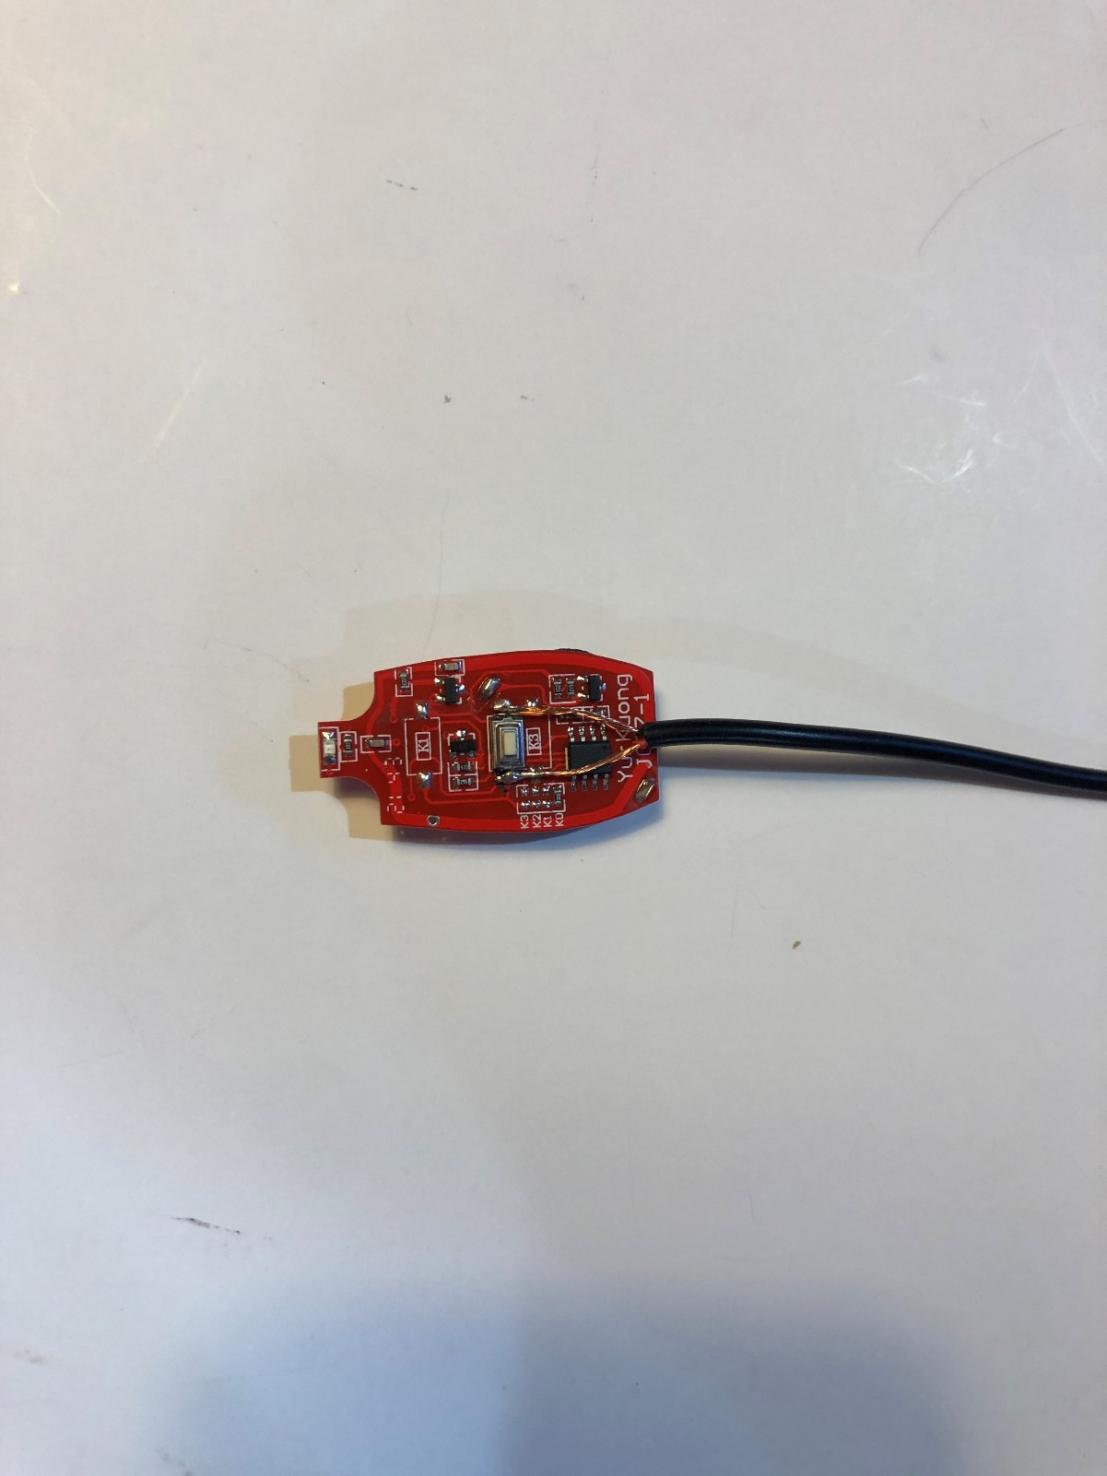

Figure 2: Modified Transmitter with Assistive Switch soldered in parallel.

### Transmitter Enclosure

The original enclosure for the remote was not large enough to accommodate the 3.5 mm input connection, so a 3D printed enclosure was designed. It was decided to design the enclosures with a snap on fit cover to reduce the materials required to build the device, as well as to provide access to change batteries when needed. The enclosure was originally designed for a 3.5 mm panel mount jack, however to reduce material costs, a male-female extension cable was used instead and cut to provide both the female portion for the transmitter and the male portion for the receiver. However, the cable holes in the transmitter and receiver enclosures are designed to be large enough to be used with 3.5 mm jacks instead if it was preferred.

|  |  |
| --- | --- |
| A picture containing text, electronics, battery  Description automatically generated  Figure : Wireless Assistive Switch Link Transmitter | A picture containing rectangle  Description automatically generated  Figure : Top view of the Transmitter's base |

## Receiver

### Receiver Wiring

The Receiver requires a power source and a means to connect to the 3.5 mm device. Three AA batteries and a suitable holder were selected to provide 4.5 V.

A latching on/off switch was added to the circuit of the receiver because the receiver was always searching for the signal from the transmitter. Without the switch, it was found the battery life for the 3 AA batteries was only approximately 3 weeks long. The latching switch used for the on/off of the batteries in the receiver came in a pack of 10, so a second switch was used for the “mode” button on the device. The original mode button on the receiver was quite small and it was determined to be easier to add a switch in parallel rather than adding 3d components to press down on the existing button. The original mode button was not a latching switch, but since the latching one came in the pack of 10 it was decided to make a latching one work instead to eliminate the need for purchasing a momentary switch. The wires that originally came on the remote device and the battery holder were repurposed to avoid the need to purchase any additional wire.

### Receiver Enclosure

The Receiver Enclosure requires space to house the original receiver circuitry, the battery holder, and the buttons for controlling the power and changing the mode. A snap fit cover was included for this enclosure as well to provide easy, tool-free access to change the receiver batteries.

|  |  |
| --- | --- |
|  |  |
| A picture containing electronics, projector  Description automatically generated  Figure : Wireless Assistive Switch Link Receiver | A picture containing indoor, accessory  Description automatically generated  Figure : Top view of the Receiver's base |

## Final Design

# Testing

As well as ensure that if a user owned 2 of these devices, that they would not interfere with one another.

# Opportunities for Improvement

* Adding an LED to indicate whether the receiver is on or off
* Making the mode light more visible. It cannot be seen if the surroundings are too bright (it is very challenging to see when outside).
* Finding a device that may have less of a delay. This device currently is likely not suitable for output devices that require negligible delay such as gaming.

1. Source: <https://m.media-amazon.com/images/I/61aabXVLcAL._AC_SL1001_.jpg>