## Introduction

The Wireless Assistive Switch Link is a device that enables a wireless connection between an assistive switch and an output device that has a 3.5 mm jack. The device also comes pre-set with timing latching settings of 10 seconds, 1 minute, and 5 minutes.

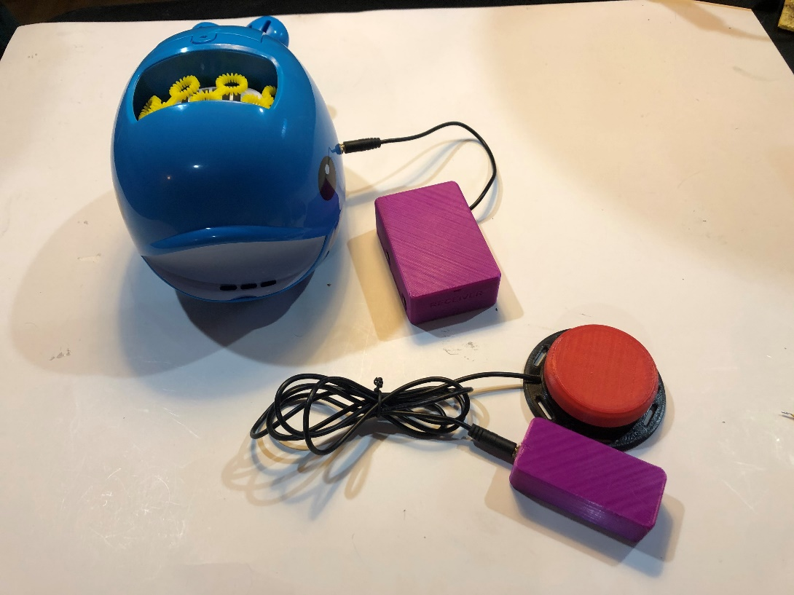

**Assistive Switch**

**Transmitter**

**Receiver**

**Output Device**

## Batteries

The Transmitter uses two CR2016 lithium batteries.

The Receiver uses three AA batteries.

## Compatibility

This device is compatible with any 3.5 mm assistive switch as well any output device that has a 3.5 mm input connection.

## Specifications

* Transmitter: 74mm Long x 35mm Wide x 22mm Deep
* Receiver: 91mm Long x 61mm Wide x 29mm Deep

## Cleaning

The outside of the Wireless Assistive Switch Link can be wiped down with a damp cloth. Please ensure that the inner contents of the device do not get wet.

## Usage

The Wireless Assistive Switch Link is used with a 3.5 mm switch, and an output device that has a 3.5 mm jack. The following is a set of instructions on how to use the device.

Step 1: Plug in an assistive switch into the device labelled “Transmitter”.

Step 2: Plug in an output device to the device labelled “Receiver”.

Step 3: Press the assistive switch. If nothing happens press the “On/Off” button on the side of the Receiver and try again.

Step 4: Determine what mode you want to use on the device. There are pre-set modes on the device, and some have been found to be more useful than others. They will be selected later by clicking the mode button again once you see the correct number of flashes as the desired mode. The following is a guide to explain the different modes:

* 1 flash = What seems to be an infinite latch? It does not appear to be useful and would recommend not using it.
* 2 flashes = momentary switch. The output device will turn off about 0.5 seconds after the user stops pressing the switch.
* 3 flashes = latching switch. It will stay on until you press the assistive switch again to turn it off.
* 4 flashes = switch latches for 10 seconds and then turns off.
* 5 flashes = switch latches for 1 minute and then turns off.
* 6 flashes = switch latches for 5 minutes and then turns off.
* 7 flashes = An “error”. Avoid using this setting. If you accidentally set the device to the 7th setting, it will not do anything. The device will have to be resynced by pressing the mode button twice quickly until the red light stays on. Next, click the assistive switch. Then, press the mode button again to pick the mode you want. The device should work again once this is complete.

Step 5: Once the desired mode has been determined, press the “Mode” button on the side of the receiver. It should do one flash, pause, two flashes, pause, 3 flashes, pause, all the way up to 7 flashes. To select a mode, press the mode button again after you see the number of flashes that corresponds with the mode you want. For example, if you are looking for the momentary switch mode (2 flashes), wait for the device to flash once, pause, and then flash twice before pressing the “Mode” button again.

Step 6: Press your assistive switch. The output device should act accordingly to the mode you selected.

Step 7: When you’re done using the device, turn the power off by pressing the “On/Off” button on the Receiver. This will save the battery life in the Receiver.