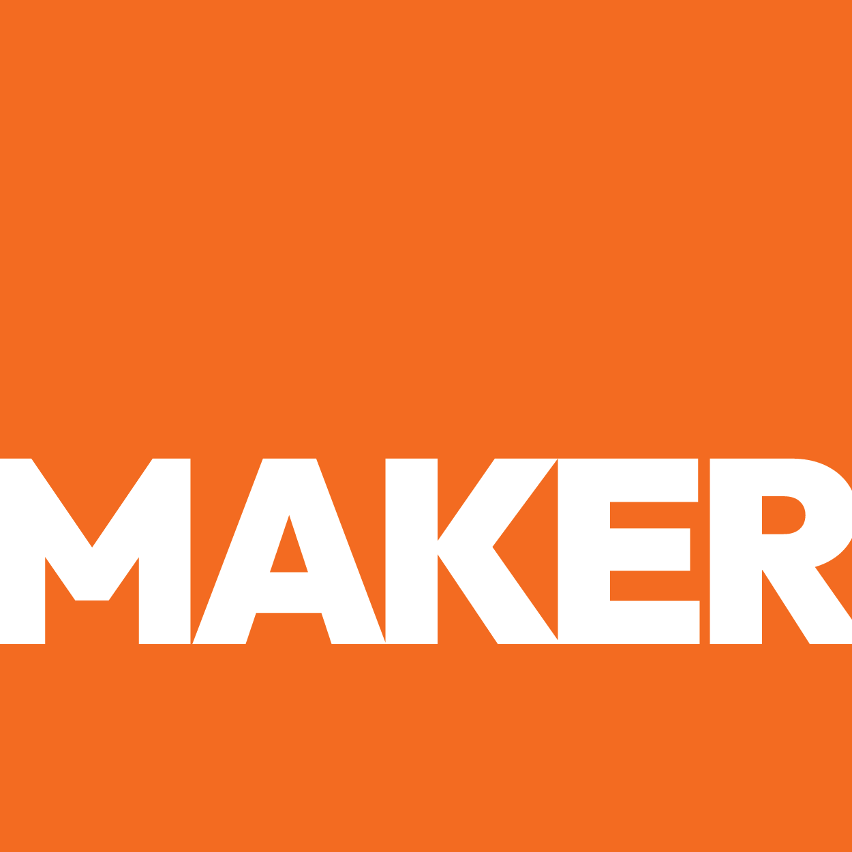

MARKET ANALYSIS & 5-YEAR FORECAST
MARKET ANALYSIS
& 5-YEAR FORECAST

Food Safety Testing & Analytical Laboratory Services Market Intelligence for Empiria Labs
● Edinburg, TX ● March 2026 ● Prepared by Maker Web Studios
CONFIDENTIAL — PREPARED EXCLUSIVELY FOR Empiria Labs
SECTION 00
Table of Contents
01 Executive Market Summary
02 Global & North American Market Landscape
03 Regional / Local Market Analysis
04 5-Year Revenue Forecast
05 Market Risks & Mitigation
06 5-Year Strategic Horizon
SECTION 01
Executive Market Summary
The global and regional market opportunity for Empiria Labs through 2026.
$[X]B+  Global Market 2026 | $[X]B  Market 2026 | %  CAGR | %  Share

%  E-Commerce / Digital CAGR | [X]B | [X]+ | [X]%
Sources: MarketsandMarkets Food Safety Testing Report (Jan 2026), Grand View Research Analytical Laboratory Services (Feb 2026), USDA Produce Safety Alliance Annual Report 2025. All figures represent published third-party market research.

SECTION 02
Global & North American Market Landscape
Structural trends driving demand in through .
01 | FSMA Produce Safety Rule Enforcement

02 | Nearshoring and Cross-Border Produce Trade Growth

03 | Consumer Demand for Transparency and Pesticide-Free Certification

04 | Retail and Foodservice Supply Chain Audit Requirements

05 | Mycotoxin and Heavy Metal Regulatory Tightening

SECTION 03
Regional / Local Market Analysis
The local and regional opportunity in and the surrounding corridor.
■ RGV Produce Corridor Concentration
The Rio Grande Valley is one of the top 5 produce import corridors in the United States. Hidalgo County alone processes billions of pounds of fresh produce annually through its international bridges. This geographic concentration of produce volume within 50 miles of Empiria's lab creates a natural catchment area that no national lab can serve with comparable convenience or turnaround time.
■ Laboratory Desert in South Texas
Between San Antonio and the Mexican border, there is no other dual A2LA-accredited food safety testing laboratory. This 300-mile gap means every produce company in the region has historically had to ship samples out, absorbing shipping costs and turnaround delays. Empiria's physical location fills a geographic gap in the national laboratory infrastructure.
■ Bilingual Market Advantage
Approximately 90% of the RGV population is Hispanic, and cross-border business is conducted in both English and Spanish. Empiria's Colombian-American leadership and bilingual capability allow them to serve both US growers and Mexican exporters with equal fluency -- a practical advantage that English-only national labs cannot replicate.

"Empiria Labs sits at 6200 E. Ramseyer Rd in Edinburg, TX -- directly in the heart of the Rio Grande Valley produce corridor. Within a 50-mile radius are the McAllen-Hidalgo International Bridge, Pharr International Bridge, and dozens of produce companies, packing houses, and cold storage facilities. No other dual A2LA-accredited lab exists within 300 miles, giving Empiria an unmatched same-day sample acceptance advantage over every national competitor."
— Maker Web Studios Market Analysis

SECTION 04
5-Year Revenue Forecast
Projected revenue scenarios based on market growth, client acquisition, and operational execution. Conservative (slow ramp), Base Case (playbook execution), Optimistic (capacity expansion + enterprise accounts by Year 3).
YEAR | CONSERVATIVE | BASE CASE ★ | OPTIMISTIC | KEY ASSUMPTIONS
2026 (Yr 1) | $[X]K ARR | $[X]K ARR | $[X]K ARR | Website launch within 30 days generates immediate credibility uplift; organic growth begins from improved digital visibility; existing client base provides baseline revenue.
2027 (Yr 2) | $[X]K ARR | $[X]K ARR | $[X]K ARR | SEO and Google Business Profile drive steady inbound leads; 3-8 new produce company clients added depending on outreach effort; cross-border testing relationships begin developing.
2028 (Yr 3) | $[X]K ARR | $[X]K ARR | $[X]K ARR | Local reputation firmly established through word of mouth and digital presence; referral pipeline active; potential second instrument suite evaluation based on demand.
2029 (Yr 4) | $[X]K ARR | $[X]K ARR | $[X]K ARR | Content marketing and directory presence generating consistent monthly leads; regional dominance in food safety testing established; environmental testing scope expansion considered.
2030 (Yr 5) | $[X]K ARR | $[X]K ARR | $[X]K ARR | Full utilization of current facility approaching; established as default testing partner for RGV produce corridor; evaluation of second location or expanded capacity underway.
★ Base Case assumes successful execution of the 90-Day Launch Roadmap and Growth Strategy Playbook. Conservative assumes minimal digital investment. Optimistic assumes capacity expansion and enterprise accounts by Year 3.

SECTION 05
Market Risks & Mitigation
Key threats to the growth trajectory and recommended countermeasures.
RISK FACTOR | MITIGATION STRATEGY
RISK  National Lab Expansion: Bureau Veritas, Eurofins, or SGS could open a satellite office in the RGV, bringing accredited testing closer to local growers. | MITIGATION  Establish brand dominance and client relationships now, before a competitor enters. Switching costs in laboratory testing are high -- once a grower has a validated method with a lab, changing is disruptive.
RISK  Accreditation Scope Challenges: Maintaining and expanding A2LA accreditation requires ongoing investment in proficiency testing, method validation, and quality system maintenance. | MITIGATION  Budget for annual A2LA assessments and proficiency testing. Document quality system rigorously. Jorge's scientific background is an asset here -- leverage it.
RISK  Instrumentation Downtime: LC/MS-MS and GC/MS-MS instruments require regular maintenance and occasional repair. Downtime directly impacts revenue and client trust. | MITIGATION  Maintain service contracts on critical instruments. Build relationships with backup labs for emergency overflow. Communicate transparently with clients about instrument status.
RISK  Regulatory Shifts: Changes in FDA testing requirements, FSMA enforcement priorities, or international trade agreements could alter testing demand patterns. | MITIGATION  Stay current on regulatory developments through industry associations and FDA guidance documents. Diversify testing capabilities across multiple regulatory frameworks.
RISK  Economic Slowdown in Produce Sector: A recession or trade disruption could reduce produce volumes through the RGV corridor. | MITIGATION  Diversify revenue streams across food safety, petroleum geochemistry, and environmental testing. The petroleum geochemistry capability provides a natural hedge against agricultural sector volatility.

SECTION 06
5-Year Strategic Horizon
Where Empiria Labs should be positioned by — and what it takes to get there.
2026 | 2027 | 2028 | 2029 | 2030
Foundation: Launch professional website, establish Google presence, capture first wave of inbound leads from digital visibility. Goal: prove that digital investment converts to testing contracts. | Growth: SEO and content marketing drive consistent monthly leads. Cross-border testing expands as Mexican exporters discover Empiria through bilingual digital presence. First full year of digital-driven client acquisition. | Expansion: Evaluate second instrument suite or expanded testing scope based on demand patterns. Consider environmental testing accreditation to diversify revenue. Hire additional analytical staff to handle volume. | Authority: Empiria is recognized as the go-to food safety testing lab in South Texas. Conference speaking, industry publication, and association partnerships cement thought leadership. Explore partnership or licensing model for laboratory management consulting. | Scale: Full facility utilization with clear path to second location or expanded capacity. Multiple revenue streams (food safety, petroleum, environmental) provide stability. Brand value supports premium pricing relative to commodity testing services.
By , the in will be meaningfully larger than it is today. The structural drivers — FSMA Produce Safety Rule enforcement increasing demand for third-party testing, Nearshoring and cross-border produce trade growth in South Texas, Consumer demand for pesticide-free and organic certification, and Retail and foodservice supply chain audit requirements tightening — will have compounded for five more years. The question is not whether there will be demand for Empiria Labs's products. The question is whether Empiria Labs will be findable, credible, and operationally scaled when that demand arrives.
The food safety testing market is not speculative -- it is driven by regulatory mandates that are only tightening. Empiria's unique combination of dual accreditation, geographic advantage, and scientific leadership positions the lab for sustained growth if the digital foundation is built now.
In five years, Empiria Labs should be the undisputed food safety testing authority in South Texas, with $1M+ ARR, a full client roster of RGV produce companies, cross-border testing contracts, and a growing petroleum geochemistry practice. The brand should command premium pricing based on accreditation, proximity, and scientific leadership. For that future to materialize, the digital presence must be built today -- every month of delay is market share ceded to distant competitors who are already investing in digital visibility.

"The does not reward the best — it rewards the most visible one. Empiria Labs has the operational excellence to win on product. The 5-year forecast belongs to the version of Empiria Labs that also wins on presence."
— Maker Web Studios Market Analysis

